Participant Information Sheet |  | 
Study title: | Understanding circulatory control in postural orthostatic tachycardia syndrome
Locality: | Auckland | Ethics committee ref.: | 2023 EXP 19246
Lead investigator: | Dr. James P Fisher | Contact phone number: | 09-373 7599  Ext 86320
You are invited to take part in a study investigating Postural Orthostatic Tachycardia Syndrome (POTS). Whether or not you take part is your choice. If you don’t want to take part, you don’t have to give a reason, and it won’t affect the care you receive. If you do want to take part now, but change your mind later, you can pull out of the study at any time.
This Participant Information Sheet will help you decide if you’d like to take part. It sets out why we are doing the study, what your participation would involve, what the benefits and risks to you might be, and what would happen after the study ends. We will go through this information with you and answer any questions you may have. You do not have to decide today whether you will participate in this study. Before you decide you may want to talk about the study with other people, such as family, whānau, friends, or healthcare providers. Feel free to do this.
If you agree to take part in this study, you will be asked to sign the Consent Form on the last page of this document. You will be given a copy of both the Participant Information Sheet and the Consent Form to keep.
This document is 10 pages long, including the Consent Form. Please make sure you have read and understood all the pages.

What is the purpose of the study?

Postural Orthostatic Tachycardia Syndrome (POTS) is a common but poorly understood condition. In POTS, the heart rate increases excessively with standing, often as a response to the shift of blood into the legs because of gravity. Accompanying symptoms include dizziness/light-headedness, chest pain, shortness of breath, extreme tiredness, and brain fog. POTS can have a big impact on everyday life, but we do not understand what causes it.

Individuals with POTS often experience blood pooling in the legs, which is thought to occur because of abnormal tightening of the blood vessels on standing. However, the mechanism underlying this is remains unclear. The aim of this project is to investigate the blood vessel structure (specifically how stretchy the blood vessels are), function (how well the blood vessels tighten), and regulation (how well the nerves tighten the blood vessels) in people with POTS and people without POTS. The data will also be used to make computer models of the cardiovascular system to better understand mechanisms of individuals with POTS. It is hoped that our work will provide insight to the mechanisms underlying POTS which may help improve and personalise treatments for patients.

This study is funded by the University of Auckland. It is being conducted by Dr. James P Fisher (Principal Investigator, University of Auckland), Dr Nicola Edwards (Auckland District Health Board and University of Auckland), Dr Kate Thomas (University of Otago), Dr. Finbar Argus (University of Auckland), Dr. Ana Luiza Carrari Sayegh (University of Auckland), Dr. Mickey Fan (University of Auckland), and Greer Pugh (University of Auckland). This study has been reviewed and approved by Health and Disability Ethics Committee. Protocol number 2023 EXP 19246.

What will my participation in the study involve?
We are inviting two groups of people to participate in this study:
- People clinically diagnosed with POTS
- People without POTS
You have been invited to participate because you potentially fit into one of these 2 groups of people.
For safety and scientific reasons, you are ineligible to participate in this study if you are: younger than 18 years old, are pregnant, are a smoker, or have another significant medical condition (e.g., heart failure, lung disease). An investigator will carefully check the inclusion/exclusion criteria with you and answer any queries.
Studies will be undertaken at the Human Cardiorespiratory Physiology Laboratory, Clinical Research Centre Facility, Faculty of Medical and Health Sciences, University of Auckland. Participation involves one short Screening/ familiarisation visit and two experimental visits. The general procedure for participating is as follows:
Once you have read this form, an investigator will contact you to make sure that your questions have been answered and check that you understand what is involved. They will then schedule a familiarisation visit with you.

Familiarisation/screening visit
At the familiarisation visit (~60 min) an investigator will further explain the nature of the procedures, answer any remaining questions, and ask you to complete the Consent Form below. You will be asked to complete some health questionnaires including general health, quality of life, physical activity, and autonomic symptoms. Participants in the POTS group will be asked to complete an additional questionnaire about POTS symptoms. Then, providing you meet the study inclusion/exclusion criteria, you will be enrolled in the study. Bodyweight and height will be measured, and specific joints will be assessed for joint hypermobility (little finger, wrists, elbows, knees, and hips). Following, you will be familiarised with the study procedures to be conducted at the experimental visits.

Experimental visits
The two experimental visits will last ~1 ½ and ~3 hours each and will be separated by ~1 weeks. Prior to the study visit, the following pre-study stipulations apply:
• No food intake for 2 hours prior to the study.
• No caffeine (e.g., coffee, coke, red bull) for 12 hours before the study.
• No alcohol on the day before the study and the day of the study.
• No exercise for 12 hours before the study.
• No ‘over the counter’ (e.g., paracetamol) or cardioactive medications (midodrine, beta-blocker, ivabradine) on the morning of the study. This can be discussed with a study investigator prior to your appointment. Please bring the medications (if you take any) to your study appointment so you can take your usual medication immediately after the research tests (usually by late morning).
The following procedures will be conducted while you rest on a comfortable bed.

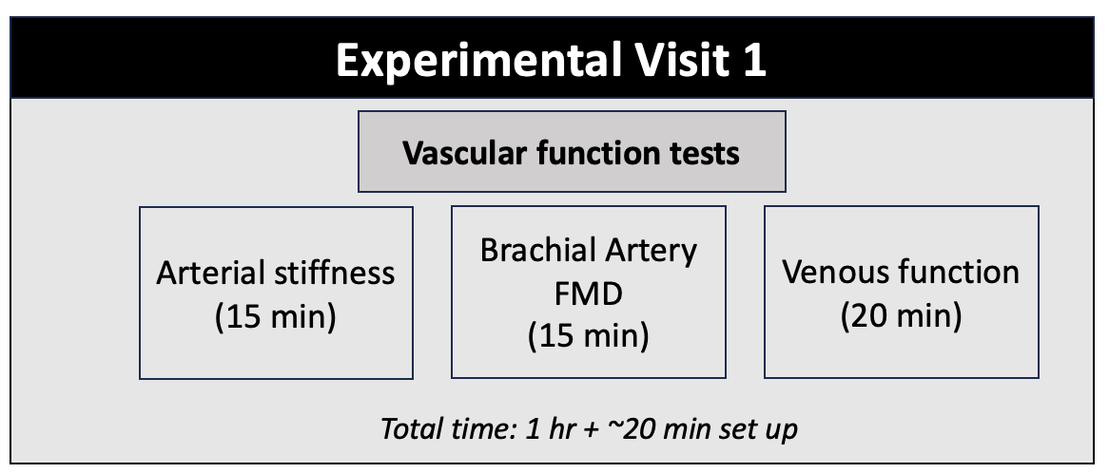
Experimental Visit 1: You will be asked to lie on a bed and equipment will be set up for the measurement of your cardiovascular system (e.g., blood pressure, heart rate, arterial stiffness, and venous function), as described below. An overview of the first experimental visit is outlined below. There are illustrations of the measures made in the pictures below.

Visit 1 Measured variables.
- Arterial stiffness will be measured by the placement of a pen-shaped probe over arteries at your neck, wrist, and ankle. A cuff will be placed around your upper thigh that will inflate for a couple of minutes. These sites correspond to your carotid, radial, tibial and femoral arteries and allow use to determine how fast the blood pressure pulse wave travels along your main arteries.
- Flow mediated dilatation will be used to examine brachial artery function using ultrasound. This involves the inflation (for 5 minutes) and then deflation of a standard blood pressure cuff around the upper arm (5 minutes).
- Venous function will be measured by a cuff placed around the thigh, above the knee and a lightweight elastic band or sensor cuff placed around the widest portion of the calf. The cuff will be inflated for 8 minutes and then slowly deflated over 60 seconds.

Experimental visit 2: You will be asked to lie on a bed and equipment will be set up for the measurement of heart rate, blood pressure, ventilation, blood flow, and sympathetic nerve activity recordings (described below). You will then rest for 10 minutes while we collect baseline measurements. You be asked to do some autonomic function tests including slow deep breathing, a handgrip test, putting your hand in cold water, and doing a Valsalva’s manoeuvre.

- Slow deep breathing: You will be asked to take slow deep breaths for 5 minutes with the guidance of an investigator.
- Handgrip test: You will be asked to hold a device that measures the force of your handgrip. You will do some short handgrip trials to establish your maximum grip strength.
- Valsalva’s manoeuvre: We will ask you to forcefully breathe out against a resistance (breathing out whilst you are wearing a mouthpiece) for around 15 seconds.
- Cold pressor test: You will be asked to place a hand in cold water for 2 minutes.

Once the autonomic function tests are completed, all equipment, apart from the heart rate and blood pressure monitors will be removed. You will then be asked to do a stand test. The stand test will start with you lying down for 5 minutes. Then you will be asked to stand still for 10 minutes while we monitor your heart rate and blood pressure. You will then lie down to rest for 5 minutes.

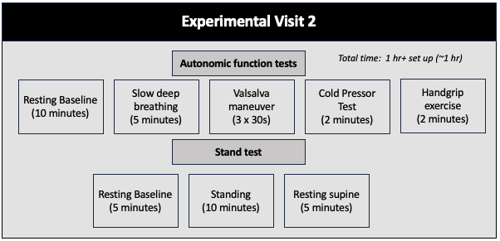
Visit 2 measured variables.
The sympathetic nervous system will be assessed using a thin wire that will be placed at the nerve just below the knee (peroneal nerve). The wires are like acupuncture needles, but the tip is very fine (it is the width of human hair). Once a good nerve recording is found, the electrodes will stay in your leg for the rest of the study. You will be asked to keep your leg as still as possible during the study. It is a well-established procedure. This is illustrated in the picture below:

All measurement equipment will be removed at the end of the session.

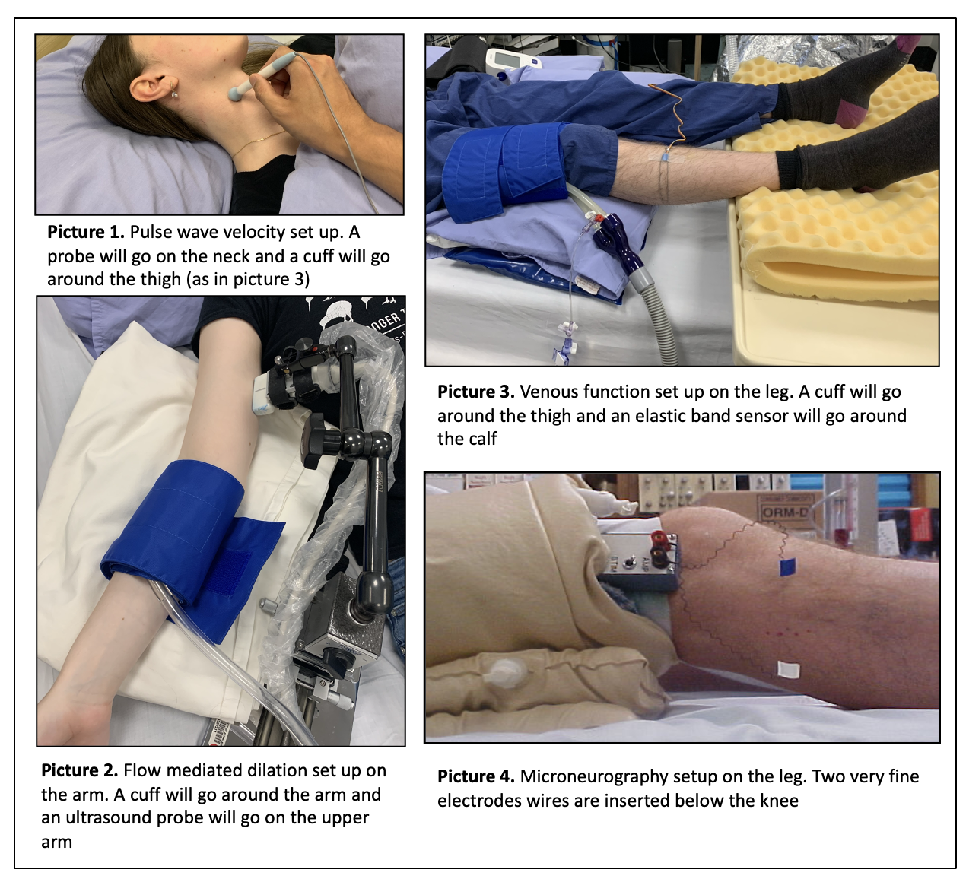

What are the possible benefits of this study?
Benefits: The information we will gather from all the people taking part in this study will help us understand the mechanisms that may be responsible for causing POTS. In the future, we hope we will be able to apply this knowledge to better diagnose and manage the symptoms of POTS to improve quality of life. However, there are no individual benefits to participating in this experimental study.

What are the possible risks and discomforts of this study?

Risks and discomforts: The risks associated with the procedures are minimal. The research team is experienced with all the procedures employed. To further minimise the risk associated with this investigation studies will be undertaken in a clinical research laboratory. Medically trained personnel will be in close-proximity, along with AED facilities, in the unlikely event that they are required. In addition, your heart rate, blood pressure, breathing, and blood oxygen levels will be very carefully monitored throughout the study. The experiment will be stopped at your request or if the investigator thinks that it is in your best interests.

Sympathetic nerve recording: This procedure occasionally may result in the leg muscles feeling tired. Also, you may have a pins-and-needles feeling or a greater sensitivity to touch in the leg. However, these side effects are rare and if they occurred, would only be temporary (e.g., lasting for a day or two at the most).

Fainting: There is a small risk of fainting during the stand test for individuals with POTS. We will monitor blood pressure and heart rate closely and the experiment will be stopped if you feel faint or the investigator believes it is in your best interest.
Detection of Abnormalities: The measures made are for research purposes and are not a medical exam or diagnostic test. There is a small possibility that we may incidentally find an abnormality that can impact your health conditions, such as a heart rhythm abnormality. In the event of this, you will be informed and will be advised to consult your general practitioner. If you do not wish to know about this type of finding, please do not participate.

With-holding morning medications: Medications for POTS are given to help you manage symptoms. It is likely symptoms will be worse without these medications, and this should be factored into your decision to participate. As stated above, please bring your usual medications to your study appointment so you can take them immediately after the research tests (by late morning).

COVID-19: The study will proceed in accordance with guidance from the University of Auckland regarding practices to minimise the risk of COVID-19 transmission. This will include the researchers wearing personal protective equipment and maintaining appropriate physical distance when able. Equipment is always sterilised between participants, and surfaces disinfected. If you feel unwell on the day of your scheduled testing, have been in close contact with a confirmed or probable case of COVID-19, or have returned from overseas in the 14 days prior to your scheduled testing, please do not come in for assessment.

Who pays for the study?
As a participant in this study, you will not incur any costs. You will receive a $50 voucher per experimental visit in recognition of your participation in this study.

What if something goes wrong?
If you were injured in this study, you would be eligible to apply for compensation from ACC just as you would be if you were injured in an accident at work or at home. This does not mean that your claim will automatically be accepted. You will have to lodge a claim with ACC, which may take some time to assess. If your claim is accepted, you will receive funding to assist in your recovery.
If you have private health or life insurance, you may wish to check with your insurer that taking part in this study won’t affect your cover.

What are my rights?
Your participation in this study is entirely voluntary. You are free to decline to participate, or to withdraw from the research at any practicable time, without experiencing any disadvantage. You can withdraw by notifying an investigator verbally or by writing. You have the right to access information collected about you as part of the study and change any information that is incorrect. Please write to us if this is the case. You will be informed of any new information related to the study that becomes available during the study that may have an impact on your health. Your identity will be kept strictly confidential, and you will not be identified in the publication of the research findings.

What happens after the study?
During this study the research team will record information about you and your study participation. This includes the results of any study assessments (e.g., ECG, BP, respiration and blood vessel function). If needed, information from your hospital records and your GP may also be collected. You cannot take part in this study if you do not consent to the collection of this information.

Identifiable Information: Identifiable information is any data that could identify you (e.g., your name, date of birth, or address). The following groups may have access to your identifiable information:
- Research team (to complete study assessments)
- Sponsor study monitors, to make sure the study is being run properly and that the data collected is accurate.
- The sponsor and its representatives if you make a compensation claim for study-related injury. Identifiable information is required to assess your claim.
- The sponsor, ethics committees, or government agencies from New Zealand, if the study or site is audited. Audits are done to make sure that participants are protected, the study is run properly, and the data collected is correct.
- Your usual doctor, if a study test gives an unexpected result that could be important for your health. This allows appropriate follow-up to be arranged.

De-identified (Coded) Information: To make sure your personal information is kept confidential, information that identifies you will not be included in any report generated by the research team, or any study information sent to the sponsor. Instead, you will be identified by a code. The research team will keep a list linking your code with your name so that you can be identified by your coded data if needed. The following groups may have access to your coded information:
- The sponsor, for the purposes of this study.
The results of the study may be published or presented, but not in a form that would reasonably be expected to identify you.
Security and Storage of Your Information: Your identifiable information is held at University of Auckland in a locked filing cabinet in a department with security-limited access, along with all paper records (e.g., health history forms) during the study. After the study it is transferred to a secure archiving site and stored for at least ten years, then destroyed. Your coded information will be entered into electronic case report forms stored in secure and password protected University of Auckland servers. Coded study information will be kept by the sponsor in secure, cloud-based storage indefinitely. All storage will comply with local and/or international data security guidelines.
Risks: Although efforts will be made to protect your privacy, absolute confidentiality of your information cannot be guaranteed. Even with coded and anonymised information, there is no guarantee that you cannot be identified. The risk of people accessing and misusing your information (e.g., making it harder for you to get or keep a job or health insurance) is currently very small, but may increase in the future as people find new ways of tracing information.
Rights to Access Your Information: You have the right to request access to your information held by the research team. You also have the right to request that any information you disagree with is corrected. Please ask if you would like to access the results of your screening and safety tests during the study. If you have any questions about the collection and use of information about you, you should ask the research team.
The full results of the studies being conducted will not be known until after the last participant has been tested and the data analysed (up to two years). The results will be reported in professional publications and meetings but will not be published in a form that identifies individual participants. If you are interested in receiving a summary of the results, please indicate as appropriate on the consent form below.
Rights to Withdraw Your Information: You may withdraw your consent for the collection and use of your information at any time, by informing the research team. If you withdraw your consent, your study participation will end, and the study team will stop collecting information from you. If you agree, information collected up until your withdrawal from the study will continue to be used and included in the study. You may ask for it to be deleted when you withdraw unless you withdraw after the study analyses have been undertaken.
HDEC Auditing: An approved auditor appointed by New Zealand Health and Disability Ethic Committees, or any relevant regulatory authority or their approved representative may review your medical records for the sole purpose of checking the accuracy of information recorded for the study, for auditing purposes.

Who do I contact for more information or if I have concerns?
If you have any questions, concerns, or complaints about the study at any stage, you can contact:
Name, position: Dr James P. Fisher, Principal Investigator
Telephone number: 09 373 7599 | Ext 86320
Email: jp.fisher@auckland.ac.nz

If you want to talk to someone who isn’t involved with the study, you can contact an independent health and disability advocate on:
Phone: 0800 555 050
Fax: 0800 2 SUPPORT (0800 2787 7678)
Email: advocacy@advocacy.org.nz

If you require Māori cultural support talk to your whānau in the first instance. Alternatively, you may contact the administrator for He Kamaka Waiora (Māori Health Team) by telephoning 09 486 8324 ext 2324.
If you have any questions or complaints about the study you may contact the Auckland and Waitematā District Health Boards Maori Research Committee or Maori Research Advisor by phoning 09 4868920 ext 3204.
You can also contact the health and disability ethics committee (HDEC) that approved this study on:
Phone: 0800 4 ETHICS
Email: hdecs@moh.govt.nz

Consent Form

Please tick to indicate your consent to the following

I have read, or have had read to me in my first language, and I understand the Participant Information Sheet.
I have been given sufficient time to consider whether or not to participate in this study.
I have had the opportunity to use a legal representative, whanau/ family support or a friend to help me ask questions and understand the study.
I am satisfied with the answers I have been given regarding the study and I have a copy of this consent form and information sheet.
I understand that taking part in this study is voluntary (my choice) and that I may withdraw from the study at any time without this affecting my medical care.
I consent to the research staff collecting and processing my information, including information about my health.
If I decide to withdraw from the study, I agree that the information collected about me up to the point when I withdraw may continue to be processed.
I consent to my GP or current provider being informed about my participation in the study and of any significant abnormal results obtained during the study.
I agree to an approved auditor appointed by the New Zealand Health and Disability Ethic Committees, or any relevant regulatory authority or their approved representative reviewing my relevant medical records for the sole purpose of checking the accuracy of the information recorded for the study.
I understand that my participation in this study is confidential and that no material, which could identify me personally, will be used in any reports on this study.
I understand the compensation provisions in case of injury during the study.
I know who to contact if I have any questions about the study in general.
I understand my responsibilities as a study participant.
I wish to receive a summary of the results from the study.
 | Yes □ | No □

Declaration by participant:
I hereby consent to take part in this study.

Participant’s name:
Signature: | Date:

Declaration by member of research team:

I have given a verbal explanation of the research project to the participant, and have answered the participant’s questions about it.

I believe that the participant understands the study and has given informed consent to participate.

Researcher’s name:
Signature: | Date:

