Building Warden Action Card

Building:

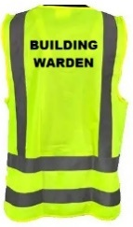
UPON HEARING THE FIRE ALARM:
- Proceed to the main entrance, collect the building warden vest and the evacuation checklist/board
- Go to the fire panel and receive the floor warden reports.
- The fire panel is located:
- Ensure Fire & Emergency have been called (you may delegate this).
- Our address is:
- The nearest intersecting street is:
- Ensure Security is called: Ext: 85000 or 0800 373 7550
- Use the evacuation checklist/board to verify the areas/floors that are clear when their area wardens report to you
- Appoint the wardens to direct occupants to the assembly point and assist with crowd control
- The assembly point is:
- Liaise with Fire & Emergency upon their arrival, advising them of the evacuation status, including the location of any persons still in the building

If applicable:
- Hazard Plans are located:
- Hazardous substances inventories available via SciTrack
- Safety data sheets are available via Gold FFX

