
Building Warden Action Card

Building:

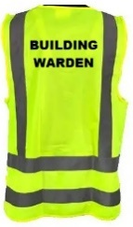
UPON HEARING THE FIRE ALARM:
- Put on the building warden vest and collect the evacuation folder
- Go to the fire panel and receive the floor warden reports.
- The fire panel is located:
- Call Fire & Emergency NZ (FENZ) on 111. You may delegate this.
- Our address is:

- The nearest intersecting street is:
- Ensure Security is called: 0800 373 7550 or use the UoA Alert App: You may delegate this
- Use the evacuation checklist/board to verify the areas/floors that are clear when their area wardens report to you
- Appoint the wardens to direct occupants away from the building to a safe location: “Disperse, Don’t Gather”
- Liaise with Fire & Emergency (FENZ) upon their arrival, advising them of the evacuation status, including the location of any persons still in the building
- Advise that no one is allowed to return to the building until given the ‘All-Clear’ by FENZ, even if the alarm stops sound
- Once FENZ allow access back into the building, ensure wardens are informed

