**Building Warden Action Card**

|  |  |
| --- | --- |
| **Building:** |  |

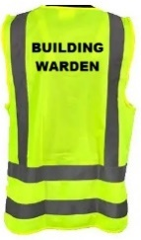**UPON HEARING THE FIRE ALARM:**

* Put on the building warden vest and collect the evacuation folder
* Go to the fire panel and receive the floor warden reports.
* **The fire panel is located:**
* Call Fire & Emergency NZ (FENZ) on 111. You may delegate this.
* **Our address is:**
* A blue sign with black text

  AI-generated content may be incorrect.**The nearest intersecting street is:**
* Ensure Security is called: 0800 373 7550 or use the UoA Alert App: You may delegate this
* Use the evacuation checklist/board to verify the areas/floors that are clear when their area wardens report to you
* Appoint the wardens to direct occupants to the assembly point and assist with crowd control
* **The assembly point is:**
* Liaise with Fire & Emergency (FENZ) upon their arrival, advising them of the evacuation status, including the location of any persons still in the building
* Advise that no one is allowed to return to the building until given the ‘All-Clear’ by FENZ, **even if the alarm stops sound**
* Once FENZ allow access back into the building, ensure wardens are informed