**Health, Safety and Wellbeing -**

**Laser Safety Guidelines**

***General guidelines for all users***

Contents

LASER SAFETY PROTOCOL 5

LEARN IT 7

Introduction 9

What the protocol does not cover 9

Lasers: the basics 10

Hazards 10

Eye hazards 11

Classification 15

Roles 18

Training and requirements 20

Vision health check 21

University Laser Competency Matrix (v0.1) 22

Recommended Minimum Training:. 24

Records 25

Laser Laboratory Authorised Personnel Training and Access Register 25

PURCHASE IT 29

Safe equipment 30

Inventory 30

Appendix 1. - Template to send to the LSO with laser details 31

Purchase request 32

USE IT 34

General rules 36

Personal Protective Equipment (PPE) 38

Storage spaces at the point of entry 39

Good example of laser eyewear protection 40

Laser pointers 41

Laser pointers purchased via the internet 41

Microscopes 42

Introduction 42

Risk assessment 42

During operation 42

Records 43

Laser survey 43

BUILD IT/MAINTAIN IT 45

How to set up a laser lab 47

Risk assessment 47

Example risk assessment 49

Repairs and maintenance 62

Records 62

Controlled areas 62

Controls during servicing 62

SECURE IT 65

Physical security and access 67

Information security 67

Why do we need information security? 67

What information needs to be kept securely? 67

Where is the information held? 67

Using shared databases 68

Review of information security 68

MOVE IT/DISPOSE OF IT 70

Transfer 72

Disposal 72

MEASURE IT 74

Internal verification 76

Annual laser laboratory inspection 76

Annual verification of the restricted lasers register 77

Documentation in each laser laboratory 77

University laser laboratory evaluation checklist 78

EMERGENCY 82

Emergency procedures 84

Incident reports 84

Appendix 1. How to find the Eye Clinic 86

# LASER SAFETY PROTOCOL

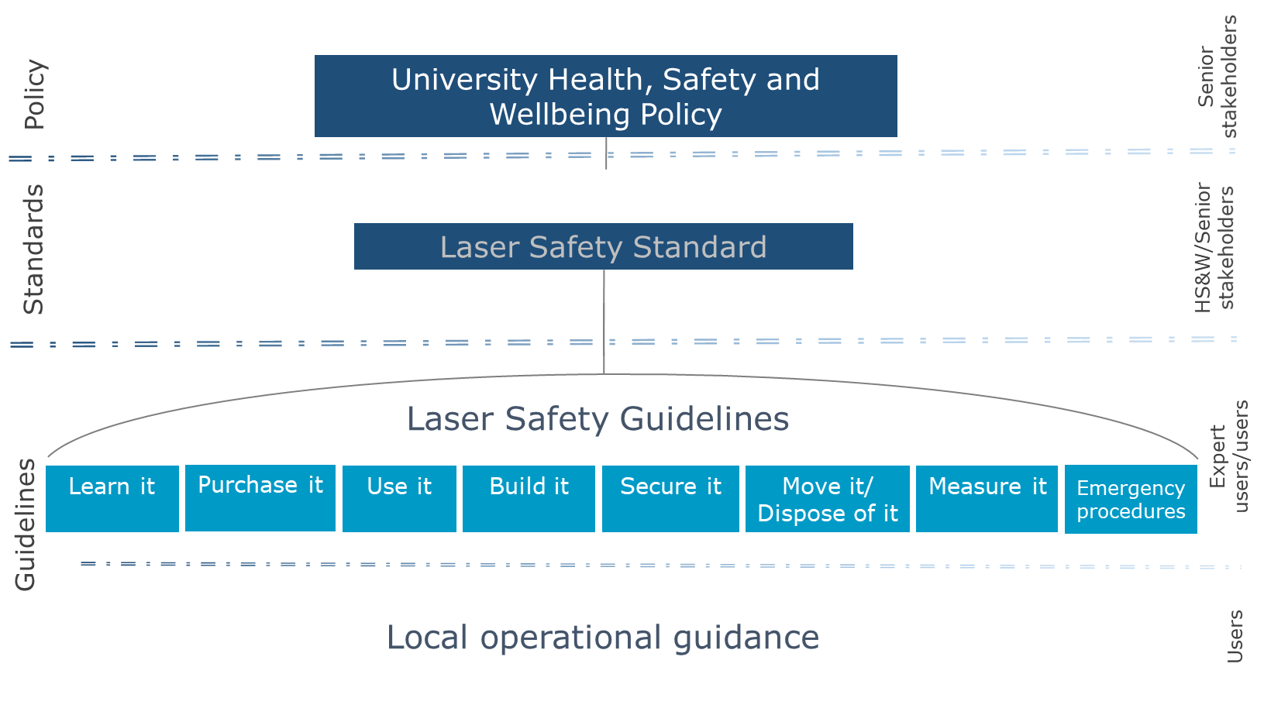

LEARN IT

# Introduction

The word laser is an acronym formed from Light Amplification by Stimulated Emission of Radiation. Lasers are equipment that pose unique hazards to their users and others who may be nearby, so we need high quality, easy-to-follow instructions on how to use them safely. The purpose of these guidelines is to provide clear instructions about how users can protect themselves and others from laser radiation. Furthermore, this guidance will assist staff and students to develop safe working practices when working with lasers. It is also essential that these practices comply with AS NZS IEC 60825.1 and AS NZS IEC 60825.14 standards.

These guidelines are part of the Laser Safety Protocol and apply at the level of the Expert users/users as shown below:



## What the protocol does not cover

**Medical or cosmetic lasers**

Note that the laser safety protocol **does not** cover medical or cosmetic lasers. The use of such lasers in a medical setting is extremely complex and users must strictly comply with all applicable regulations and guidance – seek further advice from Laser Safety Officer (LSO).

**Laser displays and shows**

Lasers used in displays and shows are regulated under a specific standard (AS/NZS-IEC-608025.3 – Safety of laser products – Part 3: Guidance for laser displays and shows) which provides guidance on the planning and design, set-up and conduct of laser displays and shows that make use of high-power lasers.

The laser power needed to produce effective theatrical or artistic displays in large spaces such as theatres, arenas, or architectural sites is high enough to pose a severe accidental exposure hazard, even when personal exposure is very brief. For this reason, sub-clause 4.1.5 of IEC/TR 60825-14 specifies that only laser products that are Class 1, Class 2, or visible-beam Class 3R should be used for demonstration, display or entertainment purposes in unsupervised areas. Laser products of other classes should only be permitted under carefully controlled conditions and under the control of a trained and experienced operator.

The standard provides recommendations for safety for laser displays or demonstrations that are classified as shows, artistic displays, advertising or light sculptures, or museum pieces used to demonstrate optical principles, etc. Laser products available for use in a domestic environment or for use by people who cannot be expected to have received a suitable level of training should be restricted to Class 1, Class 2, or visible beam Class 3R. Therefore, such equipment is outside the scope of these guidelines.

## Lasers: the basics

The word “laser” is an acronym for Light Amplification by the Stimulated Emission of Radiation. A laser produces an intense beam of light with the unique properties of coherency, collimation and monochromaticity.

It is very common for lasers to be used in modern manufactured household products such as Blu-ray players, DVD players and optical computer drives. In most cases they are safe for the eyes because they are enclosed inside a protective housing, but some exposed lasers (especially lasers in research laboratories and high-powered laser pointers) can be dangerous if they are not safely used or set up.

A laser consists of a gain medium, capable of amplifying the light passing through, and an external system that provides energy, called pumping.

Lasers can be defined according to the material used for the gain medium and also by their output power.

The laser can operate in:

* Continuous wave (CW) mode if the power output is continuous over time
* Pulsed mode if the power is turned on and off

The mode of operation of the laser depends on the application. Laser power can vary from a few milliwatts to several thousand watts.

## Hazards

The hazards related to the use of lasers are:

* Direct hazards, caused by direct exposure of the eye or skin to the laser beam.
* Indirect hazards, caused by the interactions of the laser beam with reflective objects in the environment.
* Non-beam hazards, include electrical hazards from the equipment, fire, hazardous fumes if directing lasers on to certain materials, human factor (fatigue, risk perception), computer software and more.

## Eye hazards

Looking directly into a laser beam is known as intra-beam viewing. In this case, all of the laser energy can enter the eye. Alternatively, if the laser is shone onto a mirror, or another type of *specular reflector* (shiny surface) such as a wristwatch, a piece of shiny plastic or a metal object, the reflected laser energy may still be hazardous if the beam enters the eye. Depending on the power, even looking at the *diffuse* laser dot projected onto an object may be harmful. In all cases, using an optical device such as a pair of binoculars, a telescope, or a single lens reflex camera will concentrate laser energy within the eye and worsen any potential injury.

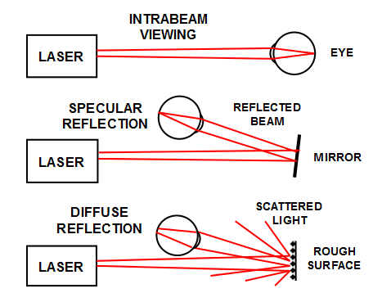

Different ways in which a laser beam can enter the eye

The amount of energy entering the eye depends on the wavelength. The wavelength of the laser also determines the type of potential injury that can be caused.

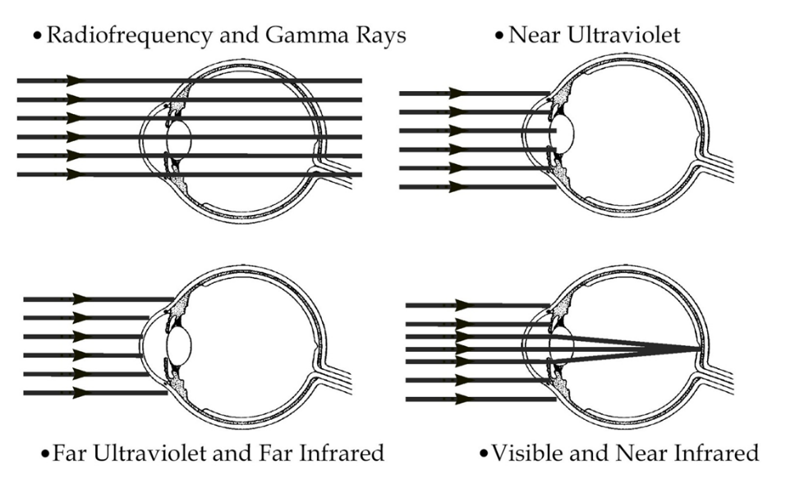

Light transmission through the eye according to wavelength

Adverse health effects of exposure to laser radiation are theoretically possible across the entire optical spectrum from 180nm in the ultraviolet (UV) to 103 µm in the far infrared (IR) but the risk of retinal injury due to radiation in the visible and infrared regions (400-1,400 nm) is of particular concern.Lasers operating in wavelengths between 400nm to 1400nm are known to easily cause retinal damage and potentially blind a person.

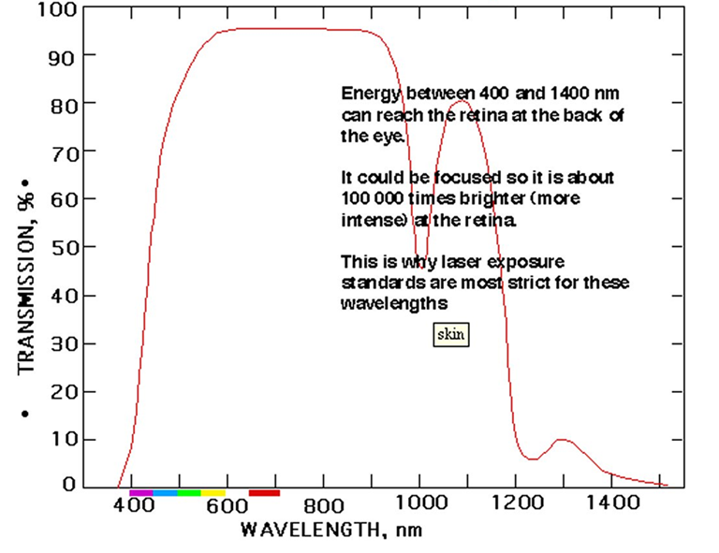

Percentage of the energy (transmission, red curve) which can reach the retina at the back of the eye.

This is why laser exposure standards are most strict for these wavelengths. The biological damage induced by optical radiation is essentially the same for both coherent and incoherent sources for any given wavelength, exposure site, area, and duration. Damage caused by laser radiation is the result of one or more interaction mechanisms: photochemical, thermal, thermo-acoustic and optoelectric breakdown and varies depending upon spectral region and duration. However, UV (180-400nm) and infrared (1400nm-1mm) lasers of Class 3B and 4 are also restricted because they can damage the cornea producing photokeratitis, photochemical cataract and corneal burns. In the 400-1400 nm band, thermal injury to the retina resulting from the temperature elevation in the pigmented epithelium is the principal effect for exposure durations less than 10 s, and thermal injury to the cornea and skin occurs at wavelengths higher than 1,400nm. For exposure duration less than 10 µs, superheating of melanin granules causing micro cavitation dominates the injury mechanism. Optical breakdown and plasma formation can occur after sub-nanosecond exposures and delayed (24 h) appearance of retinal lesions from picosecond exposures may result from secondary effects produced by reactive oxygen species (ROS). Photochemical injury predominates in the ultraviolet spectral region and is also the principal type of retinal injury resulting from exposures (10 s or more) to shorter wavelength visible radiation.

The level of laser radiation to which a person can be exposed to without experiencing hazardous effects or adverse biological changes to the eyes or skin is called the Maximum permissible exposure (MPE). The MPE is used to determine the risk associated with a laser.

Most light sources tend to scatter optical radiation in all directions, and very little energy will enter the eye. In addition, because of the way the eye processes light, that energy will be widely spread across the light sensing cells in the back of the eye (*the macula of the retina*) as an image. With a laser, all the light is aligned into a tight stream of energy known as a collimated laser beam. If this beam enters the eye, it will be concentrated even further onto the foveal region of the macula as a very intense spot. The fovea is the location in the retina that has the highest acuity as it has the highest concentration of cone cells.

If the intensity of the spot exceeds the MPE, the light-sensing cells may be burned and permanently damaged. Extremely powerful lasers may even produce small steam explosions within the eye and cause additional catastrophic internal eye trauma.

Invisible lasers are particularly hazardous as the light energy being projected into the eye can inflict damage without the user being aware. Being invisible, the laser beam will not trigger a person’s natural blink reflex as would a bright, visible laser.

As an indication of the energy levels we are talking about:

* The energy from a 1 milliwatt laser shone into the eye is 167 times that of looking directly at the sun.
* The energy from a 5 watt laser shone into the eye is 835,000 times that of looking directly at the sun.

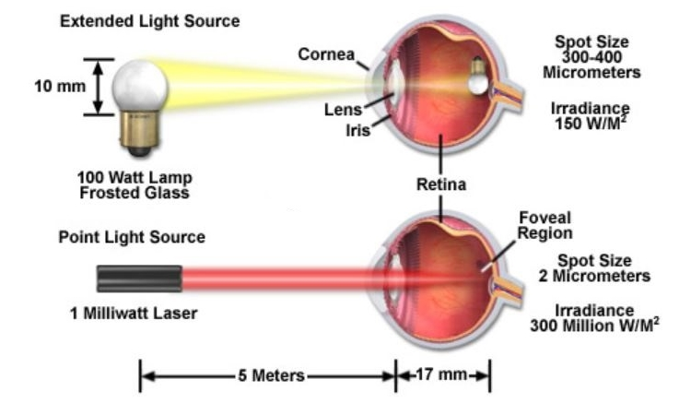

Intensity of a 1mW laser compared to a 100W light bulb

Fact: Some of the Class 4 lasers used in University research are 5,500,000 (five and a half million) times more powerful than the safe maximum permissible exposure (MPE) and can cause permanent damage to unprotected eyes that are within 23 kilometres. Some of these very powerful lasers can also cause serious skin burns.

# Classification

Lasers are classified according to the following international system:

|  |  |
| --- | --- |
| Laser class | Remarks |
| Class 1 | No precautions are required. The laser is enclosed within a housing and cannot be directly viewed, or it is of such low power that it can be directly viewed without the need for eye protection. |
| Class 1C | Cosmetic/medical lasers. Although the emitted laser radiation may be at Class 3R, 3B or 4 levels, ocular exposures are prevented by one or more engineering means. Eye damage may occur if the protective measures fail. |
| Class 1M | The laser is eye-safe with normal vision (you can directly view a Class 1M laser without having to wear eye protection). Eye damage may occur if you look at the laser through magnifying optical equipment (binoculars, telescopes, etc.). |
| Class 2 | The laser must operate only in visible wavelengths, and is eye-safe only because of the natural aversion/blink response (you instinctively blink when a bright light is shone in the eyes). The laser is safe to be viewed through magnifying optical equipment. |
| Class 2M | The laser must operate only in visible wavelengths, and is eye-safe only because of the natural aversion/blink response (you instinctively blink when a bright light is shone in the eyes). Eye damage may occur if you look at the laser through magnifying optical equipment (binoculars, telescopes, etc.). |
| Class 3R | Lasers operating in visible wavelengths are generally eye-safe because of the natural aversion/blink response. Eye damage may occur if you look at the laser through magnifying optical equipment (binoculars, telescopes, etc.). Invisible wavelengths *are not* eye safe as the blinking response will not be triggered. |
| Class 3B | Eye damage is very likely to occur. Generally safe for skin. |
| Class 4 | Eye damage is very likely to occur. Not safe for skin. |

Green: unrestricted lasers

Red: restricted lasers

For the purposes of The University of Auckland Laser Safety Standard, lasers are grouped as follows:

* Unrestricted lasers are lasers which, if used under normal operational conditions and without modification (e.g. using lenses to focus the beam) are considered to pose a low or negligible risk. For the purpose of this protocol, all lasers that are classified as Class 1, 1C, 1M, 2, 2M or 3R in accordance with AS/NZS IEC 60825.1 are deemed to be unrestricted lasers.
* Restricted lasers are lasers with such potential to cause harm that they need to be carefully controlled. For the purpose of this protocol, all high powered laser pointers and lasers that are classified as Class 3B or Class 4 in accordance with AS/NZS IEC 60825.1 are deemed to be restricted lasers. Note: Class 1 systems (enclosed beam pathlength) consisting of restricted lasers are restricted lasers for alignment, maintenance, and repair purposes, which exposes the beam path. The laser safety guidelines apply for maintenance and disposal purposes.

All lasers must be clearly labelled with a sticker that shows its classification. **If a sticker is not present**, the Laser Safety Officer should be contacted to determine whether the laser is safe to use.

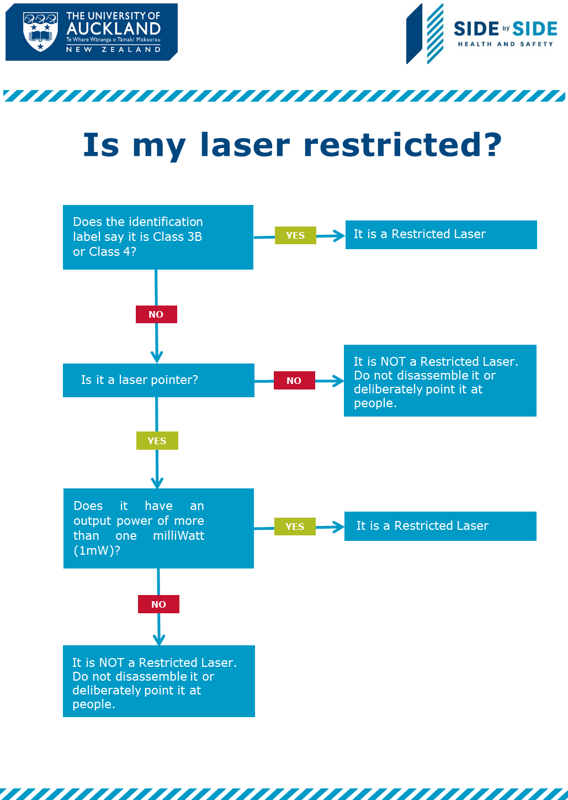

# Roles

A person’s role is an indication of their competency when interacting with restricted lasers. People operating unrestricted lasers (Classes 1, 1C, 1M, 2, 2M and 3R) must comply with the laser operating instructions and must not use the laser to blind, dazzle, or distract other people.

Roles within a workplace where restricted lasers are used : Laser User, Laser Operator, Laser Supervisor, Laser Laboratory Coordinator and Laser Safety Officer.

Laser User: A laser user is a person who has had only basic laser safety awareness training and is not yet competent enough to be designated as a laser operator. They may only use restricted lasers when a laser supervisor is present. Laser users are normally students or inexperienced staff.

Laser Operator: Laser operators are people who have demonstrated competence to a level where they can work with minimum or no supervision on the specific lasers, they have been trained to use. Laser operators are normally experienced staff, such as technicians and some postgraduate students. Laser operators may be authorised on an “as required” basis to act as a responsible person/monitor to “buddy” other operators using restricted risk lasers.

Laser Supervisor: Laser supervisors are deemed competent to instruct others on how to use lasers. They can supervise users (such as staff or students, who are authorised to use the lasers) who have not yet achieved the levels of competency required to be laser operators. They may also be required to administer day-to-day laser activities within a workplace.

Laser Laboratory Coordinator: Laser laboratory coordinators (LLC) are experienced laser supervisors who have the authority to deem people competent in laser use and operation. They can instruct others on how to use lasers They can supervise users (such as staff or students, who are authorised to use the lasers) who have not yet achieved the levels of competency required to be laser operators.

Laser safety officer: The laser safety officer (LSO) is a competent person who is appointed by the Associate Director, Health, Safety and Wellbeing, on behalf of the University. This person is required to be knowledgeable in the evaluation and control of laser hazards and is responsible for overseeing the control of laser hazards at the University. Duties of the LSO include, but are not limited to, the following:

* Approve laser laboratories and other workplaces where restricted lasers are being used
* Maintaining a register (inventory) of all restricted lasers at the University
* Approving the acquisition of any restricted laser for the University (regardless of whether the laser is purchased, replaced, hired, borrowed, gifted, manufactured, converted, etc.).
* Providing information and specialist advice on laser management and operation as requested or required.
* Conducting periodic inspections of laser laboratories and other workplaces where restricted lasers are being used to verify compliance with the laser safety standard.
* Coordinating and conducting investigations of laser **incidents** involving serious harm or notifiable events (including serious eye injuries, serious burns, and fires).

# Training and requirements

People can use lasers only after undergoing the required training (in the case of unrestricted lasers, this may require the user to read the instruction manual and complete the Canvas online training). If people are to use or operate restricted lasers in a workplace, they must be trained in the skills, capabilities, and competencies to work safely, as per the University’s Laser Competency Matrix (below). Any training received should be recorded on a person’s record of learning or similar database.

In the case of an experienced laser operator being recruited to a workplace, they will not require basic laser safety training if they can demonstrate their competency to the laser supervisor. A record of this demonstrated competency must be added to their record of learning.

Types of training within a workplace may include:

* Laser safety awareness training. An e-learning course on Canvas or short in-house workshop delivered by the LSO to communicate University laser safety protocols. The training is designed to inform participants of basic laser safety information such as mechanisms of laser injury, classes of laser, and basic safety precautions and controls.
* Workplace safety brief: Delivered by the laser supervisor or laser laboratory coordinator, this training can be used to instruct users and operators on correct set-up of a workplace where restricted lasers are being used.
* Specific instruction: Delivered by the laser supervisor or laser laboratory coordinator, this “hands on” training is delivered to users and operators of specific restricted lasers. It should include working through operating instructions for each different laser that will be used or operated, aligning of the optics and experiments if required, and practical instruction so that the laser can be used safely.

## Vision health check

University staff and students who are working in an environment that potentially exposes them to Class 3B and 4 laser beams need to have a vision health check. University staff and students who are working with Class 1 systems containing restricted Class 3B and 4 lasers and are involved in “inhouse” beam alignment are encouraged to avail themselves of the vision health check. This excludes microscopes and laser systems where the power of the exposed beam is within acceptable limits (less than Class 3B) and commercial systems where the exposure of the user to the laser beam is minimised due to design or inbuilt safety interlock features. The eye check will be performed by the Auckland Optometry Clinic at the Faculty of Medical and Health Sciences before starting at work and biennially thereafter. However, in case there is a presumed pre-existing injury, or upon a clinician’s recommendation, the eye check might be done more frequently. This medical check is free for students and staff (HOD approval is required for staff). Details of the Auckland Optometry Clinic can be found in the “Emergency” chapter.

## University Laser Competency Matrix (v0.1)

An example of the competency matrix is provided below:

|  |  |  |  |  |  |
| --- | --- | --- | --- | --- | --- |
| Core training element | Performance criteria | User | Operator | Supervisor | Coordinator |
| 1. Demonstrate an understanding of legislation, standards, and codes of practice relevant to laser use within the University. | 1.1 State how to access University laser safety information. | x | x | x | x |
| 1.2 Describe the obligations and actions that apply to an individual’s specific role or level of training. | x | x | x | x |
| 2. Identify laser hazards. | 2.1 Describe the basic anatomy of the eye. | x | x | x | x |
| 2.2 Describe the properties of laser light. | x | x | x | x |
| 2.3 Identify classes of laser. | x | x | x | x |
| 3. Assess the risks and plan for working with lasers. | 3.1 Outline the principles of risk management. |  | x | x | x |
| 3.2 Participate in the risk assessment process. |  | x | x | x |
| 3.3 Identify sources of information on laser hazards, associated risks, and risk control measures. |  |  | x | x |
| 3.4 Conduct a hazard survey of an area where restricted lasers are to be used. |  |  | x | x |
| 3.5 Conduct a risk assessment of a task or process where restricted lasers are to be used. |  |  | x | x |
| 4. Identify and implement laser risk control measures. | 4.1 Identify common laser risk control measures. | x | x | x | x |
| 4.2 Identify other potential hazards that may affect restricted laser use. |  | x | x | x |
| 4.3 Demonstrate the correct selection, inspection and fitting of laser safety eyewear if required |  | x | x | x |
| 4.4 Demonstrate competence in pre-use inspection of restricted lasers and associated equipment. |  | x | x | x |
| 4.5 Demonstrate competence in operating restricted lasers and associated equipment. |  | x | x | x |
| 4.6 Demonstrate knowledge of the correct set up and management of laser laboratories. |  |  | x | x |
| 4.7 Demonstrate knowledge of the correct set up and management of indoor experiments that involve restricted lasers. |  |  | x | x |
| 4.8 Demonstrate knowledge of the correct set up and management of outdoor activities that involve restricted lasers. * |  |  | x | x |
| 5. Apply first response rescue methods. | 5.1 Describe the actions to be carried out in the event of lasers causing eye injury or suspected eye injury. | x | x | x | x |
| 5.4 Develop emergency first response plans. |  |  |  | x |

*\*4.8**. Only required for those people who use restricted lasers outdoors*

## Recommended Minimum Training:

## More information on risk assessment can be accessed here <https://www.auckland.ac.nz/en/health-safety-wellbeing/health-safety-topics/risk-assessments.html>.

|  |  |  |  |  |  |  |
| --- | --- | --- | --- | --- | --- | --- |
| Unit Standard/ University Workshop | Training provider and record keeper | Description | User | Operator | Supervisor | Coordinator |
|  | Health Safety and Wellbeing staff member | University Laser Safety Awareness* | x | x | x | x |
|  | Supervisor or Coordinator | Laser Lab Safety Brief | x |  |  |  |
|  | Supervisor or Coordinator | Laser Lab Induction |  | x | x | x |
|  | Supervisor or Coordinator | Specific competency training in each laser to be used |  | x | x | x |
| HRHURA | Health Safety and Wellbeing staff member | How to undertake a risk assessment |  |  | x | x |
| HRSORA | Health Safety and Wellbeing staff member | Signing off on risk assessments |  |  |  | x |

*\*Laser safety awareness may take the form of e-learning or a short in-house course.*

## 

## Records

These records may be paper-based or electronic databases as per local custom. Workplaces where restricted lasers are used should maintain a Laser Operator Register. An example of training records is provided below.

## Laser Laboratory Authorised Personnel Training and Access Register

**Laboratory:** **Laboratory Supervisor:** **Laser Laboratory Coordinator:**

|  |  |  |  |  |  |  |  |
| --- | --- | --- | --- | --- | --- | --- | --- |
| **Name** | **Date Laser Safety Course Completed** | **Date**  **Vision Health Check** | **Date on the Job Training Completed** | **Date Authorised to Operate Laser** | **Read, Understood and Agree to Comply with SOPs**  **(Signature)** | **Level of Competency** | **Laser Laboratory Supervisor**  **(Signature)** |
|  |  |  |  |  |  |  |  |
|  |  |  |  |  |  |  |  |
|  |  |  |  |  |  |  |  |
|  |  |  |  |  |  |  |  |
|  |  |  |  |  |  |  |  |

**User:** Not authorised to use restricted lasers (Class 3B or 4 lasers, or high-powered laser pointers) unsupervised.

**Operator:** Unsupervised work with restricted lasers permitted, but not permitted to conduct on-the-job training (OJT).

**Supervisor:** Able to conduct OJT but does not have authority to deem people competent to use restricted lasers, unless the task is delegated by the LLC (not the responsibility).

**Laser Laboratory Coordinator:**  Able to conduct OJT and deem people competent to use restricted lasers.

PURCHASE IT

# 

# Safe equipment

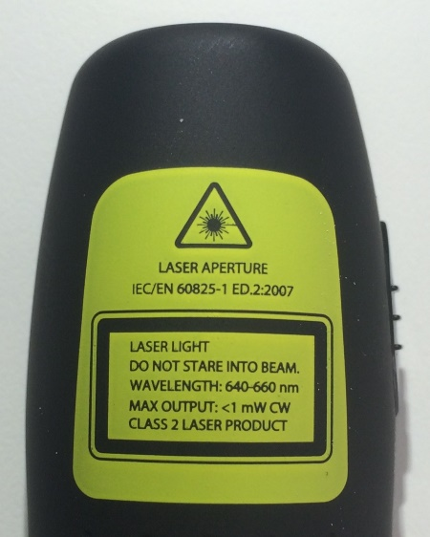If contemplating to purchase a laser, make sure that the classification is clear. The lasers need to be classified in accordance with AS/NZS IEC 60825.1.

All lasers must be clearly labelled with a sticker that shows its classification. If a sticker is not present or the reading on the sticker is not clearly readable, the Laser Safety Officer should be contacted to determine whether the laser is safe to use.

## Inventory

**All restricted lasers must be registered with the Laser Safety Officer.**

The LSO maintains a register of all restricted lasers in the University. This ensures that we know where the lasers are being used, and who is authorised to operate them.

If you are in possession of a restricted laser or are not sure of the classification of a laser, contact the Laser Safety Officer.

## Appendix 1. - Template to send to the LSO with laser details



# Purchase request

**All requests to purchase, construct or otherwise obtain restricted lasers must be approved in writing by the Laser Safety Officer.**

Some staff/students have placed themselves and others in danger because they have ordered Class 4 lasers directly from non-reputable vendors without being aware of the dangers involved, so if you need to obtain a restricted laser, you need to contact the Laser Safety Officer in the planning stages.

The LSO can verify that you have the required competencies and the facilities to safely use the laser and if necessary, they can help you to get the necessary training and resources for safe use of laser.

As an example, the template provided in Appendix 1 can be completed and sent via email to the LSO.

**Restricted lasers that have not been approved by the Laser Safety Officer shall not be used.**

Because of the inherent risk unapproved restricted lasers shall not be used due to easily inflicted injury. This includes bringing a private high powered laser pointer (output power greater than 1mW) to an event run by the University. Disciplinary action may be taken against someone who carelessly or recklessly uses a restricted laser.

**Lasers must be installed, checked, inspected, cleaned, maintained and adjusted in accordance with manufacturer’s instructions.**

Reputable laser manufacturers will recommend how to safely install and use a laser, and to keep it operating at peak performance. These recommendations must be followed.

s

USE IT

# General rules

Supervisors and academic leaders in charge of work areas need to be able to issue instructions and guidance to ensure that everyone is safe. They are allowed to make **reasonable** requests for people to do things, such as:

* Take off specular reflectors such as jewellery or watches
* Put on PPE
* Not touch equipment until given permission to do so
* Turn off cell phones
* Modify their behaviour if it is liable to affect safety of themselves or others

If the requests are not followed, the person in charge can insist that a person is removed from the workplace. A person can also be requested to leave if the person in charge has any other safety concerns.

Note that the requests must be reasonable, so if a person is being asked to do something unsafe (such as being told to remove safety eyewear so they can better observe an experiment), that person can refuse the request without having to fear repercussions.

Restricted laser operations must cease if a supervisor is called away from the workplace for any reason, or if they cannot oversee the work that is being carried out by a person who requires supervision.

People must not use restricted lasers if they are under the influence of, or are impaired by alcohol, recreational drugs, or medicines. This includes being influenced by after-affects (such as being hung-over). Medical advice on whether restricted lasers can be operated when taking prescription medicines should be sought on a case-by case basis.

**People must not use any laser to dazzle, blind, or distract other people.**

This requirement includes those people using unrestricted lasers and low powered laser pointers. There are severe penalties for deliberately dazzling people, especially if they are operating vehicles or aircraft. Offenders can be charged with causing unnecessary danger and face a term of imprisonment of up to 12 months or a fine of up to $10,000.

**As far as is reasonably practicable, workplaces in which lasers are used must maintain a satisfactory level of housekeeping.**

Bench top clutter must be minimised to reduce the chance of the laser beam being reflected or redirected. Given that many areas where lasers are operated have low ambient light levels, trip hazards must be eliminated where possible.

Bags should be avoided in the laboratory if possible. Bags are trip hazards and may cause people to bend down to get items out. In the process of doing so, a person’s head might enter the plane of laser beams.

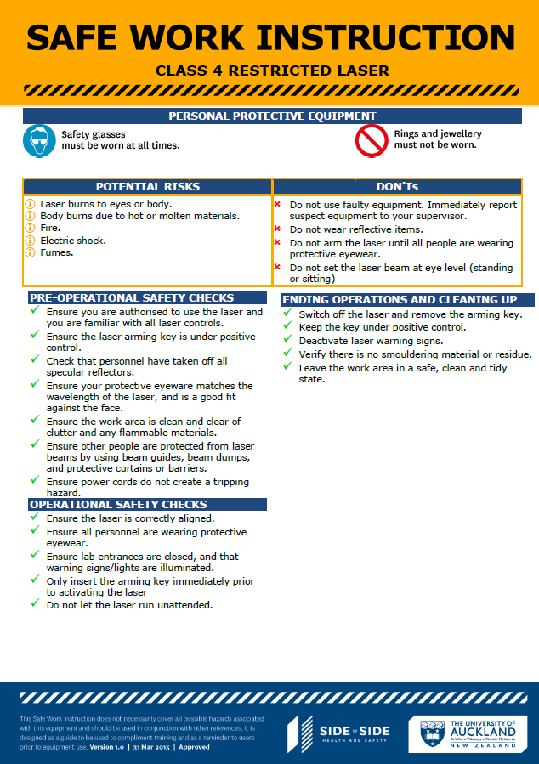**People using any laser must comply with applicable Safe Work Instructions, and/or any other applicable information that is needed** **to perform work safely.**

Safe Work Instructions are simple one page reference sheets which are normally posted near the laser(s); they list personal protective equipment (PPE), pre- and post-use checks, and other important information.

Alternatively, some complex lasers may have detailed step-by-step operating instructions which must be carefully followed in sequence.

# Personal Protective Equipment (PPE)

Eyewear is the most common and certainly the most important aspect of personal laser protection, wherever there is some risk of laser exposure. Protective eyewear does not, however, preclude a full safety evaluation and consideration of all alternative means of affording protections - such as total enclosure of the beam, interlocks, beam dumps etc. The hierarchy of controls is a way of determining which actions will best control risks and has five levels of actions to reduce or remove hazards. In hierarchy of controls, engineering controls are always more effective than PPE. Engineering controls should supersede laser safety glasses as the first line of defence. An enclosure of the laser beam path of laser equipment is the preferred method of control. However, when complete enclosure is not feasible, and other controls are inadequate to eliminate potential exposure, laser protective eye wear should be used.

The purpose of Laser safety eyewear is to attenuate any laser radiation to below the level of the maximum permissible exposure (MPE) by incorporating optical filters. The absorbance of the filters must be appropriate to the wavelength of the laser(s) used. The optical filter’s damage threshold must be high enough to withstand maximum permissible exposure (MPE) for a period long enough to enable escape from the beam. The laser protective eyewear shall be selected based on the level of protection required to protect the eyes from a worst-case scenario. All laser safety eyewear shall be clearly labelled with the optical density and wavelength for which protection is afforded. Clear information shall be made available to identify the eyewear that is suitable for each laser and whether it is for alignment work or full protection.

Periodic cleaning and inspection shall be performed to ensure eyewear are maintained in satisfactory condition. Use care when cleaning them and follow manufacturers instruction to avoid damage to the absorbing and reflecting surfaces. Users are responsible for exercising care in the use and storage of eye protection. For laser eyewear regularly inspect for pitting, crazing, cracking, and discoloration of attenuation material. Further also check for light leaks and coating damage. Any defects must be notified to the Laser Laboratory Supervisor and use of the defective item shall cease until a safe replacement is made.

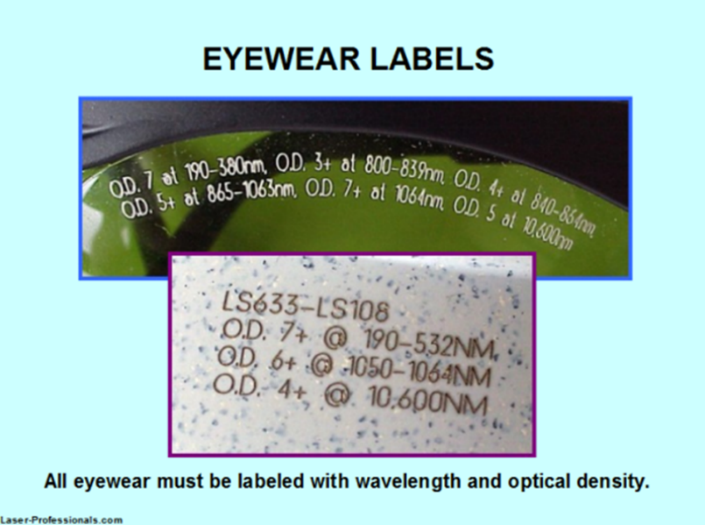Some powerful lasers that are hazardous to skin may require users to wear long clothing. Such clothing should be made of cotton or other flame-resistant material and must not feature metal or reflective buttons or fasteners.

The specifications for wavelength and optical density will be stated in the operating instructions, and users must ensure that the eyewear of the correct specification is properly fitted so that there are minimal gaps between the PPE and the face (especially if the user normally wears prescription lenses).

## Storage spaces at the point of entry

Storage space for specular reflectors such as watches, jewellery, needs to be provided at the point of entry so that people do not wear reflective items in the controlled area. Phones and other distracting devices should also be left there.

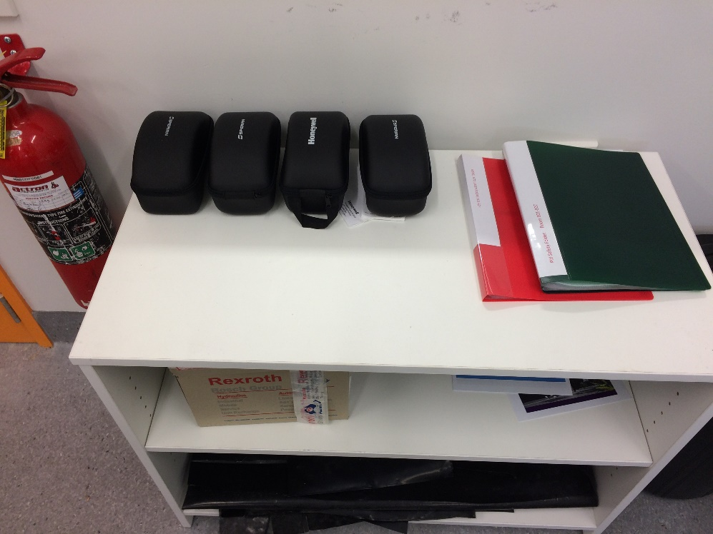

The photograph above shows eyewear storage at entry point. Also note safety folder containing the laser operator register and laser operating instructions.

**Warnings!**

Alignment glasses may only be used when aligning lasers. Sunglasses *do not* provide laser protection.

## Good example of laser eyewear protection

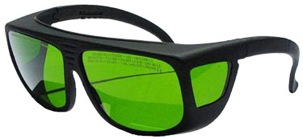

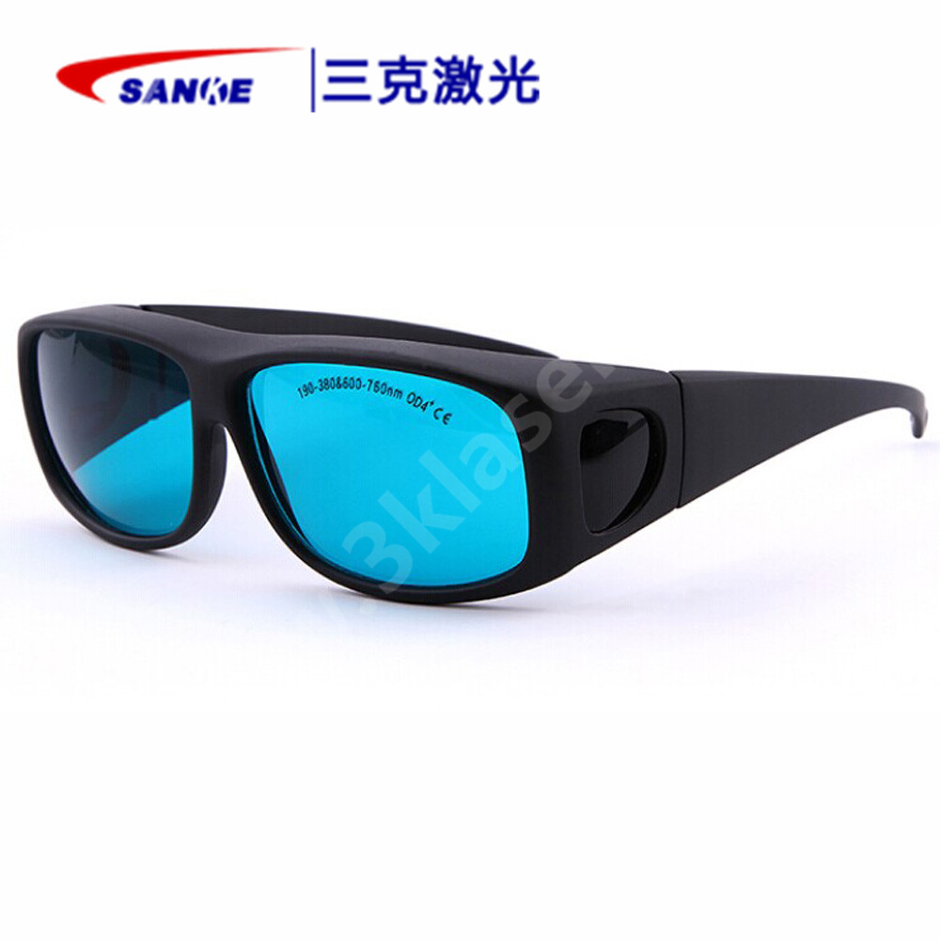

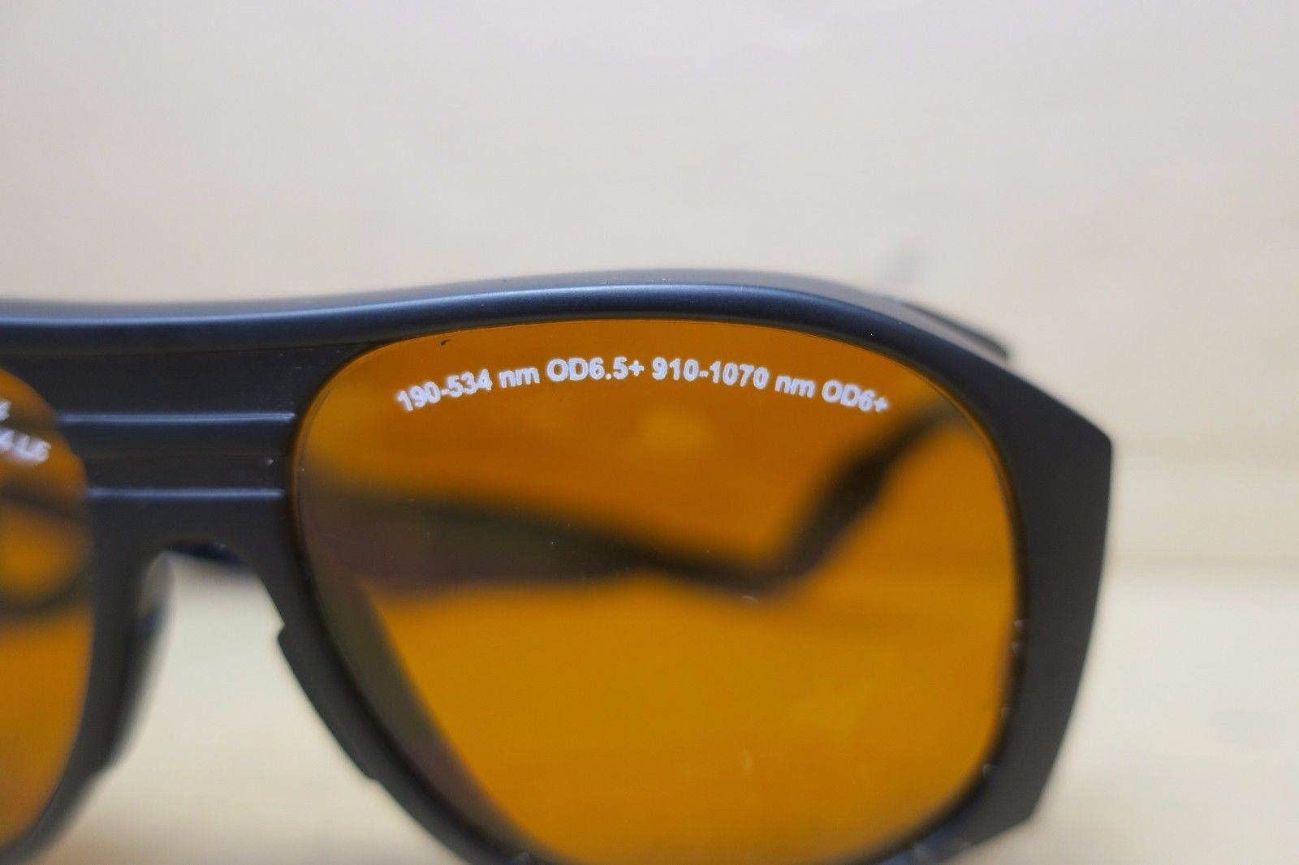

# Laser pointers

Laser pointers used at the University within classrooms and lecture theatres must be unrestricted, thereforeclearly labelled as Class 1 or Class 2, and their power must be less than 1 milliwatt. You do not need to take any special precautions with such laser pointers, other than making sure that you do not deliberately use them to blind, dazzle or distract other people.

Cheap laser pointers without labels must not be used as they may exceed safe power levels.

## Laser pointers purchased via the internet

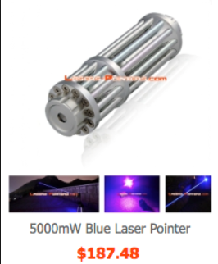*High powered laser pointers* can easily cause eye damage and because irresponsible people have used them to dazzle drivers and pilots, they are now subject to NZ Health Regulations. Severe penalties (including jail) can result if you shine them at vehicles or aircraft, and Australia classifies them as prohibited weapons.

There are very few legitimate reasons to use high powered laser pointers, so any proposal to acquire one must be properly justified. Because they are considered to be restricted lasers by the University, you must have written permission from the Laser Safety Officer before you buy or otherwise obtain one.

To clarify, a **high-powered laser pointer** is a device that:

* is commonly known as a laser pointer
* is battery operated
* is designed or intended to be operated while held in the hand
* produces a coherent beam of optical radiation of low divergence
* has a power output of greater than 1 milliwatt

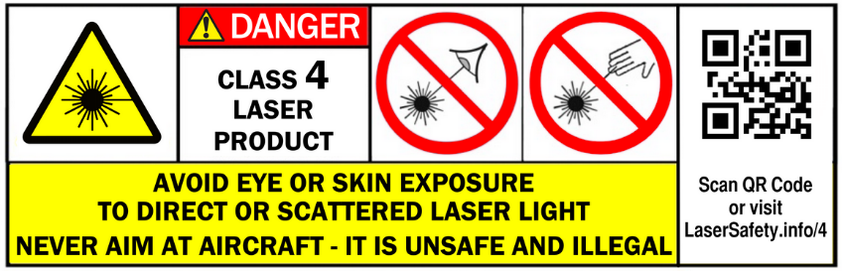

Laser warning label - example

# Microscopes

## Introduction

In terms of laser safety, most microscopes are unrestricted because, although the laser beam is accessible between the objective and the sample stage, the distance between the two is noticeably short and crucially, the laser beam is highly divergent and therefore the power at this point is likely to be below the Class 3B level. Generally, there are no other points at which the laser beam is accessible.

**Summary of hazard**

Unrestricted microscope: accessible laser power below the Class 3B minimum

Restricted microscope: accessible laser power within the Class 3B or 4 range.

## Risk assessment

The Laser Safety Officer will make a risk assessment before you start the work. It may be appropriate to measure the power output at the objective to demonstrate that it is below the Class 3B minimum.

**Commercial microscopes**

All the commercial microscopes need to undergo an annual service for safety features and accessible laser power by an authorized agent or the manufacturer. The report will be kept in the records by the Laser Laboratory Supervisor.

**In-house made microscopes**

The Laser Laboratory Supervisor needs to keep records of an annual report containing

* accessible laser power measurements
* check of safety features

The Laser Laboratory Coordinator must ensure that a risk assessment and safe operating procedures are in place. These must take account of all operations - use, cleaning, maintenance, and servicing.

## **During operation**

* Do not look directly into the laser beam.
* Do not remove the specimen while scanning.
* Do not scan without a specimen in position.
* Do not remove any of the optical components including objective lenses without permission from the Laser Laboratory Supervisor
* Do not remove laser keys or attempt to uncouple lasers or safety measures such as interlocks or collars.
* For the **inverted confocal systems**, do not tip the head back when the laser is scanning.
* For the **upright confocal systems**, do not lower the stage to load position or raise the objective to top when laser is scanning.
* When seated, avoid looking continuously into the laser beam (it is scanning at eye level).
* If a sign is on the door indicating that a service engineer is working on the system, **do not enter** before getting permission from the Laser Laboratory Supervisor.
* At end of a session, call the next user or shut down if no one is following.
* In the event of exposure, follow the instructions at the “Emergency procedures” section.

## Records

* Laser Laboratory Supervisor needs to keep the Risk Assessments and also send them to the LSO
* Laser Laboratory Supervisor needs to keep the reports of the annual services.

## Laser survey

For restricted microscopes, the Laser Laboratory Supervisor must carry out an annual Laser laboratory evaluation checklist to check the appropriate control measures are in place (check “University Laser Laboratory Evaluation Checklist”).

BUILD IT/MAINTAIN IT

# How to set up a laser lab

The opportunity to set up a new laboratory is always a great occasion, but in doing so, there are items that can be easily overlooked. For this reason, the Health, Safety and Wellbeing Team have provided a tool that can help University researchers who are undertaking this task. The “How to set up a laser lab” booklet’s goal is to identify the do’s and don’ts when setting up a laser laboratory. It is available on the Health, Safety and Wellbeing website or contact LSO.

# Risk assessment

**A risk assessment must be carried out to identify the risks associated with specific restricted lasers.**

Laser supervisors and laser laboratory coordinators should have completed risk assessment training so they can identify hazards and controls in the workplace. More information on risk assessment can be found here: <https://www.auckland.ac.nz/en/health-safety-wellbeing/health-safety-topics/risk-assessments.html>. An example model risk assessment for the operation of a laser laboratory is available as part of the Laser Safety Protocol and can be amended so that unique circumstances or local conditions can be considered. The risk assessment needs to be signed off by a laser laboratory coordinator or the LSO.

Risk assessments should be re-evaluated on the following occasions:

* Annually
* If the workplace undergoes a major change
* If there has been an incident

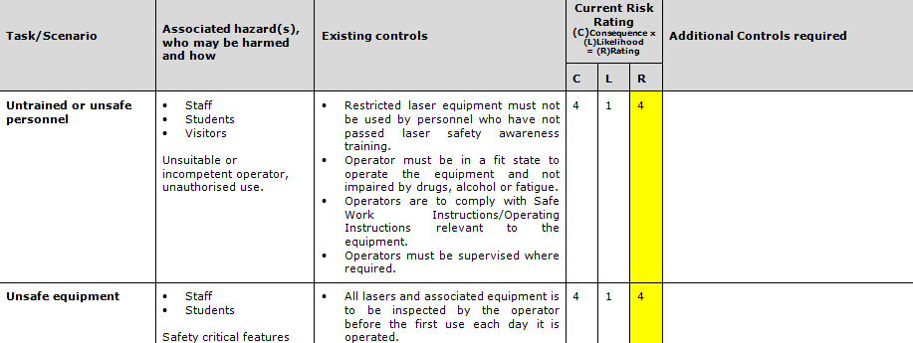

*Risk assessment for lasers – screen grab of page 1*

**Any controls identified as necessary in a risk assessment must be implemented so that the residual risk is as low as is reasonably practicable.**

You must try to *eliminate* the risks associated with lasers as much as you can, and only adopt a less effective control if it’s *not feasible* to use a higher-level control. The ways laser risks can be controlled (in order of most preferred to least preferred method of control) are:

* Elimination - totally enclose the laser so that people cannot be exposed to harmful laser beam. This is the most preferred of all the controls and should be used wherever possible.
* Substitution - minimise the risk of harm by using a less powerful laser or minimise the power of the laser to accomplish the task.
* Isolation through engineering - minimise the risk of harm by isolating a person from the high-risk laser (controlled areas, beam guides and curtains).
* Minimisation through administrative controls (standard operating procedures and training).
* Minimisation through personal protective equipment (laser safety glasses and appropriate clothing)

For further advice on control measures, contact your supervisor or the LSO.

**Any laser-related activities with a residual risk level greater than moderate must not proceed.**

If it looks unsafe, we need to stop. If we are using a restricted laser, we should have first carried out a risk assessment. If any of the controls we identified in the risk assessment are not in place, or if circumstances change, we must stop our activity.

Examples are:

* We discover that the interlock to the door of a laser lab has been defective, and we can activate the laser with the door open. We must stop the activity until it is fixed.
* Somebody discovers that the provided safety eyewear does not fit over their prescription lenses. The activity must not start until they are properly protected.

## Example risk assessment

Example risk assessments can be found on the Health, Safety and Wellbeing website. https://www.auckland.ac.nz/en/health-safety-wellbeing/health-safety-topics/risk-assessments.html

|  |
| --- |
| Health, Safety and Wellbeing (HSW) Risk Assessment |

|  |  |  |  |  |  |  |  |
| --- | --- | --- | --- | --- | --- | --- | --- |
| **Document No:** |  | | **Assessment Date:** | | |  | |
| **Faculty/ Service Division:** |  | | **School/Department:** | | |  | |
| **HSW Risk:** | **Uncontrolled Risk is High, Controlled is Moderate** | | | | | | |
| **Form completed by:** |  | | **Responsible Line Manager:** | | |  | |
| **Signed** |  | | **Signed** | | |  | |
| **Dated** |  | | **Dated** | | |  | |
| **Other Risk Assessments which might also be required:** |  | Manual Handling |  | Working at Night |  | | Workstation |
| **Description of activity  and/or location:** | ***Use of Restricted Lasers in Laboratories***  Potential Hazards – Beam related hazards, fire, electrical.  Potential Harm – Blindness, skin burns, fire, electrocution. | | | | | | |

|  |  |  |  |  |  |  |  |
| --- | --- | --- | --- | --- | --- | --- | --- |
| **Identify Hazards and Control the Risks:** | | | | | | | |
| 1. An activity may be divided into tasks. For each task identify the hazards and associated risks. Also list the possible scenarios which could potentially cause harm.  2. Determine controls necessary based on University standards, legislation, codes of practice, AS / NZ standards, manufacturer’s instructions etc.  3. List existing risk controls (take credit for what you do)  4. Rate the risk once all controls are in place using the HSW Risk Assessment Matrix (page 55)  5. List any additional controls that need to be implemented and act  6. Communicate the findings  The boxes will resize to suit your situation/the amount of text you need to use – press tab after last cell to create new rows | | | | | | | |
| **Task/Scenario** | **Associated hazard(s), who may be harmed and how** | | **Existing controls** | **Current Risk Rating**  **(C)Consequence x (L)Likelihood  = (R)Rating** | | | **Additional Controls required** |
| **C** | **L** | **R** |
| **Untrained or unsafe personnel** | * Staff * Students * Visitors   Unsuitable, inexperienced, or incompetent operator, unauthorised use. | * Supervised training must be provided on the system to be used before an operator is allowed to use it independently. * Restricted laser equipment must not be used by personnel who have not passed laser safety awareness training. * Operator must be in a fit state to operate the equipment and not impaired by drugs, alcohol, or fatigue. * Operators are to comply with Safe Work Instructions/Operating Instructions relevant to the equipment. * Operators must be supervised where required. | |  |  |  |  |
| **Unsafe equipment** | * Staff * Students   Safety critical features may be missing or damaged. | * All lasers and associated equipment are to be inspected by the operator before the first use each day it is operated. * Non-conformities to be reported to supervisor and rectified before being used. | |  |  |  |  |
| **Inappropriate facilities** | * Staff * Students   Inappropriate facilities may not completely block laser beam hazards. | * All use of restricted lasers must take place in a designated laser laboratory that has been evaluated by the Laser laboratory Coordinator. * Laboratories must be suitable for the lasers being used. | |  |  |  | * The Laser Supervisor is legally responsible for the work being undertaken. * Supervisors should ensure that laboratory infrastructure is safe for the lasers being used (e.g., laser-controlled areas, non-flammable non-reflective surfaces, curtains, safety devices, etc). |
| **Personal Injury** | * Staff * Students   Laser energy may penetrate the eye or burn skin. | * All personnel observing the laser must wear protective eyewear. * All personnel must remove personal specular reflectors upon entry to the laboratory. * Where required, non-flammable long clothing must be worn. * Laser beams must not be placed at eye level (sitting or standing). * Beam guides and dumps should be used where possible. * Laser arming keys must be always kept under positive control by the person in charge of the laser. | |  |  |  | * The laser operating instructions will specify the eyewear requirements for optical density and wavelength. * Eyewear must fit the user, especially if the user wears prescription spectacles. * All clothing must be free of specular reflectors such as buttons and nametags. * Laser arming keys must only be inserted just prior to the laser being activated. * Solo work with restricted lasers is not permitted. |
| **Fumes and vapours.** | * Staff * Students   Toxic fumes can cause long term harm. | * Ensure that personnel are aware of the hazards associated with the experiment. * Do not create fumes unless it is part of the experiment. * Arrange the work so that fumes do not rise into the worker’s face. * Use local exhaust ventilation. * Use personal protective equipment (PPE). | |  |  |  | * Respiratory protection must be appropriate for the fumes being created. |
| **Fire** | * Staff * Students   Laser beams may ignite combustible materials. | * All combustible materials to be removed or made safe. * No flammable liquids, vapours, gases, or dusts to be present. * Extinguishers/hoses to be provided outside the lab. * Operator must know how to use fire equipment. * Operator must know location of telephone/fire alarm. * Site to be inspected after completion of work for smouldering surfaces or objects. | |  |  |  |  |
| **Electrical** | * Staff * Students   High voltage equipment may deliver electric shocks. | * All lasers and associated electrical equipment to be checked in accordance with the University’s electrical appliance testing protocol. * Non-conformities to be reported to supervisor and rectified before being used. | |  |  |  |  |

|  |  |  |  |  |  |  |
| --- | --- | --- | --- | --- | --- | --- |
|  |  |  |  |  |  |  |
|  |  |  |  |  |  |  |
|  |  |  |  |  |  |  |

|  |  |  |  |  |  |  |
| --- | --- | --- | --- | --- | --- | --- |
| Action Plan | | | | | | |
| Management agreed  additional control measures  to be implemented | **Resources**  **Required** | **Action By:** | | | **Action Complete: Responsible Line Manager** | |
| **Responsible Person** | **Target Date** | **Completion Date** | **Signature** | **Date** |

|  |  |
| --- | --- |
| Review | |
| Review Details | **Comments** |
| Scheduled Review Date |  |
| Are all control measures in place? |  |
| Are controls eliminating or minimising the risk? |  |
| Are there any new problems with the risk? |  |
| Are the supervisory arrangements adequate? |  |
| Are the levels of skills, capabilities, and training adequate? |  |
| Review By: (name) |  |
| Review Date: |  |

|  |  |  |  |  |
| --- | --- | --- | --- | --- |
| Communication | | | | |
|  | **Method** | **Yes** | **Date** | **Comments** |
| Reference of formal communication to staff | **Copy of risk assessment issued to staff** |  |  |  |
| **Controls covered in team procedure issued to staff** |  |  |  |
| **Staff handbook issued to staff** |  |  |  |
| **Other** |  |  |  |
| How they were consulted  on the risk | **Health, Safety and Wellbeing Committees** |  |  |  |
| Additional Methods of Communication | **Induction** |  |  |  |
| **Toolbox Talk** |  |  |  |
| **Team Meeting** |  |  |  |
| **Email circulation** |  |  |  |
| **Other** |  |  |  |

|  |  |  |  |  |  |  |
| --- | --- | --- | --- | --- | --- | --- |
| **HSW Risk Assessment Matrix** | | | | | | |
| **Likelihood Level** | **4** | **Very likely**  Probably expect the event to occur in most circumstances | Moderate  (4) | High  (8) | Extreme  (12) | Extreme  (16) |
| **3** | **Likely**  Event likely to occur at least  once over the coming year | Moderate  (3) | High  (6) | High  (9) | Extreme  (12) |
| **2** | **Possible**  Event may occur at some time | Low  (2) | Moderate  (4) | High  (6) | High  (8) |
| **1** | **Unlikely**  Occurrence is conceivable,  but not expected to occur | Low  (1) | Low  (2) | Moderate  (3) | Moderate  (4) |
|  |  |  | **Minor** | **Moderate** | **Major** | **Severe** |
|  |  |  | **1** | **2** | **3** | **4** |
|  |  |  | **Consequence level** | | | |

|  |  |  |  |  |  |  |  |  |  |  |
| --- | --- | --- | --- | --- | --- | --- | --- | --- | --- | --- |
| **Consequence description** | | **Harm to People**  Potential for injury or death | None or trivial / negligible injury  (No or slight injury which requires localised first aid) | | | Minor injury  (Illness or injury is not serious, but medical treatment required) | Serious injury  (Serious injury or illness, hospitalisation required) | Fatality, major injury  (Death, permanent disablement, or significant long-term illness) | | |
| **People Affected**  Extent of people potentially affected | None or few  (e.g., 0 to 2) | | | Small numbers (e.g., 3 to 10) | Moderate numbers  (e.g., 10 to 50) | Wide scale  (e.g., more than 50) | | |
| **Reputation and Legal**  Potential for publicity with a negative impact on reputation / potential for legal prosecution | None or issue raised by staff or students and resolved promptly by management  None or legal dispute – found not guilty – fines up to $3 million (Body Corporate), $600,000 (Officer) | | | Internal scrutiny to prevent escalation and short-term stakeholder concern  Minor non-compliance, limited notification to regulators / affected stakeholders | Medium-term stakeholder concern, national media scrutiny and ‘brand’ impact  Medium non-compliance, moderate notification to regulators / affected stakeholder, potential for legal proceedings / fines | Persistent stakeholder concerns, international media scrutiny and long term ‘brand’ impact  Significant non-compliance, extensive notification to regulators / affected stakeholders, potential for legal proceedings / imprisonment / fines | | |
|  | **Operations**  Extent of ability to maintain core business | | None or business interruption < 4 hours  None or effectiveness and efficiency of a service, programme or project impacted in the short term  None or slight damage to property or equipment | Business interruption between 4 hours to 5 days  Operational disruption manageable by workarounds  Moderate damage to property or equipment | | Business interruption > 5 days  Medium operational impact resulting in delay of key deliverables  Major damage to property or equipment | | Business interruption of many weeks  Breakdown of key activities and significant long-term impact  Massive damage to property or equipment |
| **Environment**  Extent of negative impacts on the environment | | None or minimal impact  None or clean up expenses up to $25,000 | Minor short-term or intermittent impact, able to be contained with specialist assistance  Clean up expenses up between $25,000 to $1m | | Serious, medium-term detrimental impact  Clean up expenses up between $1m - $5m | | Very serious, long-term, or permanent damage  Clean up expenses > $5m |

**Consider the Likelihood**

How often is the task done? Has an accident happened before (here or at another workplace)? How long are people exposed? How effective are the control measures? Does the environment affect it (e.g., light, temperature, space)? What is the cause of people’s behaviours (e.g., stress, panic, deadlines)? What people are exposed (e.g., disabled, untrained students, etc.)?

**Consider the Consequences**

What type of harm could occur (minor, serious, death)? Is there anything that will influence the severity (e.g., proximity to hazard, person involved in task, etc.)? How many people are exposed to the hazard? Could one failure lead to other failures? Could a small event escalate?

**Calculate the Risk**

The final score for each risk is calculated by multiplying the likelihood and consequences response scores. This will give a risk score of between 1 and 16.

All risks rates as “High” or “Extreme” require detailed analysis of mitigating practices / controls to determine the residual risk rating. **Action must be taken.**

“Low” and “Moderate” risks may be excluded from further analysis (other than when the consequence may be severe). However, the rationale for excluding these risks should be documented to demonstrate the completeness of analysis undertaken. **Some action may be required.**

Other than in the most unlikely circumstance, risks that can cause major or severe harm to people have been determined as “high” or “extreme.” Management review is considered appropriate for risks of these nature due to the potential magnitude of the impact, even though the likelihood may be assessed as relatively low.

**Risk Priority - Legend**

|  |  |
| --- | --- |
| Extreme  (12-16) | **Intolerable risk.** Immediate action(s) is to be taken by Faculty/Service HSW risk owners - including DVCs, Deans of Faculties, Directors of Services, Academic Heads/PIs, Services Managers. Work should not be started or continued until the risk has been reduced to as low as reasonably practicable using the hierarchy of risk controls. The Associate Director Health, Safety and Wellbeing, and Manager Risk and Performance must be advised of the risk for their review. The risk should be included in the UoA wide risk register. |
| High  (6-9) | **Should not be tolerated.** Urgent action is to be taken by the immediate manager. Work should not be started or continued until the risk has been reduced to as low as reasonably practicable using the hierarchy of risk controls. The HSW Manager working with the Faculty/Service, and Manager Risk and Performance must be advised of the risk for their review. To be included in the UoA wide risk register. |
| Moderate  (3-4) | Management to **monitor risks** in case changing circumstances increase the level of risk. Some action may be required, e.g., improving controls. |
| Low  (1-2) | **Requires no further attention** above routine practices and procedures, apart from monitoring. |

**Note:** This proposed Health and Safety Risk Assessment Matrix aligns with WorkSafe NZ guidance, UoA Resilience Management Plan, UoA Risk Determination Matrix, UoA TVRA and UoA Incident Levels

# Repairs and maintenance

## Records

Where lasers and associated equipment require scheduled servicing, maintenance activities must be recorded. If a laser requires a repair, we need to know who repaired it and what work was done to the laser to fix it. All servicing must be recorded by the Laser Laboratory Coordinator or the Laser Supervisor (if delegated by the LLC).

Class 3B and 4 laser systems must undergo a check, before being put into service and annually thereafter. For a Class 1 system (enclosed beam path) incorporating Class 3B and 4 lasers, once the safety interlocks are breached, the same controls for servicing will be applicable as for restricted lasers. A template can be found in the “University Laser Laboratory Evaluation Checklist” chapter.

## Controlled areas

A controlled laser area shall be established whenever conditions allowing human access to hazardous levels of laser radiation are created temporarily, (e.g., during servicing or laser alignment), and where unauthorized person, unaware of the presence of the laser hazard could be present. Untrained/inexperienced staff or staff unversed in the necessary safety procedures should not be present during servicing or alignment procedures.

The guidance for temporary controlled areas is the same as for the controlled laser areas (refer to “How to set up a laser lab”). Although the normal requirement for engineering control of access may be difficult to achieve, administrative controls can be effective when restriction of access is only temporary. If safe access is not controlled by engineering means, then appropriate warning and prohibited entry signs should be posted at the point of entry. Defective lasers and associated equipment are to be taken out of service as soon as defects are identified. This is especially important if there is any damage or defect that affects the ability to align the laser, or if there is damage to any electrical insulation or power cords. Please refer to chapter “MOVE IT/ DISPOSE IT” for disposal guidelines.

## Controls during servicing

* Comfortable laser safety glasses with correct wavelengths for use by Laser Laboratory Supervisor or Coordinator to perform repairs or maintenance.
* Reducing the level of emission to the maximum necessary.
* Limiting the range of movement of beam steering components.
* Placing large area beam stops behind the target to stop the laser beam in case of missed target.
* Using non-reflective coating on tools and requiring the removal or covering of jewellery or watches.

SECURE IT

# Physical security and access

All laboratories and storage areas containing restricted lasers in the University of Auckland must have access control. At a minimum this will mean locked doors which are opened using conventional keys. However, swipe card access is preferable. Where segregated swipe-controlled access is not available, areas should be controlled via key or combination locks.

# Information security

## Why do we need information security?

The University has a duty of care to protect the privacy of University of Auckland staff, students, and stakeholders (such as contractors), as well as to ensure confidential information is only viewed by those authorised to do so. Information security is also designed to ensure that the data is kept intact and accurate for periods of up to 10 years.

## What information needs to be kept securely?

The requirements for information security outlined in this document apply to databases or protocols which contain:

* • Personal identities of staff and students at the University.
* • Information about access control and contingency plans for the facilities.
* • Confidential memorandums and emails.

This includes (but is not limited to):

* • Training databases.
* • Restricted lasers databases.
* • Audits databases and corrective actions.
* • Containment manuals (including archived versions).

## Where is the information held?

All information related to University of Auckland laser laboratories is to be held on information technology equipment that is:

* Exclusively owned and controlled by the University of Auckland.
* Only accessible using University of Auckland-controlled networks.
* Only accessible using University of Auckland passwords.
* Regularly backed up onto University-owned and controlled drives.

## Using shared databases

Where more than one person requires access to this information, it is to be held on separate password-controlled shared drives.

Shared databases are to be configured in a robust manner to prevent corruption of files. Wherever possible SQRL databases and web-based access is to be used.

If external virtual drives (e.g., Drop Box or data storage in the Cloud) are used, the security of data storage is to meet the security requirements of the University of Auckland Information Security services.

## Review of information security

Information security is to be reviewed annually by the University of Auckland Information Security services.

MOVE IT/DISPOSE OF IT

## Transfer

If you want to relocate a functional restricted laser, or it is no longer needed and you would like to donate it, you need to do so through a written communication to the LSO (an email suffices).

You can transfer or sell the laser within the University or to a responsible organisation (such as another university). Note that the laser system must be serviceable and fit for use. It should be sent with all instruction manuals and other relevant user information. In addition, you must check that the receiver has a viable laser safety programme and a laser safety officer in place before you transfer the laser*. Restricted lasers are not to go to public auction.*

The LSO will approve the transfer and will update the restricted lasers register.

## Disposal

Defective lasers and associated equipment are to be taken out of service as soon as defects are identified. This is especially important if there is any damage or defect that affects the ability to align the laser, or if there is damage to any electrical insulation or power cords.

Lasers being decommissioned must be disposed of responsibly. Any queries regarding disposal can be directed to Laser Safety Officer (LSO), additionally LSO can also be contacted for disposal. Systems classified as Class 1 due to closed beam path length but containing restricted Class 3B and Class 4 should also be disposed responsibly. All lasers are considered to be electronic waste, and unrestricted lasers may be taken to an e-waste recycling centre once any batteries have been removed.

When restricted lasers are being disposed of the Laser Safety Officer must be notified, this includes class 1 systems containing restricted Class 3B and Class 4 lasers. This will ensure that the laser register is up to date, and that the selected disposal method is appropriate.

Options for the disposal of restricted lasers are:

* Send it back to the manufacturer for recycling or disposal. Not all manufacturers will do this, and there may be a cost involved.
* Dispose of the laser. If this option is selected, the laser must be sent to the Laser Safety Officer for destruction.

Any costs involved will need to be borne by the unit disposing of the laser.

MEASURE IT

# Internal verification

Regular internal **verification** is an integral part of any risk management system. The purpose is two-fold:

1. To ensure that systems and procedures outlined in the laser safety guidelines are fit for purpose and achieve the desired results; and if not, appropriate improvements are identified

2. To identify risk and ensure appropriate risk mitigation procedures are put in place

Verification consists of:

* Annual Laser laboratory inspection by Laser Laboratory Coordinator.
* Annual verification of the restricted lasers registered by the LSO.
* Annual verification of records of trained users by LSO.
* Annual verification of the annual safety service for microscopes by LSO.
* Unannounced laser laboratory checks.
* Identification of underlying issues in order to ensure the reasons are addressed.
* Identification of exemplars (practices or facilities).

The results of verification exercises are as follows:

* Where **non-conformances** are identified they are documented and corrected.
* The root cause of non-conformance is also identified (where appropriate), documented and corrected.
* Exemplars identified are noted in the facility’s verification register and used as models for improvement (i.e., good practices are shared across the University community).

## Annual laser laboratory inspection

Annual Laser laboratory inspections are to be undertaken by Laser Laboratory Coordinator or Supervisor. These are designed to ensure that the physical structure of laboratories is maintained to a high standard, that the safety features are in place and that individuals are routinely observing good laboratory practice. A checklist is provided in “University laser laboratory evaluation checklist.”

## Annual verification of the restricted lasers register

Restricted laser, commercial or home-made systems, shall be registered with the LSO. The LSO will arrange a meeting every year with the Laser Laboratory Coordinators to verify the accuracy of the Restricted Lasers Register. During the meeting, LSO will also check the trained users’ records and the annual safety service for microscopes.

## Documentation in each laser laboratory

Each laboratory is to have the following registers as hard copy:

* University laser laboratory evaluation checklist.
* Laser Laboratory Authorised Personnel Training and Access Register.
* List of the restricted lasers.
* Annual safety service (only for microscopes).
* Risk assessment (if any).

# University laser laboratory evaluation checklist

To be completed for Class 3B and 4 Laser Systems, before being put into use for the first time and annually thereafter.

Location: Dated:

|  |  |  |  |  |
| --- | --- | --- | --- | --- |
| **Element** | **Y/N/NA** | **Remarks** | | |
| **Laser Identification\*** | | | | |
| Description  Class  Wavelength  Maximum Output  NOHD (if known) |  |  | | |
| All restricted lasers registered with the Laser Safety Officer |  |  | | |
| **Administration** | | | | |
| Laser operator register displayed |  |  | | |
| Laser supervisor(s) identified |  |  | | |
| UoA laser safety standard displayed |  |  | | |
| Laser activation flowchart displayed |  |  | | |
| Operating instructions available/current |  |  | | |
| Spectators briefed and supervised |  |  | | |
| **Entrance to Laser Laboratory** | | | | |
| Appropriate warning signs |  |  | | |
| Entry way controls | | | | |
| * Interlocked doors (where possible) | |  |  | |
| * door/curtain at entry way | |  |  | |
| * Visible/audible signals (e.g., illuminated sign or warning lights) | |  |  | |
| An area for protective eyewear and specular reflectors provided near entrance |  |  | | |
| Appropriate eye protection clearly identified |  |  | | |
| Skin protection when needed (i.e., UV lasers) |  |  | | |
| Windows/doorways covered/restricted |  |  | | |
| Panic button/e-stop available |  |  | | |
| Laser controlled area within a laboratory |  |  | | |
| * Laser hazard area clearly identified |  |  | | |
| Laser beam path enclosed |  |  | | |
| **Laser and Optical Components** | | | | |
| Laser warning signs and labels legible |  |  | | |
| Protective housing and shields intact |  |  | | |
| Keys under positive control |  |  | | |
| Beam stop/attenuator provided |  |  | | |
| Reflective materials out of paths way |  |  | | |
| Laser secured to table or base |  |  | | |
| Optical components secured to table or base |  |  | | |
| Beam routed above or below eye level |  |  | | |
| **Non-Beam Hazards** | | | | |
| Electric shock/high voltage minimised |  |  | | |
| Fire potential minimised |  |  | | |
| Vapour/particle generation minimised |  |  | | |
| Hazardous or toxic chemicals minimised |  |  | | |
| Metal laser tables earthed |  |  | | |
|  | | | | |
| **Check carried out by** | **Signature** | | | **Date** |
|  |  | | |  |

*Only restricted lasers need to be identified and registered.

EMERGENCY

# Emergency procedures

The University has published procedures for common emergencies such as fire, earthquake, and power cuts, however a laser lab must have extra procedures in place in case someone is exposed to harmful laser radiation. A simple laser emergency plan has been developed as an example:

* *Stop the beam with the emergency button*
* *Tell your workmate you have been exposed to the laser and have hurt your eyes or skin*
* *Get them to help you or call Security at ext. 85000. Ask to be escorted to the Auckland Optometry Clinic in the Faculty of Medical and Health Sciences as soon as possible* 
  + *Auckland Optometry Clinic operating hours: Monday to Friday 8am-5pm*

*(Phone 09-923-9909)*

* + *Out of hours: go to the Emergency Department at the Auckland Hospital*
* *Do not disturb the equipment setup*
* *Cover your injured eye/s before going into daylight*

*After the accident complete an Incident Form and inform your supervisor and LSO. The incident can be reported here: https://www.auckland.ac.nz/en/health-safety-wellbeing/report-concerns-hazards/injury-incidents-observations-reporting.html*

Master stop switches (laser kill switches/ emergency switches) should also be installed at strategic positions throughout the laser lab.

## Incident reports

Workplaces must record and report incidents (including accidents or near-misses) to ensure that any learning from such an incident is captured and not repeated. Incidents that cause serious harm or are notifiable incidents must be reported to the HSW Service without delay, and the accident scene must be preserved as much as possible for an investigation.

**In the case of laser injuries, the following are notifiable to WorkSafe NZ:**

|  |  |
| --- | --- |
| A serious eye injury that requires immediate treatment (other than first aid) | Includes:  an injury that results in, or is likely to result in, the loss of an eye or vision (total or partial) |
| Does not include:  exposure to a substance or object that only causes discomfort to the eye |
| A serious burn that requires immediate treatment (other than first aid) | Includes:  A burn that needs intensive or critical care such as a compression garment or skin graft. |
| Does not include:  A burn treatable by washing the wound and applying a dressing. |

A notifiable incident is where someone’s health or safety is seriously endangered or threatened. People may be put at serious risk even if they were some distance from the incident. Accidentally lasing a member of the public when using a high-powered laser pointer outdoors could be considered a notifiable incident.

If there is any doubt about whether the incident needs to be notified, contact the Health, Safety and Wellbeing Service on 09-9234896 as soon as possible. Ask for the Laser Safety Officer.

# Appendix 1. How to find the Eye Clinic

The Auckland Optometry Clinic is located at 143-151 Park Rd, Grafton, Auckland 1023, Building 505, Level 3.



**Auckland Optometry Clinic**