Working at Height
Guidance Information
Part One:
Meeting the University WAH Standard

Awareness People Equipment Workplaces

Working at Height Guidance – Part One
How to meet the WAH Standard

Application
All staff members (including contractors and other workers) and students at the University who plan or participate in working at height (WAH).
This guidance does not cover recreational or adventurous activities at height, or theatrical performances that involve performing at height. This is because there are many unusual situations where the tasks involved cannot meet the requirements of this protocol (such as performances where an actor “flies” about in a theatre, or Bungie Jumping).
Purpose
The Working at Height Health and Safety Standard defines working at height and provides an overview of the planning required for WAH activities. The Working at Height Procedures support the Standard and state the critical elements of operational directives that must be followed. This guidance is intended to help users with FAQs and clear recommendations for best practice.
Introduction
The University is committed to the health, safety and wellbeing of all its staff members and students, and to ensuring that other people and the environment are not harmed by the University’s activities. Staff and students at the University carry out numerous activities that involve working at height (WAH), so we have prepared a Working at Height Standard, Working at Height Procedures and this guidance to ensure our people and others are safe as far as is reasonably practicable.
In this guidance the terms “must”, “are to” and “should” are used. “Must” and “are to” are used where there is a mandatory requirement to meet legal obligations. “Should” is used as a way of indicating the practicable steps the industry regulator expects to be taken on a particular matter. Mandatory requirements for working at height are detailed in the University’s Working at Height Standard and Working at Height Procedures, but for the sake of clarity and consistency, are duplicated and expanded upon in this guidance document. Duplicated sections of the Standard are identified by (S.) and duplicated sections of the Procedures are identified by (P.).
Contents
- Building awareness
  - What is working at height?
  - Do I need to comply with the WAH Standard?
  - What about the three-metre height limit rule?
  - Is my current WAH management system OK, or do I need to revise all my paperwork?
  - What if a contractor is doing height work for me?
  - Where can I get help with managing working at height?
  - Am I working at height?
  - Training for participants
- Planning
  - Identifying hazards
  - Assessing potential risks
  - Understanding risk scores
  - Controlling identified risks
  - Planning for WAH activities
  - Approval
  - Reviewing the plan
  - Notifying WorkSafe NZ
  - Working for external organisations
- Operation
- More information
- Definitions
- Building awareness
1.1 What is working at height?
Working at height is defined in the Standard as: working in a place where a person could be injured if they fell from one level to another and the risk of falling is moderate or higher. This can be above or below ground level, and is regardless of the duration of the task – that is, it makes no difference to the level of risk whether the task takes two minutes or two weeks.

1.2 Do I need to comply with the Working at Height Standard and Procedures?
Absolutely! You should also refer to Safe Work Instructions if these are available for any equipment you are using.
The standard does not cover adventurous activities at height (e.g. rock climbing organised by the Recreation Centre), or theatrical performances (like those in a theatre) as these are covered by comprehensive specific industry guidance. Recreational sports or WAH activities carried out in a person’s own time are not covered either (the person taking part does so at their own risk).
Note that some field activities may involve work at height; the field activity planner must determine which guidance is to be followed to ensure that everyone is safe.
For further information on theatrical performances and adventurous activities, see the WorkSafe NZ website: https://worksafe.govt.nz/topic-and-industry/
1.3 What about the three-metre height limit rule?
A while back, people thought that if you were working less than three metres above the ground, you were safe. Since then, ACC’s accident records show that 50% of falls are from less than three metres, and around 70% of falls are from ladders or roofs. That’s why we have tied the University’s definition of working at height to a risk assessment instead of a specific height.

1.4 Is my current working at height management system OK, or do I need to revise all my paperwork?
If your current WAH management plan (WAH MP) (or safe work method statement, or job safety analysis, or whatever else you want to call it) features the six critical elements of a WAH MP, you do not need to change the format of your documents. If your documents are missing some of the critical elements, you will need to amend your forms or adopt the University template.

1.5 What if a contractor is doing height work for me?
Since our standard and procedures are based on industry good practice, their processes should be similar to ours. At the very least, they should be able to show you some form of working at height management plan and explain their emergency rescue plan to you. They should also be discussing their work activities with each other before they begin a job, or at the start of each day (this is known as a tool box talk).
The University could be held responsible if a contractor we have hired has an accident, so if you see anyone working dangerously, please notify the University Health, Safety and Wellbeing team at HSW@auckland.ac.nz. They will check the work site and make sure the contractor complies with University standards. If you think the contractor’s work methods are really dangerous, you have the right to ask them to stop.
1.6 Where can I get help with managing working at height?
Call the Health, Safety and Wellbeing team on 09-923-4896 (or ext 84896) or send us an email, and we will be happy to help: HSW@auckland.ac.nz
1.7 Am I working at Height?

Follow this flow chart
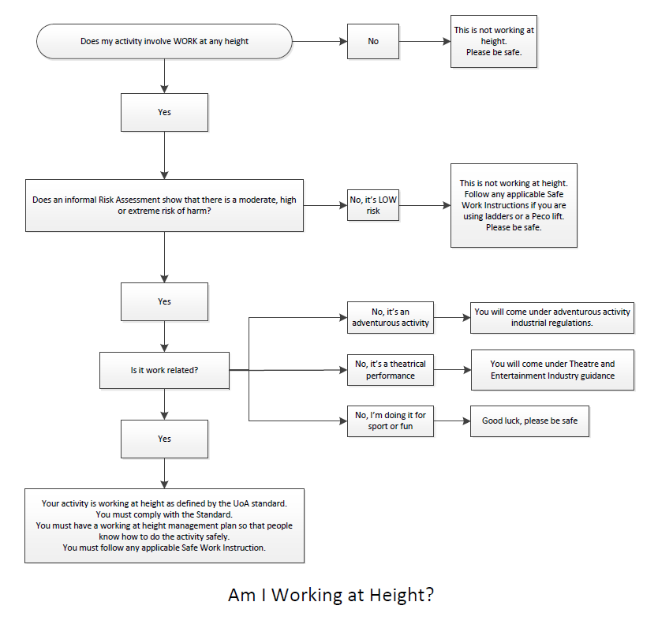

1.8 Training for participants
People involved with working at height are known as participants, and they all have a role to play to ensure the activities are carried out in a safe manner; these roles are described in the WAH Procedures. If there is any working at height carried out in a workplace on a regular basis, EVERYONE in the workplace needs to be aware of the hazards and risks associated with WAH. This basic awareness training ensures that people don’t attempt to do a job they are not trained for.
The following training recommendations are based on the University’s WAH competency matrix. Training is divided into five broad groups, with additional training required for specialised equipment such as cherry pickers, scissor lifts etc.

Height safety awareness: This is basic height safety awareness for everyone associated with WAH. This may take the form of e-learning or a short in-house course.

Height safety operator: This involves training in the skills needed to perform harness-based WAH under the direct supervision of a WAH supervisor, and to participate in first response rescue. Recommended NZQA Unit standards are Units 17600, 23229 and 25045.

Height safety supervisor: This is training in the skills needed to perform harness-based WAH unsupervised, to supervise entry level height safety operators and other people involved in the WAH activity, and to direct first response rescue. Recommended NZQA Unit standards are Units 15757, 17600, 23229, 23231 and 25045. The University workshop HRHURA “How to undertake a risk assessment” shows supervisors how to write a WAH Management Plan.

Height safety manager: University height safety managers must have completed the training as detailed for supervisors above. In addition, they must have completed the University workshop HRSORA “Signing off on risk assessments”.

Height safety equipment inspector: This involves training in the skills needed to detect faults in equipment and to determine remedial action. The applicable NZQA Unit standard is Unit 19359. Note: because this is a specialist role, equipment inspections are normally carried out by external contractors.
All training should be recorded on a person’s record of learning or similar database.

Planning

2.1 Identifying hazards
The first step in developing a WAH MP is for the height safety supervisor to assess all projects/tasks and physical locations where there is a risk of falling from height (including small heights).
Particular attention should be paid to WAH tasks:

In or on any structure or object being maintained, inspected, tested, cleaned, constructed or installed, demolished or dismantled

In or on equipment that is being used to gain access to an elevated level (for example, scissor lifts, cherry pickers or portable ladders)

Near an unprotected open edge over which a person could fall (for example, mezzanines, scaffolds or terraces)

On a sloping or slippery surface where it is difficult for people to maintain their balance (for example, on top of fuel or wine tanks, on sloping roofs, etc.)

On a fragile or potentially unstable surface (for example, fibreglass sheeting roofs, rusty metal roofs, skylights, truck awnings or tents)

In the vicinity of an opening, hole or pit through which a person could fall
Physical conditions in the workplace that create WAH hazards include:

Level changes that expose people to a fall from one level to another

Uneven or unstable/soft ground that will affect the stability of work platforms or ladders

Fragile or weak work surfaces that a person could fall through (for example, skylights)

Open access holes such as man-holes, drains, lift shafts, excavations etc.

Working areas above walkways and other working areas that may expose people on lower levels to falling tools and other objects
2.2 Assessing potential risks
When the height safety supervisor is conducting a risk assessment for the WAH MP the following additional factors specific to WAH should be taken into consideration:

The design and layout of any elevated work areas, including the distance of any potential fall

The training and competency of the person(s) carrying out the task

The stability of the working surface, especially when working outside on uneven or soft ground

The number and movement of all people at the workplace

The proximity of people to unsafe areas

The risk of falling objects (for example, tools etc.)

The adequacy of inspection and maintenance of equipment used for working at heights (for example, work platforms, cherry pickers etc.)

The adequacy of lighting for clear vision

Weather exposure – rain, wind, extreme heat or cold, which can cause slippery or unstable conditions

The suitability of footwear and clothing of persons for the conditions (for example, unsuitable footwear, loose clothing, jewellery and accessories that may snag and cause slipping, tripping or falling)

The suitability and condition of ladders, including where and how they are being used

The adequacy of emergency and rescue plans

2.3 Understanding risk scores
The risk scores associated with a task then tell us what level of controls we need:

If the uncontrolled risk of a fall is classified as LOW, the hazard does not need to be formally documented. However, you should still strive to reduce the risk as far as is reasonably practicable and comply with any Safe Work Instructions if you are using equipment such as ladders.

If the uncontrolled risk of a fall is MODERATE or higher, the task must be classified as WAH and treated in accordance with these guidelines. The additional WAH-specific safety requirements outlined below must be applied in addition to the University’s standard risk management requirements.

If the controlled risk of a fall is HIGH or EXTREME, the task must not be performed. You must either implement extra controls to bring the risk down to a low or moderate level, or cancel the activity completely.

2.4 Controlling identified risks
All WAH risks should be controlled in accordance with the following hierarchy, which is in order of most preferred to least preferred method of control.
You should start from the top and try to eliminate working from height – you should only work your way through the list if it’s unreasonable to use a higher level control. Further clarification of these control methods is detailed in the WAH guidance document “How to reduce risk”.

Elimination – remove the exposure of the worker to WAH by carrying out the task at ground level. This is the most preferred of all the controls and should be used wherever possible.

Minimisation through substitution – replace a high risk WAH work method with a less risky work method such as working from a cherry-picker or scissor lift instead of a tall ladder, or by using a drone to conduct surveys at height instead of abseiling.

Minimisation through isolation – minimise the risk of a fall by providing and maintaining a safe system of work. Examples of engineering/isolation controls include:

Working on a solid construction (scaffold or dock)

Installing barriers near an unprotected edge

Working on a temporary work platform

Using a work positioning system (using a harness and tether to work in restraint)

Modifying tools or equipment to minimise or prevent the risk of a fall

Minimisation through administrative controls. Examples include:

Clearly describing the process needed to safely undertake a task in a WAH MP, job safety analysis, Safe Work Instruction, or other similar document

Providing specific training for the task

Posting signs to restrict access to an area

WAH awareness training

Minimisation through personal protective equipment (PPE). This is the least preferred method, as you are not preventing the fall. You can reduce the risks of injuries associated with a fall by providing PPE such as:

Soft landing systems

Fall arrest systems

Helmets

2.5 Planning for WAH activities
All WAH activities must be documented by the height safety supervisor in a WAH management plan (WAH MP) (noting that this term includes equivalent external documents such as a safe work method statement, job safety analysis, or local operating instruction).
The WAH MP must include the following six critical elements:

The type of work to be carried out: This is a description of the overall task (such as “fitting a solar panel to a roof” or “cleaning the window exteriors of building 620”).

The work methods to be used (for instance, working on a solid construction, working on scaffolds, using mobile elevated work platforms (MEWPs), using industrial rope work, or using fall prevention systems, work positioning systems, fall restraint systems etc.).

Personal protective equipment (PPE) requirements (including helmets, non-slip shoes/boots, harnesses, lanyards etc.).

An activity risk assessment (this could be a modified version of the University model WAH risk assessment).

The number of participants required (operators and supervisors, and other persons such as spotters or people preparing loads for lifting).

Emergency response (including preferred method of rescue): Note that calling 111 is NOT a rescue plan. There is no guarantee that the Fire service will be able to respond in a timely manner to a fall.

2.6 Approval
All WAH MPs must be approved by a height safety manager, who must not be the person who drafted the plan (this ensures a cross check has taken place). In the case of contractors, a competent person (normally a project manager) must grant approval.
If the risk assessment within the WAH management plan identifies the activity as having a high or extreme residual risk, the activity must not be performed.

2.7 Reviewing the WAH Management Plan
WAH MPs must be continually monitored and reviewed to ensure that they remain effective in controlling hazards as far as is reasonably practicable. All plans must be reviewed at least annually or after any incident.

2.8 Notifying WorkSafe NZ
It is a legal requirement that WorkSafe NZ is notified at least 24 hours before the following WAH activities take place:

Work where participants could fall five metres or more, excluding work on a two-storey house, work on a power or telephone line, work carried out from a ladder only, and maintenance or repair work of a minor or routine nature

The erection or dismantling of scaffolds from which a person could fall five metres or more

Notifications can be made online: https://worksafe.govt.nz/notifications/hazardous-work/
2.9 Working for external organisations
University of Auckland staff and students, when working with or embedded into external working environments, are to follow the WAH work methods of that particular organisation, provided the level of protection does not fall below the University’s standards.

Operation
The following directives must be followed when performing working at height as per the University WAH Standard:

“All health and safety control measures identified in the working at height management plan must be in place before the activity begins” (WAH Standard, S.5). You have a plan, so stick to it.

“All participants listed in the working at height management plan must be trained to a level that reflects their role” (WAH Standard, S.6). See the training requirements above. People must not try to do a task if they have not been properly trained.

“All equipment required for the activity must be inspected and confirmed to be serviceable before the activity begins” (WAH Standard, S.7). It is good practice to have all equipment registered in a log book or electronic management program (such as Vault), so that inspections and service can be recorded.

“Any factors that may affect the successful application of the working at height management plan (such as rain, high winds or physical ability of participants) must be taken into account before the activity commences, and if necessary, the activity must be delayed or cancelled” (WAH Standard, S.8). You should never be in a situation where you or your team are jeopardised due to a change in circumstances.

“All participants must be briefed on the working at height management plan by the activity supervisor before the activity commences” (WAH Standard, S.9).

Participants must ask for clarification if any part of the plan is not understood” (WAH Standard, S.10). Everyone must be confident in the work they are about to do. Do not force people to work at height if they are likely to suffer panic attacks or vertigo, otherwise you may need to conduct a rescue.

“All incidents (including accidents or near-misses) occurring during working at height activities must be reported as per University of Auckland policy” (WAH Standard, S.11). This is to ensure that any lessons that can be learned from such an incident are captured, in order to avoid repetition of the incident.

- More information

The following publications provide extra information on working at height and good practice:
AS/NZS 1891 Series – Industrial Fall-Arrest Systems and Devices (Available through University Library Services)
AS/NZS 1892 Series – Portable Ladders (Available through University Library Services)
Worksafe Guidance for Working at Height https://worksafe.govt.nz/topic-and-industry/working-at-height/working-safely-at-height/
NZS/AS 1657 Fixed platforms, walkways, stairways and ladders (Available through UoA Library Services)

Definitions

Control: An item or action designed to remove a hazard or reduce the risk from it.
Fall: An unexpected sudden drop by a person or object from a higher to a lower level.
Hazard: Anything that has the potential to cause harm (injury or ill-health) or damage to property or equipment in connection with a work activity.
Incident: Any unplanned event resulting in, or having a potential for injury, ill health, damage or other loss.
Risk: The likelihood a hazard will cause harm (injury or ill health) and the degree of harm (consequence).
Risk assessment: The process of evaluating the risk(s) arising from a hazard(s), taking into account the adequacy of any existing controls, and deciding whether or not the risk(s) is acceptable.

University means the University of Auckland and includes all subsidiaries.

Working at height: Working at height (WAH) means working in a place where a person could be injured if they fell from one level to another and the risk of falling is moderate or higher. This can be above or below ground level, and is regardless of the duration of the task.
Working at height includes, but is not limited to, circumstances in which a person is working:
- In or on an object or structure that is at an elevated level
- In or on an object or structure that is being used to gain access to an elevated level
- In the vicinity of an opening through which a person may fall
- In the vicinity of an edge over which a person may fall
- On or in the vicinity of a surface through which a person could fall
- On or near a slippery, sloping or unstable surface
Specific examples of activities that are considered working at height are:
- An employee working on a roof
- An engineering student working from a scaffold to build a structure in the structures test hall
- A staff member using a cherry picker to replace a light on a lamp post
- A wine science student working on top of a large cylindrical tank
- Campus Life personnel setting up a banner for an approved event above a hall entrance
- A person working near an open lift shaft on the ground floor of a building
- Window washers abseiling as part of their normal work
- A theatre worker rigging lights above a stage
Specific examples of activities that are NOT considered working at height are:
- Staff using an approved step ladder to change a light bulb at a low height
- Ascending/descending internal or external stairs
- Adventurous activities such as rock climbing and non-work related abseiling
- An actor performing while suspended from a harness
- Flying and parachuting
- Students holding an unapproved roof party
- Criminal activity (including trespassing)

- Further key relevant documents
- Health and Safety at Work Act 2015
- University of Auckland Health and Safety Policy
- Working at Height Standard
- Working at Height Procedures
- Working at Height Competency Matrix
- Working at Height Guidance Part Two: “How to control WAH risk”
- Working at Height Management Plan
- Working at Height Management Plan - Template Instructions
- AS/NZS 1891 Industrial fall-arrest systems and devices
Document management and control
Content manager: HSW Manager
Owner: Associate Director Health, Safety and Wellbeing
Approved by: Director, Human Resources
Date approved: October 2019
Review date: October 2022

