Working at Height Guidance - Part Two
How to control WAH risk
- Common methods and equipment used to control WAH hazards
  - Work from the ground
  - Work on a solid construction (work platform)
  - Mobile elevating work platforms (MEWP)
- Fall prevention systems
  - Work positioning systems
  - Industrial rope access
  - Dropped objects
  - Ladders
  - Fall arrest systems
  - Personal protective equipment
- Incidents notifiable to Worksafe NZ
  - Suspension intolerance (trauma)
- More information
- Definitions

Common methods and equipment used to control WAH hazards

1.1 Work from the ground
Eliminating the need to work at heights is the most effective way of protecting people from the risk of falls, though this may require an engineering solution or a change in local work methods. If a work area has only a small amount of equipment, it may also be more cost effective for servicing to be carried out by a specialist height safety company.

Supervisors/persons in charge should ask themselves:

Do we actually need to do the task at all? Can we replace those old air conditioners that keep breaking down with better, more reliable equipment? If so, do we still need to do regular checks?

If we do need to carry out that task, can we do it less often? Can we replace incandescent light bulbs with more reliable and longer lasting LED light bulbs? Instead of changing the batteries on smoke alarms every six months, why don’t we install alarms that have batteries that last ten years? Why do we need to do a check each day... Can we do once a week instead… Or even just once a month?

Can we modify the work area or equipment so we can do our task from the ground? Can we fit theatre/foyer lights to a light bar that we can lower to the ground? We could also make sure we fit power switches and pneumatic system charging points to somewhere people can reach them.

Can we use specialist tools or new technology to carry out the task from the ground? Why not use a drone to check gutters instead of climbing on a roof? Can we get tools with extendable handles to clean windows on a two story building?
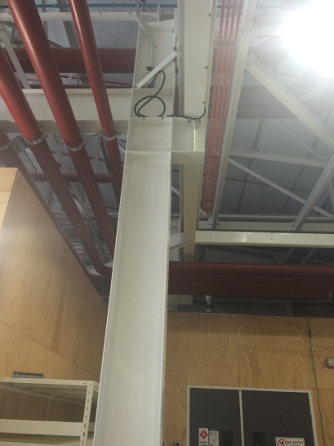
Figure 1. Work from the ground. Why is there an electrical switch near the ceiling?

1.2 Work on a solid construction (work platform)
Working on a solid construction can significantly reduce the likelihood of a fall. Examples of these include docking stations for loading/unloading trucks, barriers on a mezzanine floor and solid work platforms with guard rails. A solid construction will:

Be structurally capable of supporting people, equipment and any other loads applied to it

Provide effective barriers around its perimeter and around any openings through which a person could fall

Have a safe means of entry and exit

Be a permanent or semi-permanent structure

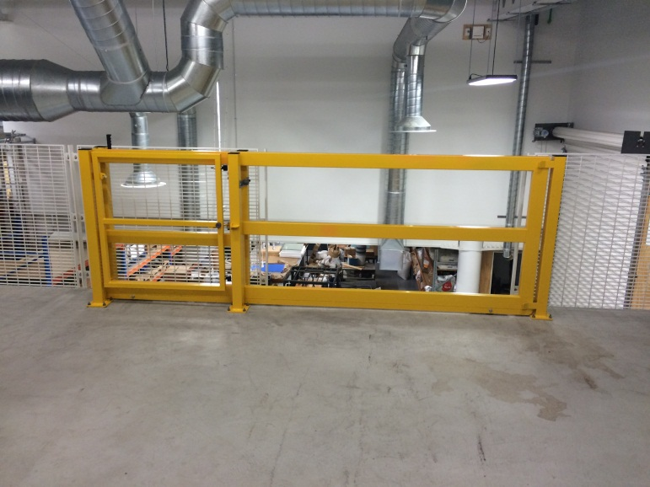
Figure 2. Solid construction. A mezzanine floor fitted with barriers and a safety gate

1.3 Mobile elevating work platforms (MEWP)
MEWP are work platforms that can be raised or lowered to an appropriate height, normally with hydraulics. Examples include boom lifts (cherry pickers), scissor lifts, vertical mast lifts, and vehicle mounted access systems. Simple, easy to use manual MEWP such as “Peco-lifts” are also being used within the University as a safer alternative to ladders.
If you are using a MEWP, you should ensure that:

You are trained and authorised to use the equipment

You follow Safe Work Instructions

You not exceed the rated lift capacity of the MEWP

The MEWP is used on level and firm surfaces

Any fitted MEWP stabilising devices are correctly deployed

Hazards associated with power lines are appropriately controlled

The MEWP will not create a hazard, e.g., the boom will not swing out into the path of vehicles or pedestrians

The MEWP will not be overloaded or used as a crane

You wear a helmet with chin straps if you are working near ceilings or near projections that might strike your head
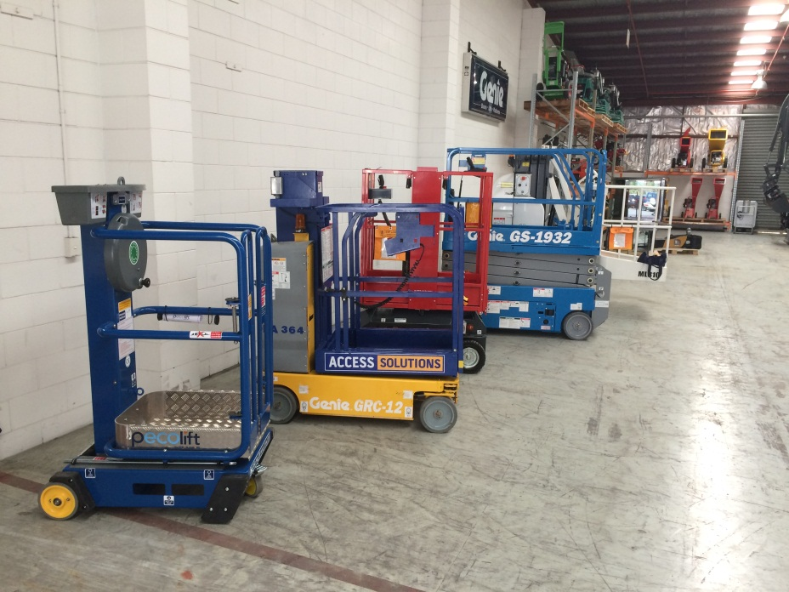
Figure 3. Various mobile elevated working platforms (MEWP)

Harnesses and MEWP

Because of the likelihood that an operator can be catapulted from the basket, if you are using a boom-style MEWP (also known as a knuckle boom or cherry picker) you must wear a safety harness that is connected to a shock absorbing lanyard. The lanyard in turn must be attached to a certified anchor point (even if you are just driving around with the boom lowered). The lanyard should be just long enough to provide free movement within the confines of the bucket and not allow you to climb out of the basket.
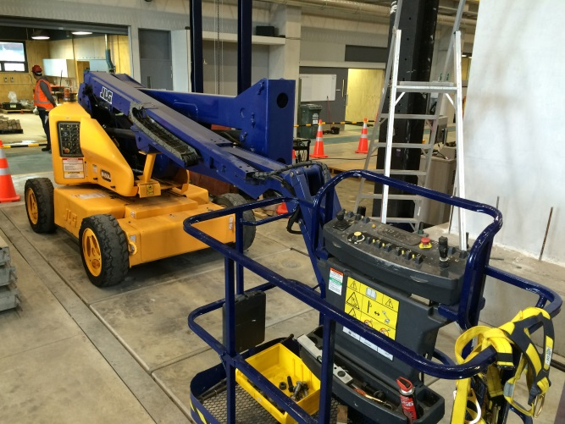
Figure 4. Boom-style MEWP

Because scissor lift or vertical mast lift MEWP are more stable, harness systems are not generally required. Harnesses must be worn if specified by the manufacturer, or if work needs to be done with the guardrails removed or with the access gate opened.

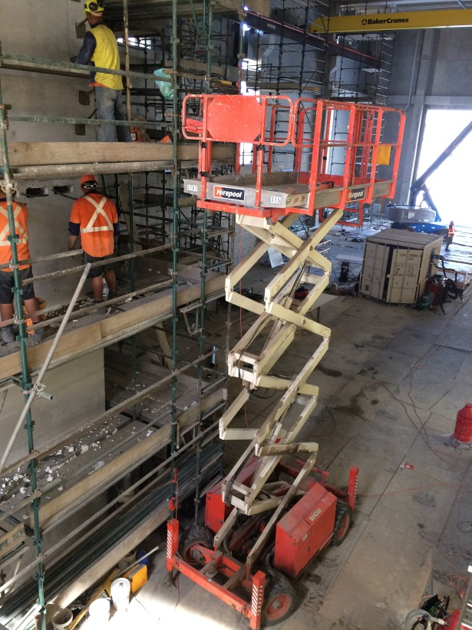
Keep the soles of both of your feet on the work platform. Do not reach over or climb over the rails of the MEWP to access a work area.
Figure 5. Scissor lift - note stabilisers on corners

MEWP can be used as a means of access to a work area. Where the MEWP’s platform is next to the work area’s landing, the landing and platform should be no more than 100mm apart. If there is any chance of falling, you should be protected by a double lanyard system fixed to certified anchor points.

2. Fall prevention systems
Fall prevention systems are intended to prevent a person from being placed in a position where they would be able to fall. These include:

Temporary work platforms - used to provide a working area for the duration of the task. Examples include scaffolding and work-stands. If you are using scaffolding, the additional requirements and scaffolding guidelines outlined in the Approved Code of Practice for the Safe Erection and Use of Scaffolding, and AS/NZS 1576 must be followed.

Perimeter guard rails – these are generally assembled or locked into place when required and locked down/removed when not required. Examples include removable guard rails around a floor hatch/manhole, pop-up guard rails on the top of a fuel delivery tanker and removable guard rails providing edge protection on roofs, vehicle docks or around vehicle servicing pits.
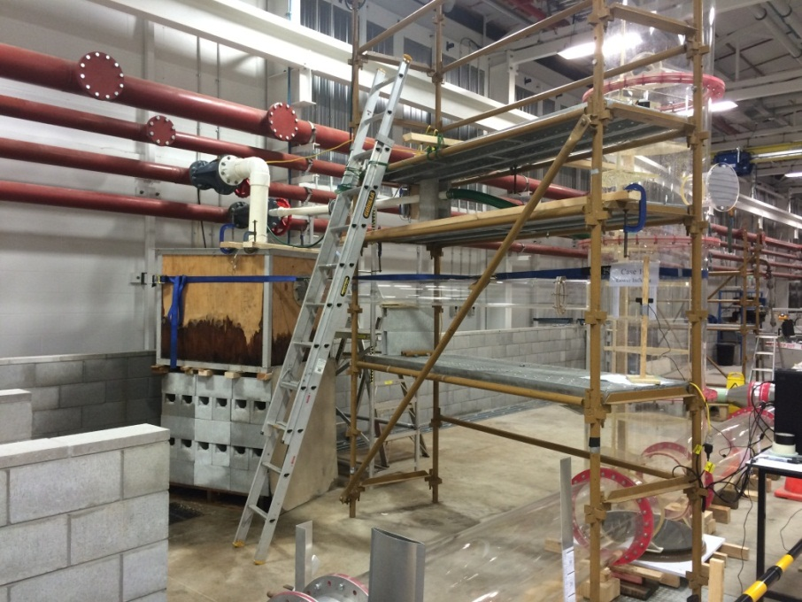
Figure 6. Short term scaffold with ladder access
2.1 Work positioning systems
A work positioning system involves the use of equipment that enables a person to work in a harness in such a way that they cannot reach an unprotected edge. Work positioning systems require competent operators and supervisors in order to be safely used.

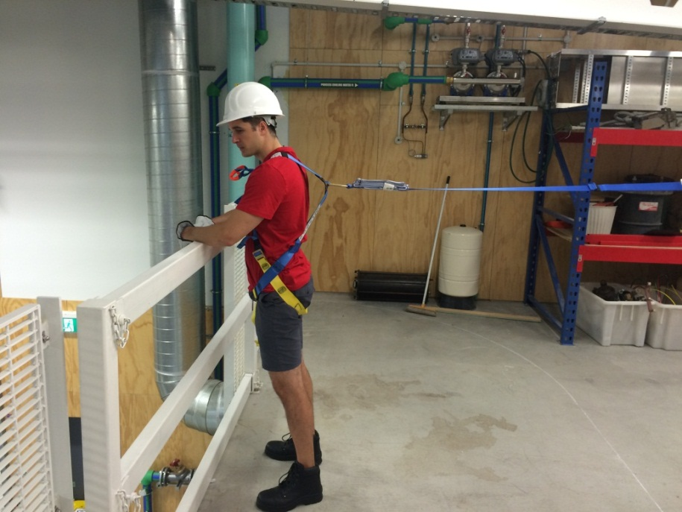

Figure 7. Work positioning system: setting up prior to removing edge protection

Industrial rope access
Industrial rope access uses techniques originally developed in caving and climbing to give people access to difficult-to-reach locations. Industrial rope access is highly complex and is beyond the scope of these guidelines. Best practice guidelines have been prepared by the Industrial Rope Access Association of New Zealand (IRAANZ) and the Department of Labour to provide guidance and advice to employers, operators and clients on the health and safety requirements for rope access work projects. These guidelines take precedence over any guidance material detailed in AS/NZS 1891 or in our WAH standard, procedures or guidance.
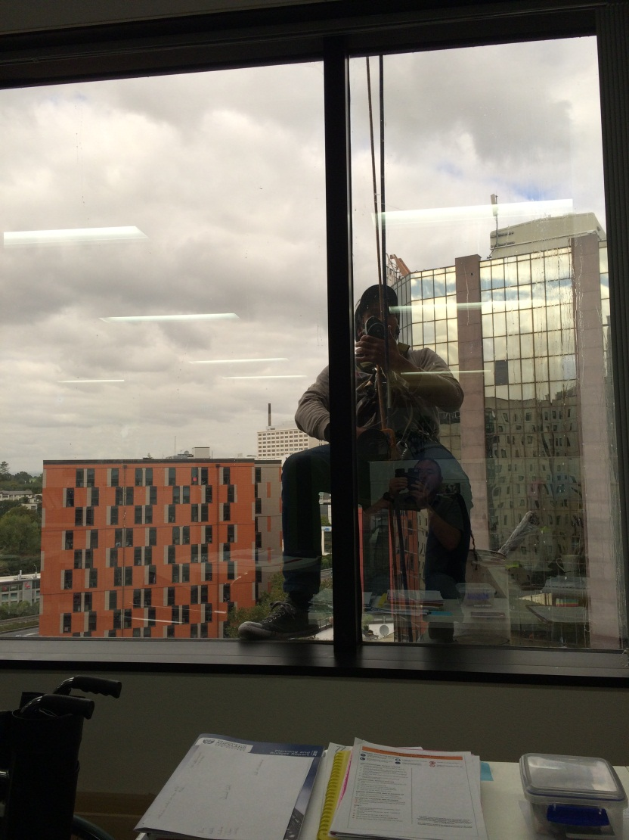
Figure 8. Industrial rope access

2.3 Dropped objects

Objects such as tools and equipment and materials such as bricks, nails, or chunks of concrete present a significant hazard to people located in or passing through the area below the WAH activity – people have been killed by objects that have fallen from scaffolding and other high places.

Common control methods in order of preference include:

Eliminate: Do not carry any object with you unless you actually need it.

Eliminate: Connect tools to you with a tool tether that is attached to a strong point on your harness or tool belt.

Minise through isolation: Raise or lower tools or other objects to/from your work platform using closed tool bags and other safe methods.

Minimise through isolation: Use a secure barrier or kick guards to prevent objects falling off your work platform.

Minimise through engineering controls: Use nets or awnings to catch falling objects.

Minimise through administrative controls: Set up an exclusion zone to prohibit access to the area below the task.

Minimise through Personal Protective Equipment: Use hard hats and other PPE to reduce the severity of injury from falling objects hitting you.

Ladders

The majority of falls from height take place when people are working from ladders, mainly because ladders are generally not regarded as being dangerous and are not used with caution as they should be.

Ladders are designed primarily to be a means of access and egress. If a ladder must be used as a working platform, it should only be used for light work of short duration and the ladder should be rated for industrial use.

All ladders are subject to the same requirements for safe work instructions, inspection and maintenance as any other risk control. Users must get information and (basic) training on safe use before using a ladder in the workplace. More guidance on the safe use of ladders is on the WorkSafe website.
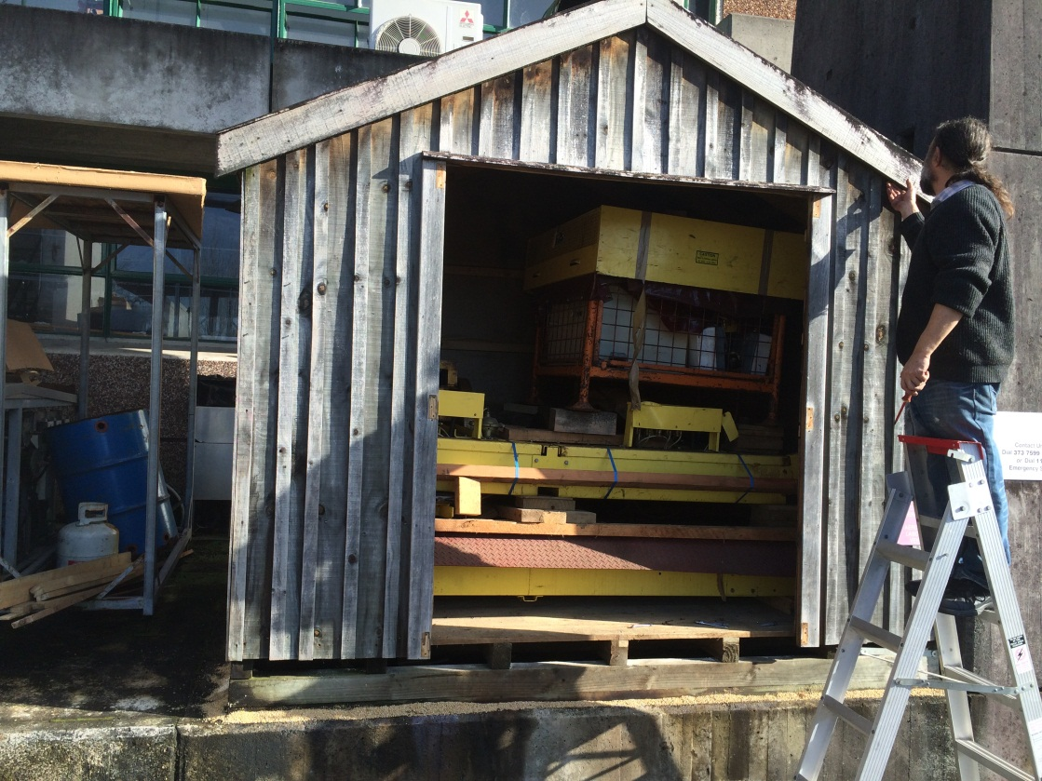
Figure 9. Safety-minded ladder use. Short term access; knees braced against top steps.

2.5 Fall arrest systems

Fall arrest systems are intended to minimise harm by slowing and stopping a falling person before they land on a lower surface. Because some sort of injury is expected to occur during a fall (even with fall arrest), these systems are at the least desirable end of the hierarchy of controls. They are only to be used if:

It is not reasonably practicable to use higher level controls.

Those higher controls are considered not fully effective.

The most common form of fall arrest systems consist of harnesses, connectors and anchor points. Other systems may take the form of soft landing systems such as fall bags, safety nets and catch platforms.
All equipment used for a harness-based fall arrest system must be designed, manufactured, selected and used in compliance with the AS/NZS1891 series of standards. Only full body harnesses are to be used for fall arrest; lower body harnesses may allow people to fall out if they are inverted, and belts or waist straps can cause significant internal injuries in a fall.

When using a fall arrest system, the following key safety requirements, in addition to those outlined in AS/NZS 1891, the following must be considered:

A person must never work alone while using a fall arrest system; there must always be another person in the workplace able to conduct emergency rescue if a fall occurs.

All persons using a harness-based system must be trained and competent in its use.

The straps must be correctly adjusted and buckles must be properly secured/locked off.

Harnesses must be fitted with suspension intolerance/trauma relief straps. These simple devices can significantly delay the onset of suspension intolerance, meaning that rescues can be carried out in a safer, more deliberate fashion.

All persons must wear adequate helmets to protect themselves in the event of a fall. This is because you can strike objects such as walls when you fall. The helmets must have chin straps so they don’t get knocked off.

People using a fall arrest system must not deliberately place themselves in a situation that could result in a fall.

The system is to be designed, installed and used so that the person falls the shortest distance possible. You need to reduce the “pendulum effect” whereby a person can swing into walls and other objects as they fall.

Where the fall arrest equipment has been subject to the forces of a fall, it must be immediately quarantined for inspection.

Note: The fall arrest equipment (harness and shock absorber – if fitted), once used in the arrest of a fall, is to be quarantined and disposed of in accordance with normal processes for the disposal of unserviceable equipment. All other equipment is to be inspected and checked by a height safety equipment inspector before being certified as safe for use and reintroduced to service.

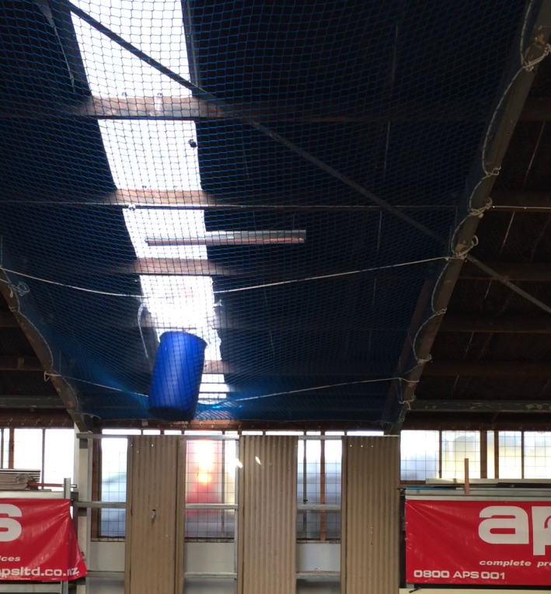
Figure 10. Safety net catching a 100kg barrel.
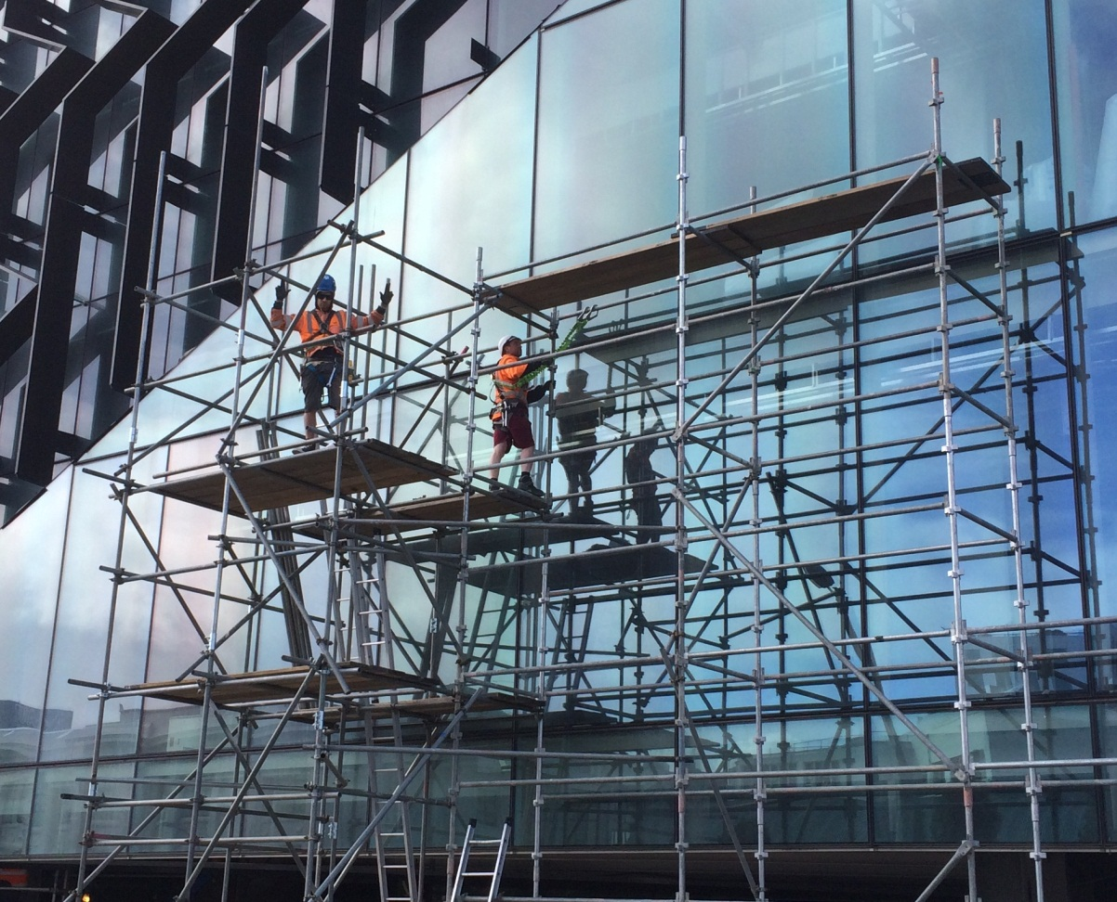
Figure 11. Fall arrest system. A double lanyard is being used by the man on the right.

Personal protective equipment

PPE is the lowest tier of the hierarchy of control, but it can assist in preventing falls or minimising injury in the event of a fall.

Footwear: Shoes and boots should be provided with safety toe caps (where required) and non-slip soles. Footwear must allow the user to use steps and footholds without snagging. Footwear must be securely fastened and checked to ensure that soles are free of slippery substances or contaminants before WAH is conducted. People wearing high heels must never climb ladders.

Clothing: All clothing such as overalls, jackets and hi-viz vests should be well fitted and securely fastened so it does not snag projections and structures at height.

Helmets: Ordinary construction helmets are not designed to protect workers at height, but are only designed to protect workers from falling objects. Cranial protection can be provided by WAH approved industrial helmets that meet AS/NZS 1801 or superior standards such as EN397 or ANSI Z89.1 (noting that a WAH helmet must have a four-point harness). Chin straps must be fastened and correctly adjusted. Helmets should be worn when:

Working at height where the risk of a fall is moderate or greater

Using a fall restraint/arrest harness

Operating a MEWP near ceilings or near projections that might strike an operator’s head

Warning: Due to the risk of sustaining serious injury such as strangulation or de-gloving/serious lacerations to the hand (or even death), all personnel must remove any items that are likely to be snagged or hooked up in a fall, such as rings, watches, jewellery, neck ties and scarves, before commencing any work at height (including climbing ladders).
- Emergency response plans

The WAH Procedures state that “University work groups engaging in WAH tasks and using harness based control measures or mobile elevated working platforms must have documented emergency first response rescue plans in place”. These plans can be based on University templates but must be designed to provide for rapid rescue and first aid for a person who has suffered a fall, is suspended in a fall arrest harness, or has had a medical event when a MEWP is at height.
Factors to consider while developing the emergency and rescue plan include:

The need to keep the plan simple

Ensuring there is a person on ground level who is trained in WAH and is able to initiate the emergency plan in the event of a fall

Checking that suspension intolerance relief straps are fitted to the harnesses being worn by the worker/s (these will significantly reduce the time pressures during a rescue)

Checking the type of rescue equipment on site and its proximity to the work area

Checking there is a first aider on site

Checking what methods are available to communicate with emergency services

Knowing where the nearest medical facilities are located
The WAH rescue plan must be briefed to persons working at height and designated rescuers before the task commences.
Special note: Incidents notifiable to Worksafe NZ:
By law, the following incidents must be notified to Worksafe NZ via the HSW Service on 09-923-4896 WITHOUT DELAY:

A fatality

A serious injury

An unplanned or uncontrolled fall that exposes a worker or any other person to a serious risk to that person’s health or safety

An unplanned or uncontrolled release from a height, of any plant, substance, or thing that exposes a worker or any other person to a serious risk to that person’s health or safety
In addition, the scene must be preserved as much as possible to aid an investigation. Photos should be taken if the scene cannot be preserved.
The exception to this rule is to remove an injured person to a medical aid facility.

3.1 Suspension intolerance (trauma)
Suspension intolerance, also known as suspension trauma, may occur when a person falls and is then suspended above the ground in a fall-arrest harness. Supervisors and all people who use fall-arrest safety harnesses are to be aware of suspension intolerance and how to respond when a person becomes suspended in a harness after a fall.
Suspension intolerance is caused by the constriction of the femoral artery in the groin, restricting the flow of blood from the lower limbs back to the heart. Without the use of suspension intolerance relief straps, it can occur in as little as five minutes and can lead to fainting, nausea, breathlessness and, if not quickly alleviated, unconsciousness and death.
UNCONSCIOUS VICTIMS OF A FALL ARE IN IMMEDIATE DANGER AND URGENT INTERVENTION IS REQUIRED.
Symptoms of suspension intolerance onset include but are not limited to:

A tingling of the toes and fingers

Numbness

Sweating on the side of the head

Disorientation and nausea

To prevent suspension trauma from occurring, the worker must get out of a suspended position as soon as possible. If this is cannot be achieved:

Use leg support equipment (suspension intolerance relief straps) on fall arrest harnesses to stand up and relieve the pressure of the harness.

Move the legs regularly in a pedalling motion.

Raise the knees towards the chest.

IMMEDIATE MEDICAL ATTENTION MUST BE GIVEN TO ANY PERSON WHO HAS BEEN UNCONSCIOUS WHILE SUSPENDED IRRESPECTIVE OF WHETHER THEY APPEAR TO RECOVER ONCE ON THE GROUND.

According to the Australian Resuscitation Council (2013), some agencies recommend that rescuers maintain victims in a sitting position and avoid lying them flat for 30 minutes. There is no evidence to support this practice as a treatment of suspension trauma and it may be harmful. Care of the airway takes precedence over any injury.

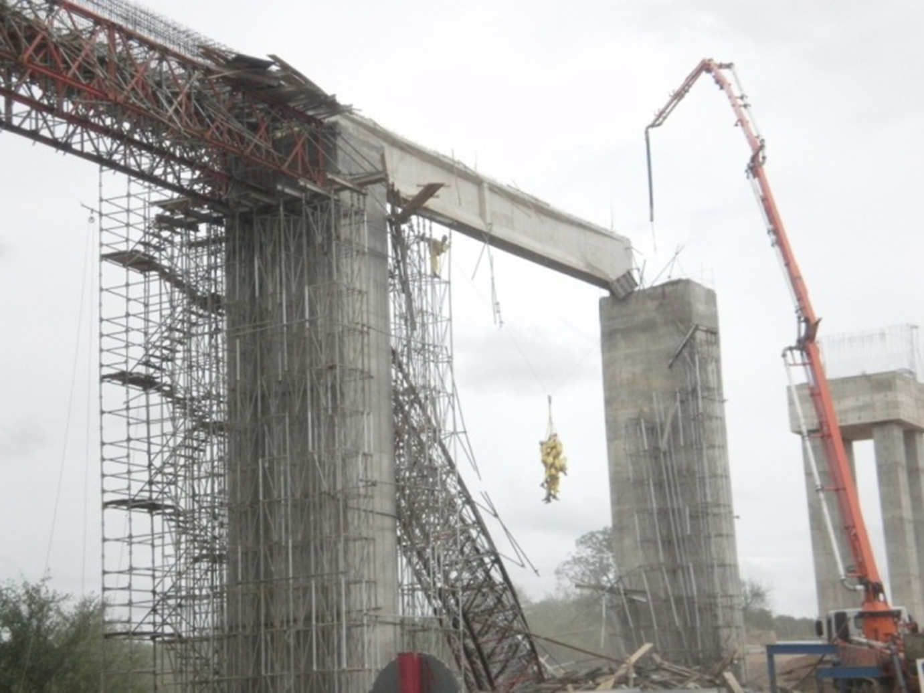
Figure 12. Chinese scaffold collapse. All survived due to the fall arrest system they were using.

- More information

The following publications provide extra information on working at height and good practice:
AS/NZS 1891 Series – Industrial Fall-Arrest Systems and Devices (Available through University Library Services)
AS/NZS 1892 Series – Portable Ladders (Available through University Library Services)
Worksafe Guidance for Working at Height https://worksafe.govt.nz/topic-and-industry/working-at-height/working-safely-at-height/
NZS/AS 1657 Fixed platforms, walkways, stairways and ladders (Available through UoA Library Services)

Definitions

For the purpose of this guidance:
Fall(s) refers to an unexpected sudden drop by a person or object from a higher to a lower level.
Hazard is anything that has the potential to cause harm (injury or ill-health) or damage to property or equipment in connection with a work activity.
Incident is any unplanned event resulting in, or having a potential for injury, ill health, damage or other loss.
Risk refers to the likelihood a hazard will cause harm (injury or ill health) and the degree of harm (consequence).

University means the University of Auckland and includes all subsidiaries.
Working at height: Working at height (WAH) means working in a place where a person could be injured if they fell from one level to another and the risk of falling is moderate or higher. This can be above or below ground level, and is regardless of the duration of the task.
Working at height includes, but is not limited to, circumstances in which a person is working:
- In or on an object or structure that is at an elevated level
- In or on an object or structure that is being used to gain access to an elevated level
- In the vicinity of an opening through which a person may fall
- In the vicinity of an edge over which a person may fall
- On or in the vicinity of a surface through which a person could fall
- On or near a slippery, sloping or unstable surface
Specific examples of activities that are considered working at height are:
- An employee working on a roof
- An engineering student working from a scaffold to build a structure in the structures test hall
- A staff member using a cherry picker to replace a light on a lamp post
- A wine science student working on top of a large cylindrical tank
- Campus Life personnel setting up a banner for an approved event above a hall entrance
- A person working near an open lift shaft on the ground floor of a building
- Window washers abseiling as part of their normal work
- A theatre worker rigging lights above a stage
Specific examples of activities that are NOT considered working at height are:
- Staff using an approved step ladder to change a light bulb at a low height
- Ascending/descending internal or external stairs
- Adventurous activities such as rock climbing and non-work related abseiling
- An actor performing while suspended from a harness
- Flying and parachuting
- Students holding an unapproved roof party
- Criminal activity (including trespassing)

- Further key relevant documents
- Health and Safety at Work Act 2015
- University of Auckland Health and Safety Policy
- Working at Height Standard
- Working at Height Procedures
- Working at Height Competency Matrix
- Working at Height Guidance Part One - “How to meet the standard”
- Working at Height Management Plan
- Working at Height Management Plan - Template Instructions
- AS/NZS 1891 Industrial fall-arrest systems and devices
Document management and control
Content manager: HSW Manager
Owner: Associate Director Health, Safety and Wellbeing
Approved by: Director, Human Resources
Date approved:
Review date:

