AUCKLAND MATHEMATICAL OLYMPIAD 2024
From Google Images and http://letsgetvisualvisual.wordpress.com/2012/02/21/1-618/

The 2024 AMO will be on Saturday 11 May at the University of Auckland City Campus. The test starts at 10am and runs for up to two hours. Please familiarise your candidates with the test format which is similar to previous years.

- In 2024 the Junior Division (Years 9-11) will be held in MLT 1 (or 303-G23) while the Senior Division (Years 12-13) will be held in PLT 1 (or 303-G20). Please ensure your students arrive in plenty of time. There is a large construction site next door so access to the rooms may only be made via a walkway from Symonds Street and from Princess Street (near the Wellesley St end). Notices will be put up outside in both streets.
- Year 9-11 candidates should attempt all of questions 1-10. Year 12-13 candidates are expected to attempt all of questions 3-12.
- Candidates will write in a Question and Answer booklet, set up with one question per page so solutions may be written under the question. Each person is allowed to have their solution checked twice. Markers will rule a line under each attempt and sign off after checking the current solution. Markers will mark one question at a time and move off to another student.
- Markers will also record the mark in a different coloured score sheet that each candidate will be given. This sheet is the only item that will be collected at the end of the assessment.
- During the test, if a candidate believes they have correctly answered a question, they should raise their hand and a marker will go across to check their script. The marker will tear off the page with the question so that the student may keep working on a new question. They will be awarded a score of 0 – 3 marks according to how well their solution answers the question.
- Note that if a candidate does not ask to have their answer checked or runs out of time at the end then that question will not be marked and therefore will not count towards their total.
- We strongly advise candidates to write in blue or black pen (not pencil); if they make a mistake then cross it out and restart below the previous attempt.
- At the end of the time, all the coloured student score sheets with the record of their marks for each question, will be collected and totalled.

An approximately 30 minute lunch break will follow, before everyone meets for a prize giving function. Prizes for winning candidates will be awarded, and every participant will receive a certificate. To avoid congestion we will give each school their participation certificates in the one envelope so please ensure a school representative is present.

2024 - AUCKLAND MATHEMATICAL OLYMPIAD
ENTRY FORM
To be sent by e-mail as an attachment to Joy Rane <joy.rane@auckland.ac.nz by 4pm, on Friday 3rd May, 2024.
Please do not send entries by fax nor by post
Please do not send unregistered students as the facility holds a limited number of people.

Date: Saturday 11th May

Time: 10:00am – 12 midday

Assemble at 9:30am – please do not arrive before

Venues: The University of Auckland

Building 303 (corner of Wellesley & Princes Streets)

Rooms: MLT 1 (or 303-G23) for Years 9 – 11

PLT 1 (or 303-G20) for Years 12 – 13

You will have your registration form acknowledged by return e-mail.
School……………………………………………………Phone……………………………………
Address……………………………………………………………………………………...……
Teacher-in-Charge………………………………………………………………………………………...……
E-mail…………………………………………………………………………………………………
 | Years 9 – 11 students (5 max) | Years 12-13 students (5 max)
Please check your students’ names then submit these in BLOCK  Capitals: | ……………………………  ……………………………  ……………………………  ……………………………  …………………………… | ……………………………  ……………………………  ……………………………  ……………………………  ……………………………
2024 - AUCKLAND MATHEMATICAL OLYMPIAD

RESERVE LIST
Please note – having names on this reserve list does not guarantee place(s) for these students.
Teachers-in-charge will be advised (by return email) whether these students are eligible to take part in competition once all the original entries have been finalised.
All names including those of reserve students will be finalised by Tuesday 04th May.

School……………………………………………………………Phone……………………………
Address………………………………………………………………………………………...……
Teacher-in-Charge……………………………………………………………………………………….……….
E-mail…………………………………………………………………………………………………

Notes – these students will only be entered if there is space at their levels.
Also, students cannot be entered into a level outside of their year group.
 | TWO RESERVE STUDENTS  at  Years 9 – 11 students (2 max) | TWO RESERVE STUDENTS  at  Years 12 – 13 students (2 max)
Please check students’  names then submit in  BLOCK  Capitals: | ……………………………  …………………………… | ……………………………  ……………………………

The event is expected to finish at around 1:15pm to 1:30pm. If you have any other queries or suggestions, please email Phil Kane, p.kane@auckland.ac.nz or Joy Rane, joy.rane@auckland.ac.nz

Entry into Building 303
Princes St
Symonds St
Construction Zone

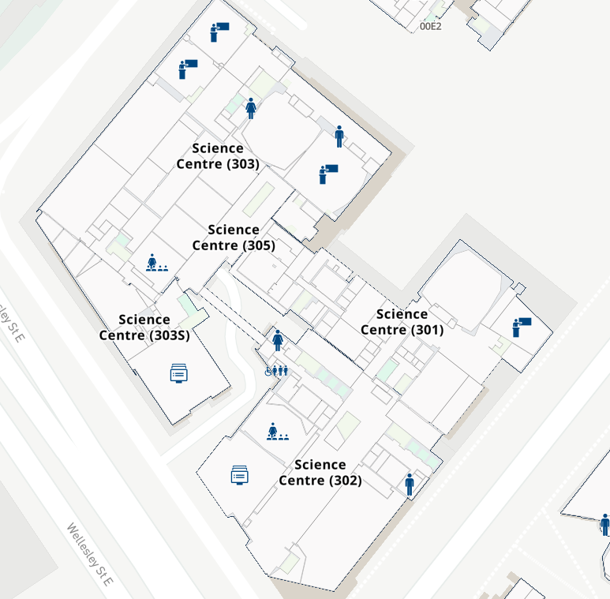

PLT
MLT

If you enter Building 303 from Princes St, this is at the Basement Level (through two sets of sliding doors – see solid green arrow) and you will need to go up one floor to the Ground Floor where the two large lecture theatres MLT and PLT are to be found.

If you come from Symonds St through the walkway (see red dashed arrows) this is at the Ground Level and you will walk about 50m before going through three sets of glass doorways before turning right which leads you straight to the corridor where MLT and PLT are to be found.

Please stay away from the Construction Zone as there are many trucks moving in and out of there onto Princes Street very near to where Building 303 is situated.

