2026 AUCKLAND MATHEMATICAL OLYMPIAD
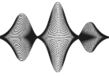
Sound wave icon

The 2026 AMO will be held on Saturday 2 May at the University of Auckland City Campus. The test starts at 10am and runs for up to two hours. Please familiarise your candidates with the test format which is similar to previous years (previous copies on line).

- In 2026 the Junior Division (Years 9-11) will be held in MLT 1 (or 303-G23) while the Senior Division (Years 12-13) will be held in PLT 1 (or 303-G20). Please ensure your students arrive in plenty of time. Access to rooms may be made from Princes Street ① (near the Wellesley St end) or from Symonds St ②, beside Hiwa Recreation Centre. (See map on p3).
- Note this year there are no reserve places in order for our team to get to as many students as possible for marking.
- Year 9-11 candidates should attempt all of questions 1-10. Year 12-13 candidates are expected to attempt all of questions 3-12.
- Candidates will write in a Question and Answer booklet, printed with one question per page so solutions may be written under the question. Each person is allowed to have their solution checked twice. Markers will rule a line under each attempt and sign off after checking the current solution. Markers will mark one question at a time and move off to another student.
- Markers will also record the mark in a different coloured score sheet that each candidate will be given. This sheet is the only item that will be collected at the end of the assessment.
- During the test, if a candidate believes they have correctly answered a question, they should raise their hand and a marker will go across to check their script. The marker will tear off the page with the question so that the student may keep working on a new question. They will be awarded a score of 0 – 3 marks according to how well their solution answers the question.
- Note that if a candidate does not ask to have their answer checked or runs out of time at the end then that question will not be marked and therefore will not count towards their total.
- We strongly advise candidates to write in blue or black pen (not pencil); if they make a mistake then cross it out and restart below the previous attempt.
- At the end of the time, all the coloured student score sheets with the record of their marks for each question, will be collected and totalled.

A lunch break of approximately 30 minute will follow, before everyone meets for a prize giving function. Prizes for winning candidates will be awarded, and every participant will receive a certificate. To avoid congestion we will give each school their participation certificates in the one envelope so please ensure a school representative is present.
2026 AUCKLAND MATHEMATICAL OLYMPIAD
ENTRY FORM
To be attached to an e-mail to ELLA ZHANG at "can.zhang@auckland.ac.nz" by 5pm, on MONDAY 27th April, 2026. Do not send entries by fax nor by post

Please don’t send unregistered students as the rooms hold a limited number of people.

Date: Saturday 2nd May, 2026

Time: 10:00am – 12 midday

Assemble at 9:30am – please do not arrive before

Venues: The University of Auckland

Building 303 (corner of Wellesley & Princes Streets)

Rooms: MLT 1 (or 303-G23) for Years 9 – 11

PLT 1 (or 303-G20) for Years 12 – 13

You will have your registration form acknowledged by return e-mail.
School……………………………………………………Phone……………………………………
Address……………………………………………………………………………………...……
Teacher-in-Charge………………………………………………………………………………………...……
E-mail…………………………………………………………………………………………………
 | Years 9 – 11 students (5 max) | Years 12-13 students (5 max)
Please check your students’ names then submit these in BLOCK  Capitals: | ……………………………  ……………………………  ……………………………  ……………………………  …………………………… | ……………………………  ……………………………  ……………………………  ……………………………  ……………………………
Please print all students’ names clearly as these are used for certificates.
The event is expected to finish at around 1:15pm to 1:30pm. If you have any other queries or suggestions, please email Phil Kane, p.kane@auckland.ac.nz or Ella Zhang, can.zhang@auckland.ac.nz

Entries into Building 303
Symonds St
PLT
MLT
Hiwa Recreation Centre
①
②
Princes St

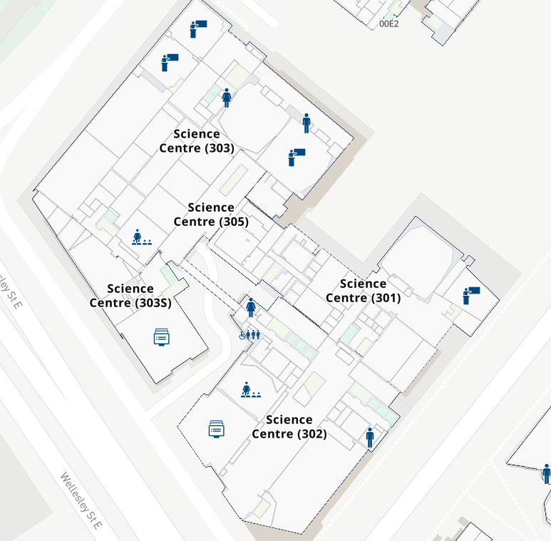

If you approach Building 303 from either Princes St ① or from Symonds St ②, you can enter at the Ground Level (see dashed orange arrows) where the two large theatres, MLT and PLT are.

Either way leads you straight to the corridor where MLT and PLT are located.

Parents and Teachers
During the Test time you are very welcome to go to Room 303-G01 (aka SLT1) to have a break and to catch up with our staff, particularly if you have questions about our programmes here.

