Student Services Levy

**2026 Levy Setting Consultation**

1. What is the Student Services Levy?

The Student Services Levy is the fee paid by all enrolled students to fund non-academic student support services provided by the University. In 2025 the fee is $9.24 per point, which works out to be $1,108.80 for a typical undergraduate taking eight papers.

There are specific categories of services that the Levy can be used to fund (as defined by the Education Amendment Act (2011), these are:

|  |  |
| --- | --- |
| **Category** | **Description** |
| Advocacy and legal advice | Advocating on behalf of individual students and groups of students and providing independent support to resolve problems. This includes advocacy and legal advice relating to accommodation |
| Careers information, advice and guidance | Supporting students’ transition into post-study employment. |
| Childcare services | Providing affordable childcare services while parents are studying |
| Clubs and societies | Supporting student clubs and societies, including through the provision of administrative support and facilities for clubs and societies. |
| Counselling services and pastoral care | Providing non-academic counselling and pastoral care, such as chaplains |
| Employment information | Providing information about employment opportunities for students while they are studying. |
| Finance support and advice | Providing hardship assistance and advice to students with financial issues. |
| Health services | Providing health care and related welfare services |
| Media | Supporting the production and dissemination of information by students to students, including newspapers, radio, television and internet-based media. |
| Sport, recreation and cultural activities | Providing sports, recreation and cultural activities for students |

It’s important to note that the categories are broad and sometimes cover a wide range of activities. For example Sport, recreation and cultural activities includes Orientation and Transition, Co-curricular activities, social events on campus and recognition programmes amongst other activities. Counselling services and pastoral care includes Te Papa Manaaki | Campus Care, Be Well Team, the Chapel and Faith Spaces, Faculty support and mentoring programmes.

The Levy is set at a level sufficient to cover the costs of the student services it funds. Some of these services have other revenue sources and these are taken into account. For example, we receive funding from the Ministry of Health that partially covers our student wellbeing services and reduces the amount we need to contribute from the Levy. Other services such as Early Childhood Centres, the Health Service and the Recreation Centre, are partially funded by fees from those students who use them.

Every year we consult with students and seek views on the types of services we should fund through the levy and how to achieve the best balance between levy funding and user- charges. We do this through two mechanisms:

* A survey open to all students.
* Consultations with elected student representatives through the Student Consultative Group (SCG).

1. Forecasted Expenditure of the Student Services Levy in 2025*

The below graph shows the total forecasted expenditure on the services provided within the ten designated categories. This expenditure is made up from combined student services levy contributions and other external income (in ‘000s) (e.g. Ministry of Health Funding for Wellbeing Services).

*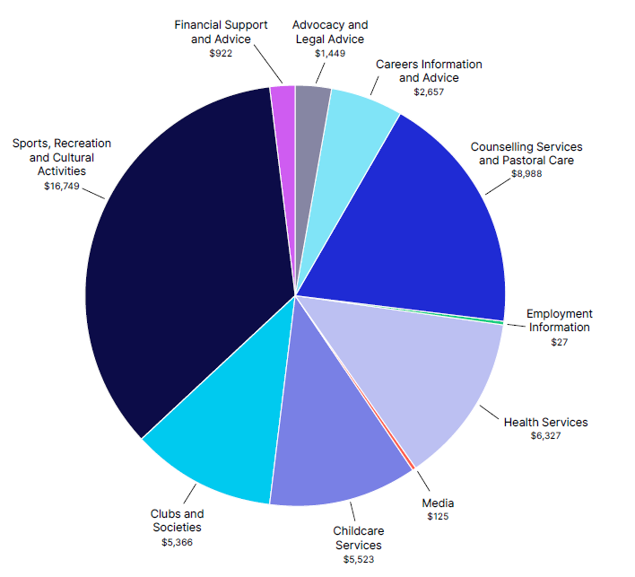*The amounts stated are as per the May Forecast, as this is the latest official Forecast we have at the time of publishing this information and the numbers will be subject to change.*

The below graph shows the total forecasted student services levy contributions (in ‘000s) to the services provided by the University within the ten designated categories.

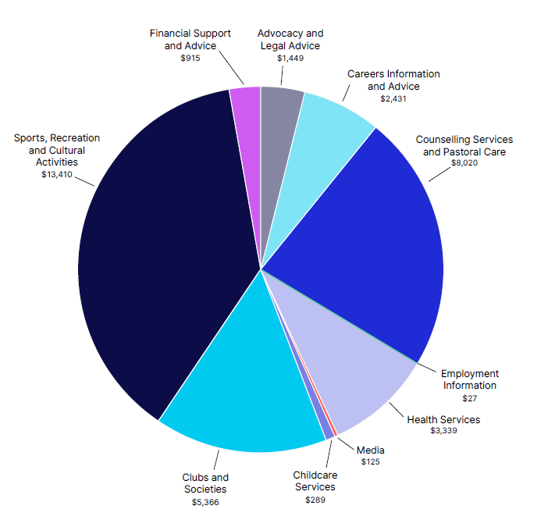

*\*The amounts stated are as per the May Forecast, as this is the latest official Forecast we have at the time of publishing this information and the numbers will be subject to change.*

A total of $48.1m is expected to be spent on the provision of Student Services by the University of Auckland in 2025. Of that total, $35.4m comes from the levy and $12.8m is provided from non-levy funding sources.

The below table shows the forecasted split of funding (levy vs. direct funding) for each of the ten categories, and the value per $100 collected from the levy spent on University services within the defined categories.

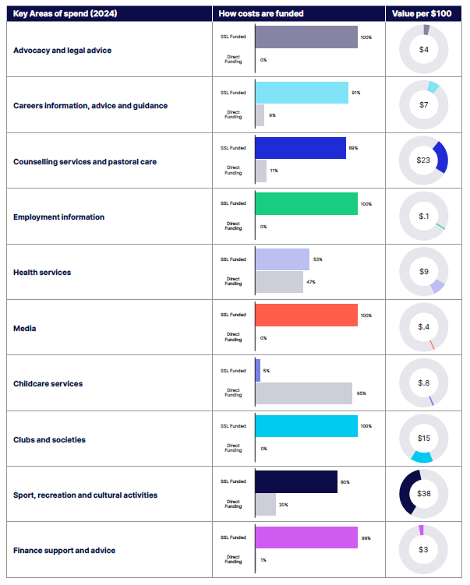

*\*The amounts stated are as per the May Forecast, as this is the latest official Forecast we have at the time of publishing this information and the numbers will be subject to change.*

An overview of the key services and activities that are funded by the Levy is provided below (with all figures based on the 2025 forecast).

**Advocacy and legal advice**

Key services and activities included:

* Auckland University Students Association – Advocacy and Representation ($700k)
* Auckland University Students Association – Occupied spaces, repairs and maintenance ($750k)

What the fee covers and why we think it’s important

The University funds AUSA to provide representation and advocacy services. AUSA Advocacy plays an important role in representation and advocacy for both individuals and student groups. It is important for students to have a safe and independent advocate to help them understand their options, rights and responsibilities. AUSA is a voice for students in other important ways, including representation on University Committees. AUSA has sole use of a number of spaces on campus to ensure its vital advocacy and support work can be delivered effectively, this includes AUSA House, Womxn’s Space and Queer Space. A portion of the funding in this category covers the occupancy costs paid on behalf of AUSA for their physical spaces. This covers items such as property taxes, insurance and utilities.

**Careers information advice and guidance**

Key services and activities included:

* Career Development and Employability Services (CDES) ($1.0m)
* Faculty career support teams ($1.3m)
* Capital (Space Costs Allocation) ($107k)

What the fee covers and why we think it’s important

CDES, along with Career Development teams within Faculties assist current students to clarify their future direction, build employability skills during their studies and confidently navigate the transition from campus to career. The funding is also used for a number of expos, career events and presentations, which provide opportunities for students to connect with employers on campus.

A priority of the Tertiary Education Strategy (updated in 2022) is ‘Ensure learners, vocational education providers, employers and industry are fit for today’s needs and tomorrow’s expectations.’ Career development for students ensures students have opportunities to develop employability skills so they are ‘work ready’ upon graduation.

**Childcare services**

Key services and activities included:

* Early Childhood Centres ($276k)
* Capital (Space Costs Allocation) ($13k)

What the fee covers and why we think it’s important

ECE centres are available to parents and caregivers at both the City and Grafton campuses. The funding provided subsidises the costs of access to childcare services for students. Early Childhood Centres allow students with pre-school aged children to have access to cost-effective, high-quality childcare which is conveniently located for them and is suited to the student timetable.

**Clubs and societies**

Key services and activities included:

* AUSA events and Ngā Tauira Māori ($500k)
* Club grants/events ($1.2m)
* Administrative support for clubs ($3.5m)
* Capital (Space Costs Allocation) ($236k)

What the fee covers and why we think it’s important

We have 286 active clubs on campus supported by engagement teams in Campus Life, across the faculties and by several service divisions. Clubs receive administrative assistance and have access to a range of support and resources including spaces on campus, equipment, funding, training and development workshops. Club events are delivered throughout the year including expos, award events, social and networking events. The funding allocated to AUSA in this category is used to cover the cost of staff salaries, the remuneration of Student Council representatives and the funding of club events as part of themed weeks such as International Week and Politics Week.

Having a range of strong student clubs and associations is important in contributing to student engagement levels and creating a sense of belonging across the University. Well-run clubs and associations with strong and active memberships mean that a diverse range of events and activities are in place for students to engage in.

**Counselling services and pastoral care**

Key services and activities included:

* University Health and Counselling Services ($800k)
* Te Papa Manaaki | Campus Care ($1.95m)
* Wellbeing Ambassadors and AUSA International buddies ($150k)
* Faith and Chaplaincy services ($400k)
* Student Support & Teams in service divisions and faculties ($4.3m)
* Capital (Space Costs Allocation) ($353k)

What the fee covers and why we think it’s important

The University provides student support teams in each faculty and in service divisions including the International Office and Campus Life. These teams are available as a first point of contact for students who need help. They can work with students to develop support plans or refer to more specialist services such as Te Papa Manaaki | Campus Care or Health and Counselling.

Pastoral care is about more than addressing issues when they arise. It is also about helping students to engage fully in University life and develop a strong sense of belonging because that is critical to a successful and enjoyable student experience. The Code of Pastoral Care also requires that universities consider the needs of Māori and equity groups and that we seek to provide safe and inclusive learning environments.

Further details on the pastoral care services that the University provides can be found at: <https://www.auckland.ac.nz/en/students/student-support/personal-support.html>

**Employment Information**

Key services and activities included:

* AUSA - Student Job Search ($27k)

What the fee covers and why we think it’s important

A portion of the levy is provided to AUSA to retain membership to the Student Job Search (SJS) service, the University also looks to promote opportunities for students while they are studying with us, providing students with easy access to job information.

**Financial Support and Advice**

Key services and activities included:

* Hardship funds and financial advice ($915k)

What the fee covers and why we think it’s important

Hardship funding assists students experiencing unforeseen financial difficulty and can cover a wide range of needs including food, travel, accommodation, medical expenses and laptop repairs. Sudden financial hardship can cause significant disruption to a student’s life and their ability to study. The emergency funds are available to provide short-term relief for students who are in sudden, unexpected hardship to enable them to continue to study.

**Health Services**

Key services and activities included:

* University Health Services ($2.76m)
* Disability Services ($432k)
* Capital (Space Costs Allocation) ($147k)

What the fee covers and why we think it’s important

The University provides primary healthcare services to students to help prevent and overcome personal difficulties relating to their physical and mental wellbeing. The funding is used to partially fund GPs and nurse salaries to deliver health services, along with more specialist services including Health Coaches, Health Improvement Practitioners and Mental Health specialists. UHCS is a low- cost service which aims to keep healthcare accessible to all students who need it.

Student Disability Services (SDS) who provide support for students with a wide range of impairments, both visible and invisible. These supports range from ensuring the campus can be safely accessed by all students, to advising and assisting individuals and departments in how to access a range of specialist equipment such as adaptive technology and specialist services such as New Zealand Sign Language Interpreters. The University is committed to ensuring that all students can reach their potential irrespective of any disability.

**Media**

Key services and activities included:

* Craccum ($117k)
* Faculty journals ($8k)

What the fee covers and why we think it’s important

This funding allocation is used by AUSA to produce AUSA’s weekly paper ‘Craccum’ and other specialty student journals and publications. A strong student voice is essential at the University. Publications produced by and for students allow students to showcase their achievements and share authentic insights into life as a student with one another.

**Sports, Recreation and Cultural Activities**

Key services and activities included:

* Recreation Centre ($9.0m)
* Sport tournaments and activities ($1.6m)
* Orientation ($260k)
* AUSA events ($377k)
* Recognition awards and events programme ($280k)
* Student events including Faculty Support ($1.25m)
* Capital (Space Costs Allocation) ($591k)

What the fee covers and why we think it’s important

The University provides sports and recreation facilities, services, and a range of cultural activities on campus. This funding enables the Sport and Recreation team to operate and subsidise sport, fitness and active wellbeing facilities for over 20,000 current student members annually via the Hiwa Recreation Centre and sport and recreation programmes. There have already been over 700,000 visits to Hiwa, since it opened. The Hiwa membership is comprised of 95% University of Auckland students. On a peak day, over 8000 users will visit the Hiwa Recreation Centre. Fitness and sports facilities, programmes, services and tournaments are provided to benefit students. Over 2000 students play in organised sports leagues each week, in addition to the many student club-led programmes and more social sports hosted weekly. Events, wellness programmes and supporting student sports club activities are key priorities for the funding support. Participants in sports programmes report an average 92% overall programme experience rating. The University also offers a High-Performance Support Programme to help students manage tertiary study while competing at elite sports or performance activities; in 2025, there are 279 students supported by this programme and 98% reported feeling ‘supported’ or ‘very supported’.

The University offers a broad range of recreational, cultural and recognition-based events for students, which are provided free of charge or heavily subsidised. Run by and with central services, faculties, AUSA, and/or other partners, these events are designed to appeal to a wide range of interests, spanning culture, music, performance, sport, and skill development. These events are designed to help students make friends and develop a sense of belonging. Activities last year included Orientation activities ($258k), Campus Calling ($80k), Comedy Week ($10k), Music Week ($10k), Blues Awards ($85k) and Distinguished Graduate Awards ($20k).

Both academic and social engagement are key to academic success. Social engagement becomes especially important in institutions as large as Waipapa Taumata Rau, with many students commuting rather than living on campus. A range of small, medium and significant events on campus that cater to the diverse student body enables students to take a break from their studies and assists in helping students make connections with others, create a sense of belonging, promote wellbeing and contribute to good student outcomes.

1. Proposed increase to the Student Services Levy for 2026

The University, like the rest of New Zealand, continues to face inflated costs. CPI is currently tracking at 2.7% as of July 2025 and some costs, such as wages and salaries, have been higher than CPI. For example, living wage costs have increased by 4.2%. To cover the cost of inflation across all services, and to fund the additional expenditure above, the University is proposing a maximum 3.5% increase in the Student Services Levy for 2026. This would see the fee increase from $9.24 per point to $9.56 per point, meaning for a typical undergraduate student taking eight papers the fee would be a maximum $1,147.20 in 2026, up from $1,108.80 in 2025.

The final fee will be determined later this year following the completion of the consultation period and consideration of feedback by the Finance committee. It is expected that even with the proposed increase, the levy will remain one of the lowest in New Zealand universities, despite a higher cost base in Auckland.

|  |  |  |  |  |  |  |  |  |  |
| --- | --- | --- | --- | --- | --- | --- | --- | --- | --- |
| **NZ$ (GST inclusive)** | **Canterbury** | **Massey (Manawatu)** | **Massey (Albany)** | **Otago** | **Waikato** | **Victoria (within the Wellington Region)** | **Victoria (within NZ or overseas)** | **Auckland** | **AUT** |
| 2025 | $1,166 | $1,128 | $1,128 | $1,152 | $926 | $1,193 | $596 | $1,109 | $1,192 |
| 2024 | $1,100 | $900 | $1,080 | $1,076 | $926 | $1,104 | $552 | $1,066 | $1,146 |
| 2023 | $992 | $741 | $793 | $1,015 | $887 | $1,032 | $516 | $1,006 | $1,074 |
| 2022 | $892 | $717 | $767 | $906 | $845 | $1,018 |  | $979 | $934 |
| 2021 | $877 | $689 | $739 | $879 | $792 | $890 |  | $962 | $867 |
| **Change vs. 2021 ($)** | **$289** | **$439** | **$389** | **$273** | **$134** | **$303** |  | **$147** | **$325** |
| **Change vs. 2021 (%)** | **33%** | **64%** | **53%** | **31%** | **17%** | **34%** |  | **15%** | **37%** |

1. Consultation

The University is inviting feedback on the above allocations and welcomes your opinions. To provide your feedback please complete the Student Services Levy survey which will be open 12–24 August 2025.

Survey feedback will be discussed at the [Student Consultative Group](https://www.auckland.ac.nz/en/about-us/about-the-university/the-university/governance-and-committees/committees/a-z-committees/student-consulative-group.html) in August, prior to final decisions by University Council in October.