

How to Guide
360 International Course Approval Process for:
- Faculty of Science
- Faculty of Health Science
- Faculty of Arts and Education
- Faculty of Business
1. Check Programme Requirements

2a. Course Pre-Research
2b. Filling out Study Plan Form

n

6. Faculty Advisor to review Study Plan Form and sends to 360 Int Team and Student

5. 360 International Team sends Study Plan form to Faculty to review

4.Course Assessment Review – 360 International sends to departments to assess

3. Submit Study Plan Form to 360 International via website

1.Check Programme Requirements
It is your responsibility to ensure that any courses taken on exchange have prior approval and meet the programme requirements for your University of Auckland programme. Use the ‘My Programme Requirements’ function in Student Services Online (SSO) to ensure you have a suitable plan to meet all of your degree requirements.
Courses may be approved for University of Auckland credit without fulfilling the necessary requirements for graduation in your degree, so check your programme requirements carefully and seek advice from the faculty programme advisers or Student Hubs if you are unsure.

2A. Course Pre-Research
You are advised to submit 2x as many courses as you plan to take on exchange for your initial assessment (8-10 courses – this includes your back up options). Note: The course approval process is time-intensive, so we kindly ask that you carefully choose your courses for assessment after reviewing the Host University course outlines.
When searching for equivalent/specified courses, you’re looking at 2 course outlines and comparing them side by side.:
- UoA Course Outlines
- Partner university course outline (access the course catalogue through the fact sheet).
Course Outline Requirements
It is very important that you submit courses for assessment with full course outlines. Brief course descriptions from the host university website are generally considered insufficient for assessment and will most likely be declined or delay the outcome.
Course outlines should include details of:
- course objectives
- topic schedule
- weekly schedule
- assigned readings
- assessment schedules
- credit and contact hours
- stage/year level
Extra helpful information around course research
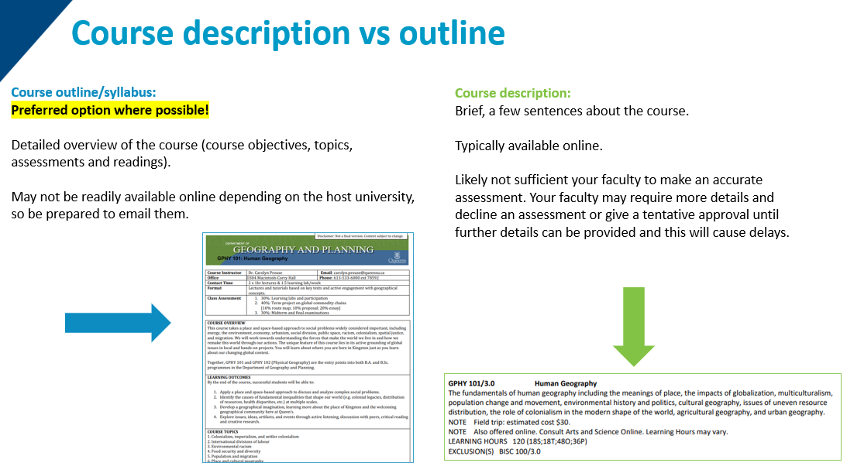
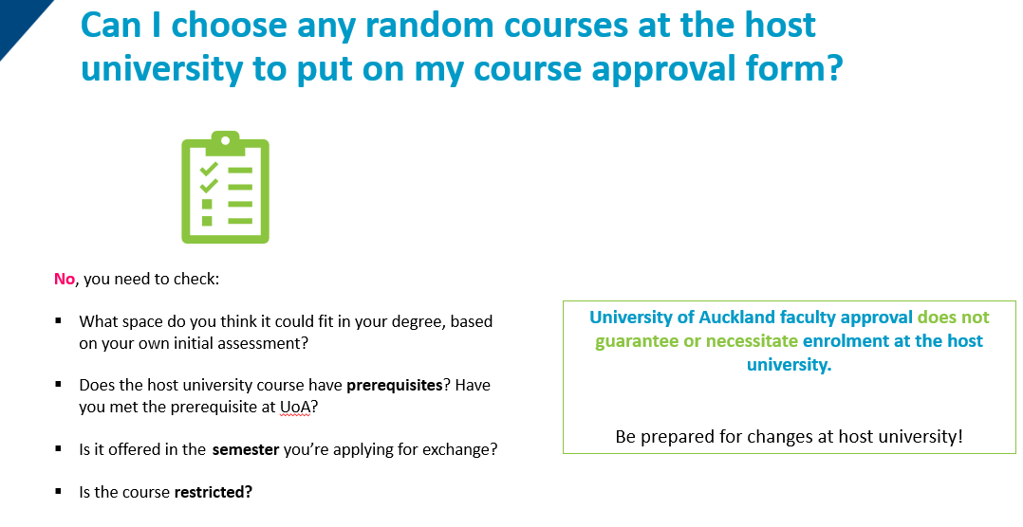
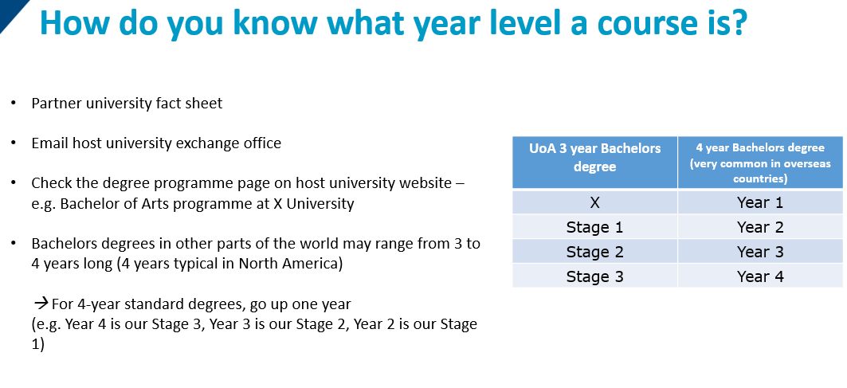
Please also keep in mind:
- It is always important to have back-up options, as schedules and course availability can change.
- University of Auckland course and study plan approval does not guarantee the availability of courses or your enrolment at the host university. It is also important that you check that there are no restrictions against enrolment and that you meet any relevant prerequisites.
- You must take reasonable care in ensuring that the courses you would like to take will be offered by the host university in the semester/term that you will be enrolled on exchange. This may not always be possible, so if referring to a previous year's course catalogue, look at which semester the course was last taught.
- New Zealand's academic calendar and seasons are the opposite of almost all of our partner universities, and the host university's course catalogue and websites will refer to terms according to their own local calendar.

2b. Filling out Study Plan Form
Download Study Plan Form from LINK
Note that your final schedule at your Host University needs to match your signed study plan
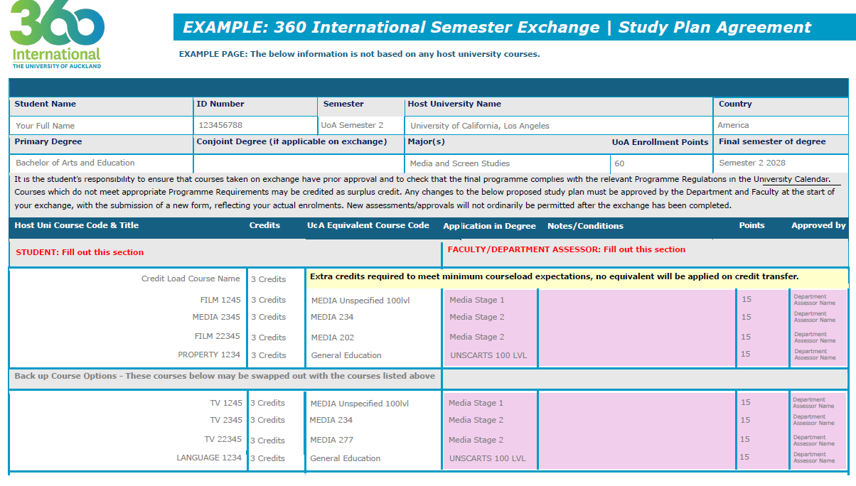
- You must fill out sections highlighted in red:
- Host University name
- Student Name
- UoA ID Number
- UoA Exchange Semester (e.g. Semester One 2025)
- Primary Degree (e.g. Arts, Engineering, etc.)
- Expected UoA Enrolment Points (45, 60, or 75)
- Host University Course code and title (e.g. SCI7546 Introduction to Earth Science)
- Host Credits (see courseload requirement and conversion reference guide if having trouble finding information on this (this is on the last page on every study plan form)
- You can use the Adobe Acrobat Reader app to complete your form using the fillable fields available in the form – fillable fields mean you type straight into the text box provided. Avoid adding text on top of the fillable fields:
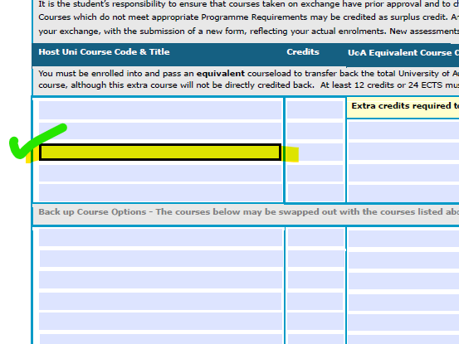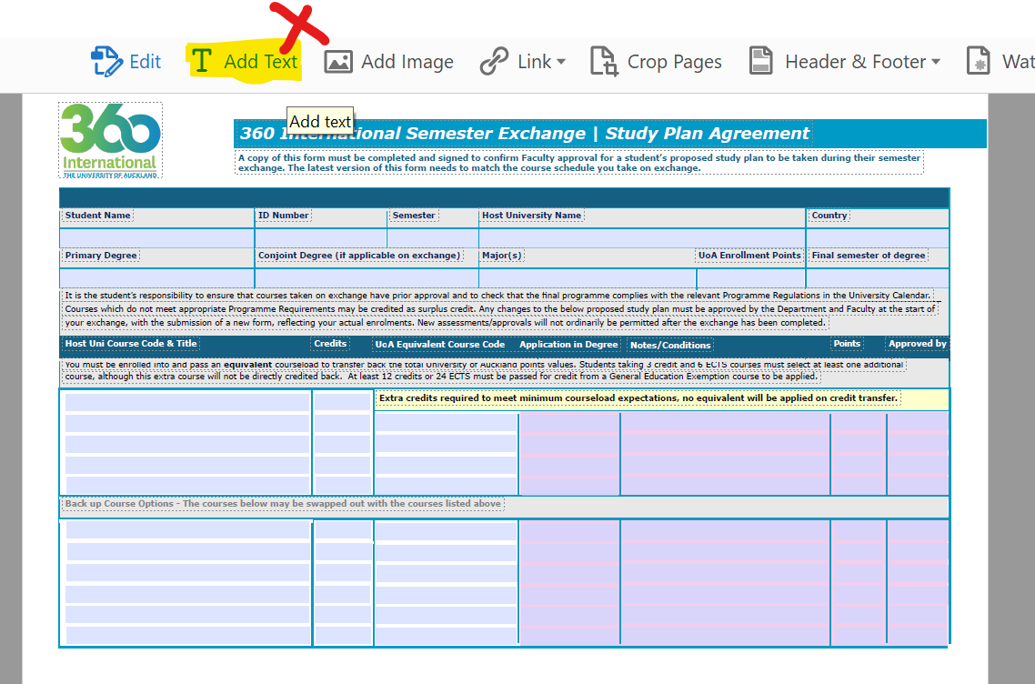
Or you can also use the web browser to fill your form too:
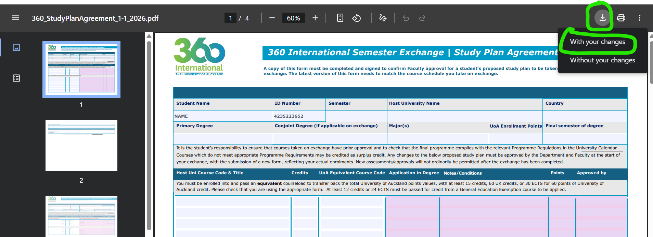
- Check the Courseload requirement and conversion guide reference Guide either from the last page on your study plan or on our website here. Please see the course equivalency columns for reference on how many courses you may be required to enrol in on exchange to credit back 45/ 60/ 75 points and ensure that you have taken enough courses that fulfil the total credit requirements of your host university.
    - See the two visual guides below on what it means to meet the course load requirement at your host university in order to bring back either 45/60 or 75 UoA points.

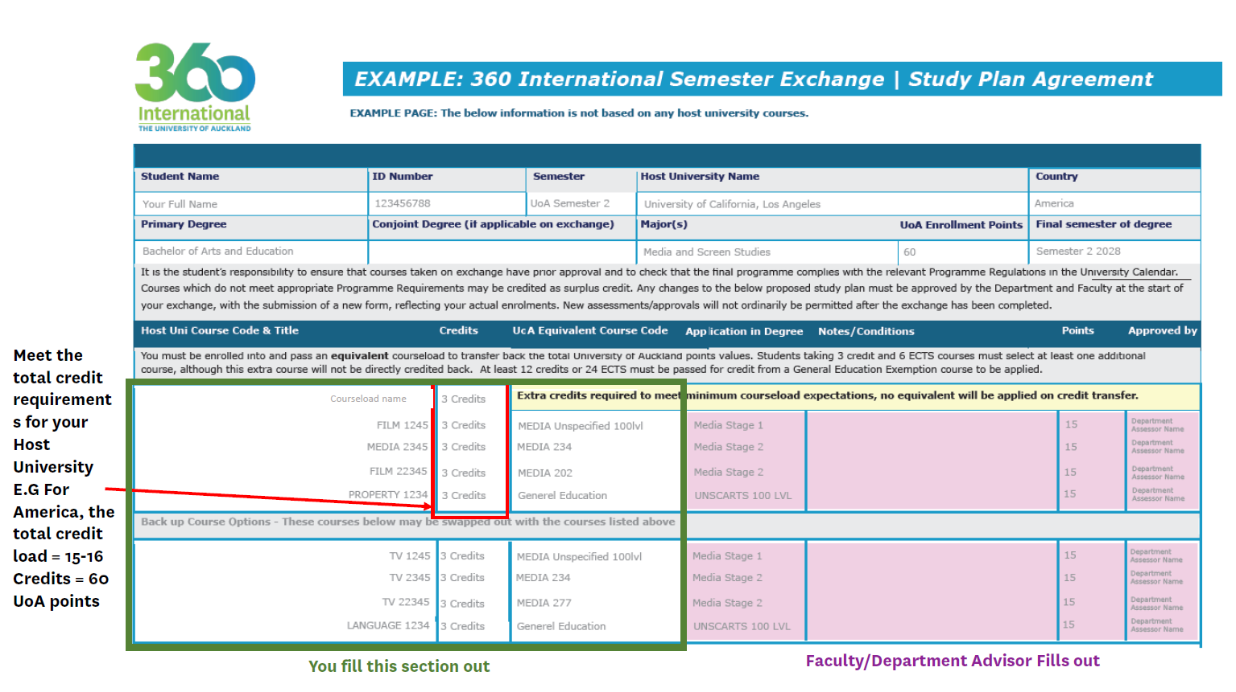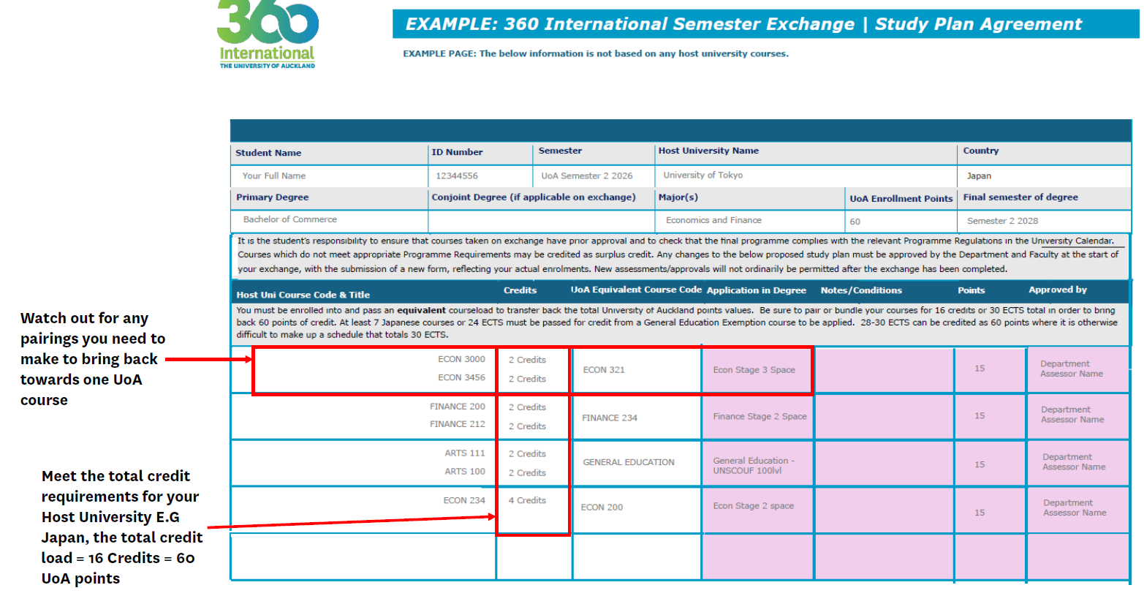

What should you do if your host university has not yet released the most recent course outlines?
If the course outlines for the current academic year have not yet been released or the professors at the host university are unable to release the syllabi for next semester until close to the semester start date, you can use course outlines from the previous year when submitting your course approval form for assessment.
Please ask your host university if they can provide you with the previous year’s course outline, or if they can provide you with the most recent course outline available for that course. We expect many students will still use the previous semester’s course outlines for the initial course approval form, as the current year’s outlines may not be available until closer to the start of the term.

What should you do if your host university does not post full course outlines online?
Firstly, you can reach out to your host university’s exchange office to see if they are able to provide the course outlines for you (for the most recent term, or for previous terms).
In some instances, the lecturers at the host university may be able to provide you with the course outlines as well, but it would be best to first ask the host university exchange office.

3.Submit Study Plan Form to 360 International
Fill out the Submission form on our website here and upload:
- Study Plan Form (from step 2)
- Full course outline PDF files for each course you are requesting approval for
Please rename your course attachments as “HostUniversityName_HostUniCourseCode_CourseName” e.g Maryland_123_SubjectName and make sure your host university course code and name is consistent across your course approval form, email and attachments.

4. Course Assessment Review
I. The 360 international exchange team will receive your submission and reach out to the Department Advisors to review your courses.
II. The 360 International Exchange Team will only reach out to you if your courses are declined and if this occurs, you will need to resubmit.

5. Study Plan Form Submitted to Faculty to Review
If all priority courses are approved, the 360 international team will submit to your Faculty to review.
What does Faculty Approval mean?
Department Advisors are responsible for assessing course match between your host university and UoA. Once we have collated your department course assessments, we will send to your Faculty for review as your Faculty is responsible for ensuring that your approved courses can be transferred towards an available space in your degree.

6. Faculty Advisor sends approve study plan to 360 International Advisors
- If your form is approved, your Faculty Advisor will sign your form and will email to both you and 360 International directly
- If your form is not approved, you will be contacted directly
- If you receive your signed form but do not receive a confirmation email from 360 International within 7 business days that your form as been received, please reach out to 360international@auckland.ac.nz to enquire.

7. Need to Submit another Course Approval Request?
If you need extra courses approved post receiving a signed Study Plan Form, you need to repeat the process again by filling out another Study Plan Form and upload it on our website alongside a full course outline per new course.
Remember, your final course schedule at your Host University needs to match your signed Study Plan form.

