APPENDIX 1

Overview of Selection Criteria and use of Matrices and Rubics

Process
- Identify the key selection criteria for the role before writing the advertisement
- Identify and list the minimum skill or experience levels applicants must have for each key selection criteria to progress to the next stage of the selection process
- Determine methods of assessment, or what evidence will be considered. For instance;
  - How will advertised criteria, ‘Excellence in teaching/research/project management’ be assessed? Is it, number of publications, impact score, success at attracting students, innovations in teaching/research, schedule management, stakeholder satisfaction, performance to business case, etc.
  - It may not always be possible to think of all potential evaluation criteria but the efforts to define the criteria more rigorously usually results in greater clarity regarding what qualities you are seeking
- Criteria should be clearly defined, as abstract or vaguely defined criteria may increase the possibility for unconscious bias to influence evaluation
- Well defined criteria focuses the attention on the merits of individual applicants and on the degree to which they meet the criteria
- Consider weighting the most important criteria, this gives a more nuanced result
- Score or rate each applicant against the criteria, ie, how well they meet the criteria
- Multiply the score against the weighting
- Use a criteria matrix to record the rating, weighting and total score
- The quantitative assessment is backed up by a qualitative evaluation which details how the applicant meets the criteria.

Further Reading
- Assessment matrix example University of Western Australia
- UNC Charlotte Resources for Search Committees. Includes a number of rubic examples for the academic environment
- Recruitment and Selection of General Staff Guidelines - University of Otago. Includes a criterion grid for an administrative position

Example 1: Criteria Matrix with criteria weightings Professional Staff

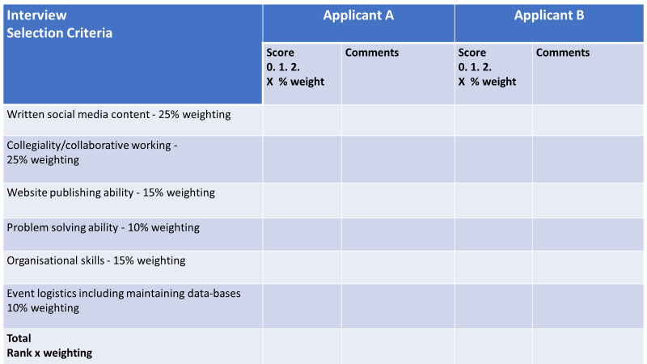

Example 2: Criteria Matrix with criteria weightings and applicant ranking Academic Staff

Criteria → | Research  programme | Post-Grad teaching | Under-Grad teaching | Student engagement | Supervision | Collegiality | Total Scores | Overall Rating
Weighting | 20% | 10% | 20% | 10% | 10% | 30%
Applicants |  |  |  |  |  |  | Rating x weighting
A  Score or Rating  Weighting x rating | 1  20x1=20 | 0  10x0=0 | 2  20x2=40 | 2  10x2=20 | 0  10x0=0 | 2  30x2=60 | 8  130 | 1st  1st
B | 1  20x1=20 | 2  10x2=20 | 0  20x0=0 | 0  10x0=0 | 2  10x2=20 | 0  30x0=0 | 5  50 | 4th  4th
C | 1  20x1=20 | 1  10x1=10 | 1  20x1=20 | 1  10x1=10 | 1  10x1=10 | 1  30x1=30 | 6  100 | 2nd =  2nd
D | 2  20x2=40 | 1  10x1=10 | 2  20x2=40 | 0  10x0=0 | 1  10x1=10 | 0  30x0=0 | 6  90 | 2nd =  3rd

Criteria weightings:
10% 20% 30%
Rank or score of applicants:
2 = exceeds criteria 1 = meets criteria 0 = doesn’t meet criteria

Weighting gives a more nuanced result.

Example 3. Criteria Matrix for Senior Lecturer/Lecturer Sciences
Weight the most important criteria 3, then scale to 2 and 1 for other criteria.
Assess how meets criteria:
0=Does Not Meet Criteria/Not Qualified; 1=Minimally Meets Criteria/Minimally Qualified; 2=Meets Criteria/Competitive; 3=Exceeds Criteria/Highly Competitive

Note sources of evidence: a) Letter of application, b) C.V., c) Reference, d) Transcript, e) Awards..
Applicant | Weighting  3, 2, or 1  Score  0, 1, 2, or 3 | Comments  Qualitative assessment using evidence, applicant’s responses etc; Record applicant’s own words
Ph.D.in relevant discipline. Must have

Evidence of relevant research program for a Senior Lecturer:
Several peer-reviewed articles/projects
Additional work in progress and future plans
Summary of most significant work
Endorsement of references
Impact and Scopus index …

Evidence of relevant research program for a Lecturer
Published peer-review article(s) or project(s)
Work in progress and future plans
Summary of most significant work
Endorsement of references
Impact and Scopus or h index …

Evidence of teaching ability for Senior lecturer
High-quality teaching ability at both UG and PG levels
Significant course coordination
High quality & extensive supervision at all levels (H, BAScHo, M, PhD)

Evidence of teaching ability for Lecturer
Demonstrated potential for excellence in teaching at both UG and PG levels
Course coordination experience
Supervision experience

Student engagement, development and mentoring; experience and commitment to

International and community links
Senior Lecturer; Strong international links;
Community outreach

Lecturer; Appropriate international links;
Community outreach

Equity
Senior Lecturer;
Demonstrated ability to contribute to an engaged relationship with Te Tiriti o Waitangi
Evidence of implementation and leadership in inclusive ways of working, teaching and learning

Lecturer;
Ability to contribute to an engaged relationship with Te Tiriti o Waitangi
Demonstrated ability to work with and support diverse groups of staff and students

Service and collegiality
Senior lecturer; Recognised collaborative activities with other scholars;
Dept/School/University Committee chair, Journal editor, Conference coordination, Reviews written, Leadership positions held, etc

Lecturer; Collaborative activities with other scholars;
Dept/School/University Committee membership, Conference coordination, Reviews written, Leadership positions held, etc

Science Communication
Record of communicating science, outreach and application of research to address challenges to food security and the environment

Demonstrated synergy or complementarity with other relevant research groupings to enhance output, quality and reputation of University

