Inclusive Recruitment: Support for Hiring Managers and Recruitment and Selection Committees

Introduction
The following comprehensive recruitment toolkit for faculties and service divisions provides strategies and ideas drawn from best practice nationally and internationally particularly from the university sector.
The commitment to inclusive recruitment and equity outcomes will attract, retain and support talented people to achieve their potential. This will benefit the creative and intellectual life of the University, and support engagement with the University’s diverse communities and stakeholders.
The University of Auckland is committed to meeting its responsibilities under Te Tiriti o Waitangi, and acknowledges the distinct status of Māori as tangata whenua.

We seek to ensure our recruitment process is equitable and inclusive by identifying and eliminating bias and unfair practices and support equitable access, participation, engagement and success for all staff particularly Māori as well as those from equity groups. Equity groups include people with disabilities, Pacific people, LGBTQI+Tākatapui, people from refugee background, men, women and gender diverse people where there are barriers to success and under-representation.

It is envisioned that this toolkit will support the implementation of the University’s Recruitment, Selection and Appointment Policy and Procedures and used alongside the University’s recruitment process SmartRecruiters.

This toolkit was developed by the University of Auckland Equity Office as part of a pilot project with the Faculty of Science Equity Committee. Staff Equity are keen to hear of any innovative approaches to inclusive recruitment that enables us to attract, appoint and retain diverse applicants.

Why we need to consider inclusive recruitment practices

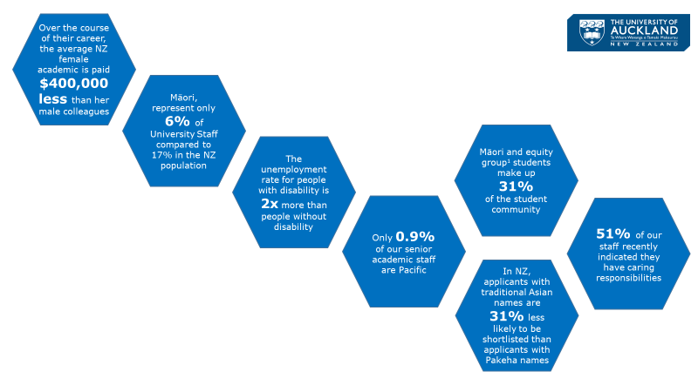
¹ Equity Groups
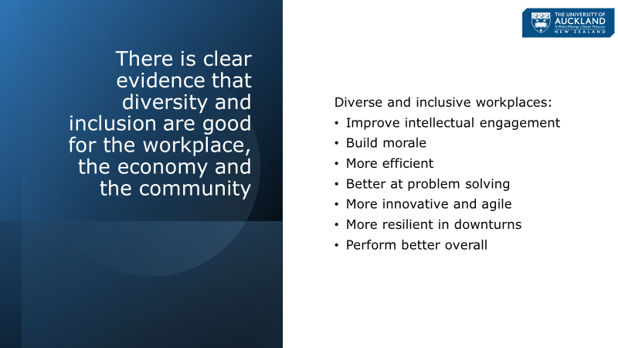

Contents

Step 1: Prior to recruitment

Step 2: Scoping the position

Step 3: Selection Committee membership

Step 4: Selection Criteria

Step 5: Attracting candidates

5.1: Writing the advertisement

5.2: Seeking diverse applicants

Step 6: Shortlisting

6.1: General principles

6.2: Long listing

6.3: Phone screening

6.4: Shortlisting including video screening

Step 7: Interviewing

Step 8: Decision making

