

**Equity Profile 2020**

**Compiled by the Planning and Information Office and the Equity Office – Te Ara Tautika**

Contents

Introduction 4

Achievement of University Key Performance Indicators 7

Student equity 8

Key facts 8

Student enrolments 10

Māori and Pacific domestic enrolments 10

Domestic undergraduate enrolments 11

Domestic postgraduate enrolments 12

Māori domestic EFTS distribution by faculty 13

Pacific domestic EFTS distribution by faculty 14

Domestic EFTS by level of study and ethnic group 15

Māori EFTS by level of study 16

Pacific EFTS by level of study 17

Māori and equity group domestic enrolments 18

Gender 22

Student achievement 27

Successful course completions 27

Stage One SCR - new domestic students 29

Stage One SCR across faculties for domestic students 30

New undergraduate retention 32

New undergraduate retention across faculties 33

Qualification completions 35

Students with disabilities and impairments 37

Ethnicity 39

Gender 40

Student Disability Services data by gender and ethnicity, 2016-2020 41

Where students are studying 42

EFTS with disability by funding level 44

Staff equity 46

Key facts 46

Ethnicity and equity 48

Māori staff 49

Māori academic staff 50

Māori professional staff 51

Pacific staff 53

Pacific academic staff 54

Pacific professional staff 55

Asian staff 57

MELAA staff 57

Gender 58

Women academic staff 58

Senior women academic staff 63

Promotions success by gender - associate professor 66

Promotions success by gender - professor 67

Women professional staff 68

Professional staff by gender in faculties and service divisions 70

Senior women professional staff 74

Staff with disabilities 76

Age 78

Appendix 80

Large Scale Research Institutes’ Data 80

Auckland Bioengineering Institute 80

Liggins Institute 83

Glossary and data sources 86

# Introduction

This report presents data on the participation and achievement of staff and students from Māori and equity groups[1], at the University of Auckland.[2]

The representation and success of these diverse groups are not the only indicators of equity progress. They are, however, key

* Measures of how well we welcome and support those with the potential to succeed in a university of high international standing[3]
* Contributors to the University’s work on advancing the United Nations Sustainable Development Goals[4].

In 2020, over a quarter of students identified as being Māori or as part of an equity group. In relation to total EFTS:

* 8% were Māori
* 9.6% Pacific
* 5.6% identified as having a disability
* 7% identified as belonging to the rainbow community
* 22.5% were from a low socio-economic background
* 2% were from a refugee background.

Some of these students identified as belonging to multiple equity groups.

Covid-19 meant that*,* even with immense efforts made by staff, students experienced issues of financial hardship, difficulties with access, a lack of suitable study space and social isolation.

Vulnerable students with disabilities and those from refugee and low socio-economic backgrounds or Rainbow group membership have faced particular complex disadvantages including safety concerns, mental health issues and lack of places to study.

Staff and students were juggling parenting and carer responsibilities with studying/working at home, having difficulty accessing appropriate technology and equipment, and some were experiencing family violence and abuse.

Despite the challenges brought on by the pandemic, the 2020 data shows that the University continued to make progress in reaching student and staff equity goals that align with its strategic objectives.

In student equity

* Overall, Māori domestic Equivalent Full-Time Students (EFTS) have been decreasing since 2016. Pacific EFTS have fluctuated between 2016 and 2019, but increased in 2020.
* Students from low socio-economic backgrounds comprised the highest proportion of undergraduate EFTS, compared to other Māori and equity cohorts, followed by those who identify as LGBTQITakatāpui+.
* Women students remain under-represented in some areas of Science, Technology, Engineering, Mathematics and Medicine (STEMM), despite small improvements. Women were least represented in the Faculty of Engineering and the Department of Computer Science. The percentage of women in Computer Science has increased by 0.9% since 2016 and the proportion of female EFTS enrolled in the Faculty of Engineering has increased by 2%.
* Male students were significantly under-represented in the Faculty of Education and Social Work, the Liggins Institute and in some areas of Medical and Health Sciences, including Nursing.
* Across the key measures of student achievement, Māori undergraduate domestic student completion rates (SCR) increased by 2% in 2020 compared to 2016. Pacific SCR has increased by 7%. Students with a disability had the highest SCR compared to other equity groups and females had a slightly higher SCR than males.
* Stage One new domestic undergraduate Māori and Pacific SCR has increased in comparison with 2016. Students with a disability had a slightly higher 1N SCR compared to other equity groups.
* Local undergraduate 1N retention was very similar across Māori and equity groups, with refugee background students being slightly higher than the other cohorts. Local undergraduate 1N retention was slightly higher for males and gender diverse students than females. The retention rate for Māori students decreased by 2% compared with 2016 figures. The retention rate for Pacific students decreased by 8%.
* Student Disability Services (SDS) registrations have been steadily increasing, and the number of students seeking assistance from SDS increased by 5% from 2019 to 2020. “Invisible” disabilities remain the majority of impairments disclosed to SDS.

In terms of staff equity

* The percentage of Māori academic staff was 6.1% in 2020. The percentage of Pacific academic staff 2.6%.
* The percentage of Māori professional staff in 2020 was 6.7%. The percentage of Pacific professional staff was 6.7%.
* The gender balance of academic staff remained substantially the same as in 2019 (48%).
* The percentage of senior women professional staff (51.3%) increased by 1.4% compared to 2019.
* In Science, women academics were under-represented in the departments of Computer Science, Environment, Mathematics and Physics. Women were also under-represented in Engineering, particularly in the higher position ranks, and at senior levels in Medical Sciences and Optometry and Vision Sciences in the Faculty of Medical and Health Sciences.
* Men were under-represented in Education and Social Work, and in the departments of Nursing and Pharmacy in Medical and Health Sciences.
* In 2020, 37.1% of academic staff and 27.7% of professional staff were 51 years of age and over.

## Achievement of University Key Performance Indicators

|  |  |  |  |
| --- | --- | --- | --- |
| University KPIs | 2020 Target | 2020 Actual | Achieved/Not achieved |
| Students | | | |
| % Māori undergraduate students (Domestic EFTS) | 8.8 | 8.6 | Not achieved |
| % Pacific undergraduate students (Domestic EFTS) | 12.5 | 12.6 | Achieved |
| % Māori postgraduate students (Domestic EFTS) | 7.0 | 6.3 | Not achieved |
| % Pacific postgraduate students (Domestic EFTS) | 6.5 | 6.3 | Not achieved |
| Staff | | | |
| % women in senior academic positions (associate professor and professor) | 33.0 | 35.0 | Achieved |
| % senior women professional staff | 49.0 | 50.0 | Achieved |
| % Māori staff in academic positions | 6.5 | 6.1 | Not achieved |
| % Pacific staff in academic positions | 3.0 | 2.6 | Not achieved |
| % Māori professional staff | 7.0 | 6.7 | Not achieved |
| % Pacific professional staff | 7.0 | 6.7 | Not achieved |

*\*Calculation includes professional staff in the faculties and LSRIs only*

# Student equity

## Key facts

* Māori EFTS (domestic) at the University decreased from to 2,334 in 2019 to 2,316 in 2020. Between 2016 and 2020 Māori EFTS decreased by 112.
* Pacific EFTS increased from 2,756 EFTS in 2019 to 2,843 in 2020. Between 2016 and 2020 Pacific EFTS increased by 69.2.
* In relation to students who identify as being Māori and/or from an equity group, the highest proportion of EFTS were from low socio-economic backgrounds (22.5%)
* The percentage of Māori EFTS enrolled in postgraduate studies in 2020 was 18.3%, a decrease from 18.7% in 2019. The percentage of Pacific EFTS enrolled in postgraduate studies in 2020 was 13.7%, an increase from 13.5% in 2019. In comparison, 25.1% of Pākehā/European EFTS, and 21.1% of Asian EFTS were enrolled at postgraduate level in 2020. Middle Eastern, Latin American or African (MELAA) had the highest proportion of enrolments at postgraduate level at 38%.
* Students from low socio-economic backgrounds made up the highest proportion of students, identifying as being Māori and/or from an equity group, enrolled at undergraduate and postgraduate level.
* Women students made up 25.6% of the EFTS in Engineering. The proportion of women enrolled in Mathematics increased marginally between 2019 and 2020 from 33.1% to 33.3%. The proportion of women enrolled in Computer Science increased from 22.1% in 2019 to 22.2% in 2020, while in Physics it increased from 33.1% to 36.5%.
* The domestic undergraduate student completion rate (indicating successful course completions) in 2020 for Māori students was 87%. The successful course completion rate for Pacific students was 80%. Rates for students overall were 91% in 2020.
* The Stage One student completion rate of new Māori students increased from 79% in 2019 to 81% in 2020. For new Pacific students, it increased from 65% in 2019 to 71% in 2020.
* In 2020, students with a disability had a slightly higher student completion rate, and Stage One student completion rate, compared to other equity groups.
* Retention of new undergraduate Māori students decreased to 80% in 2020 from 82% in 2019. Retention of new undergraduate Pacific students decreased to 77% in 2020, from 81% in 2019. The retention of overall new domestic undergraduates decreased from 88% in 2019 to 85% in 2020.
* The rate of degree level or higher qualifications obtained by domestic students within five years was 64.8% in 2020, up from 59.4% in 2019. For Māori students, the figure was 56.1%, an increase from 49.2% in 2019.

* The five-year qualification completion rate for Pacific students in 2020 was 44.0%, an increase from the 2019 rate of 42.2%.
* There was an increase of 5% in the number of students seeking assistance from Student Disability Services (SDS) from 2019 (1033) to 2020 (1086).
* “Invisible” disabilities, such as specific learning and mental health issues continued to make up the largest section of those impairments disclosed.
* Women continued to make up a higher percentage of the students registered with SDS than men.
* Since 2016, the faculties of Arts and Science have had the highest proportions of students registered with SDS. These are also the faculties with the highest numbers of students.

## Student enrolments

### Māori and Pacific domestic enrolments

Overall, Māori domestic Equivalent Full-Time Students (EFTS) have been decreasing since 2016. Pacific EFTS have fluctuated between 2016 and 2019, but increased in 2020.

*Source: SMR Headcount and EFTS 5 year Detailed*

**Table 1: Māori and Pacific domestic EFTS 2016-2020**

|  |  |  |  |  |  |
| --- | --- | --- | --- | --- | --- |
| Ethnic Group | 2016 | 2017 | 2018 | 2019 | 2020 |
| Māori | 2428.1 | 2371.5 | 2321.6 | 2334.0 | 2,316.1 |
| Pacific | 2773.9 | 2745.0 | 2809.9 | 2756.0 | 2,843.1 |
| Total | 5202.0 | 5116.5 | 5131.6 | 5090.0 | 5,159.2 |

*Source: SMR Headcount and EFTS 5 year Detailed*

### Domestic undergraduate enrolments

The Faculty of Education and Social Work had the highest proportion of Māori and Pacific students undergraduate in 2020. The Faculty of Engineering had the lowest.

*Source: SMR Headcount and EFTS 5 year Detailed*

**Table 2: Domestic undergraduate EFTS by faculty and ethnic group (as a percentage)**

|  |  |  |  |  |  |  |  |  |
| --- | --- | --- | --- | --- | --- | --- | --- | --- |
| Ethnic Group | Arts | B&E | CAI | EDSW | Engineering | Law | Medical & Health Sciences | Science |
| Māori | 10.6 | 6.1 | 7.6 | 17.6 | 4.9 | 10.8 | 9.8 | 6.4 |
| Pacific | 16.8 | 9.04 | 9.0 | 23.5 | 4.4 | 11.1 | 8.5 | 8.7 |
| Asian | 25.8 | 46.5 | 38.5 | 18.0 | 52.6 | 33.7 | 46.2 | 43.7 |
| MELAA | 3.2 | 2.6 | 2.3 | 2.4 | 2.9 | 3.3 | 4.0 | 3.7 |
| Pākehā/ European | 42.5 | 35.0 | 41.9 | 37.5 | 34.6 | 39.7 | 30.4 | 36.5 |
| Other | 1.1 | 0.9 | 0.7 | 1.0 | 0.6 | 1.3 | 1.1 | 1.0 |

*Source: SMR Headcount and EFTS 5 year Detailed*

### Domestic postgraduate enrolments

The Faculty of Education and Social Work had the highest proportion of domestic postgraduate Māori EFTS and the highest proportion of domestic postgraduate Pacific EFTS.

*Source: SMR Headcount and EFTS 5 year Detailed[5]*

**Table 3: Domestic postgraduate EFTS by faculty and ethnic group (as a percentage)**

|  |  |  |  |  |  |  |  |  |
| --- | --- | --- | --- | --- | --- | --- | --- | --- |
| Ethnic Group | Arts | B&E | CAI | EDSW | Engineering | Law | MHS | Science |
| Maori | 9 | 6 | 6 | 10 | 1 | 7 | 8 | 5 |
| Pacific | 8 | 5 | 7 | 12 | 2 | 9 | 6 | 3 |
| Asian | 27 | 50 | 33 | 29 | 61 | 19 | 35 | 40 |
| MELAA | 5 | 7 | 6 | 3 | 17 | 7 | 4 | 6 |
| Other | 2 | 1 | 2 | 2 | 3 | 5 | 2 | 2 |
| Pakeha/European | 49 | 31 | 46 | 44 | 16 | 53 | 45 | 44 |

*Source: SMR Headcount and EFTS 5 year Detailed[6]*

### Māori domestic EFTS distribution by faculty[7]

Between 2016 and 2020, compared with other faculties, the Faculty of Medical and Health Sciences showed the greatest increase in the proportion of Māori EFTS. The other faculties have had more variable results, with a number experiencing decreases in the proportion of Māori EFTS since 2016.[8]

*Source: SMR Headcount and EFTS 5 year Detailed*

**Table 4: Māori domestic EFTS distribution by faculty 2016-2020 (as percentage)**

|  |  |  |  |  |  |
| --- | --- | --- | --- | --- | --- |
| Teaching Faculty | 2016 | 2017 | 2018 | 2019 | 2020 |
| Arts | 19.2 | 18.7 | 17.3 | 18.6 | 19.8 |
| Business & Economics | 11.6 | 11.7 | 10.6 | 10.5 | 10.1 |
| Creative Arts and Industries | 5.4 | 4.9 | 4.8 | 4.4 | 4.2 |
| Education and Social Work | 16.4 | 16.1 | 15.0 | 13.7 | 12.8 |
| Engineering | 7.1 | 6.6 | 6.2 | 6.3 | 6.0 |
| Law | 6.0 | 6.1 | 7.6 | 7.6 | 8.8 |
| Medical and Health Sciences | 15.7 | 17.7 | 20.4 | 21.1 | 20.8 |
| Science | 18.6 | 18.1 | 17.9 | 17.7 | 17.6 |

*Source: SMR Headcount and EFTS 5 year Detailed*

### Pacific domestic EFTS distribution by faculty[9]

Across all faculties, the Faculty of Medical and Health Sciences showed the most growth in the proportion of Pacific EFTS since 2016. The faculties of Engineering, Law and Science also showed increases since 2016.[10]

*Source: SMR Headcount and EFTS 5 year Detailed*

**Table 5: Pacific domestic EFTS distribution by faculty 2016-2020 (as percentage)**

|  |  |  |  |  |  |
| --- | --- | --- | --- | --- | --- |
| Teaching Faculty | 2016 | 2017 | 2018 | 2019 | 2020 |
| Arts | 27.4 | 26.5 | 24.6 | 25.1 | 25.3 |
| Business & Economics | 11.9 | 12.5 | 12.3 | 12.5 | 11.9 |
| Creative Arts and Industries | 4.6 | 5.0 | 4.8 | 4.1 | 4.1 |
| Education and Social Work | 17.8 | 16.7 | 16.0 | 14.4 | 13.5 |
| Engineering | 5.0 | 5.2 | 5.3 | 5.4 | 5.2 |
| Law | 4.6 | 5.0 | 6.1 | 6.4 | 7.4 |
| Medical and Health Sciences | 11.1 | 11.5 | 12.6 | 13.9 | 14.1 |
| Science | 17.6 | 17.6 | 18.4 | 18.3 | 18.5 |

*Source: SMR Headcount and EFTS 5 year Detailed*

### Domestic EFTS by level of study and ethnic group

The proportion of Māori and Pacific students that studied at undergraduate level in 2020 is higher than that for other ethnic groups, but is lower than that for other ethnic groups at postgraduate (taught and research combined) level.

*Source: SMR Headcount and EFTS 5 year Detailed[11]*

**Table 6: Domestic EFTS by level of study and ethnic group 2020 (as percentage)**

|  |  |  |  |  |  |  |
| --- | --- | --- | --- | --- | --- | --- |
| Funding Level | Māori | Pacific | Asian | MELAA | Pākehā/ European | Other |
| Undergraduate | 81.7 | 86.3 | 76.9 | 62.0 | 74.9 | 63.2 |
| Taught Postgraduate | 13.1 | 9.7 | 11.6 | 11.4 | 16.3 | 12.6 |
| Research Postgraduate | 5.2 | 4.0 | 11.5 | 26.6 | 8.8 | 24.2 |

*Source: SMR Headcount and EFTS 5 year Detailed[12]*

### Māori EFTS by level of study

The percentage of Māori domestic EFTS enrolled in undergraduate and postgraduate studies has not changed significantly between 2016 - 2020.

The highest percentage of Māori domestic EFTS enrolled in undergraduate studies was in 2016, taught postgraduate studies in 2017 and research postgraduate studies in 2019.

*Source: SMR Headcount and EFTS 5 year Detailed[13]*

### Pacific EFTS by level of study

There have been relatively small fluctuations in the percentage of Pacific domestic EFTS enrolled in undergraduate studies and postgraduate studies since 2016.

The highest percentage of Pacific domestic EFTS enrolled in undergraduate studies was in 2017, taught postgraduate studies in 2016 and research postgraduate studies in 2020.

*Source: SMR Headcount and EFTS 5 year Detailed[14]*

### Māori and equity group domestic enrolments

The following charts and tables provide information on domestic EFTS who are Māori and/or from an equity group.

While they provide an indication of the proportion of students who identify as belonging to these groups, provision of this demographic information is not mandatory. As such, and there are likely to be more students who form part of these cohorts but have not identified themselves as such to the University.

*Source: Equity dashboards (Restricted access)*

**Table 7: Māori and equity group domestic EFTS 2020**

|  |  |
| --- | --- |
| Groups | EFTS% |
| Māori | 8.0 |
| Pacific | 9.6 |
| Students with a disability | 5.6 |
| LGBTQITakatāpui+ | 7.0 |
| Low SEB[15] | 22.5 |
| Refugee | 2.0 |

*Source: Equity dashboards (Restricted access)*

*Source: Equity dashboards (Restricted access)*

**Table 8: Faculty domestic undergraduate Māori & equity group EFTS (%)**

|  |  |  |  |  |  |  |
| --- | --- | --- | --- | --- | --- | --- |
| Faculties | Māori | Pacific | Students with a disability | LGBTQITakatāpui+ | Low SEB | Refugee |
| Arts | 9.5 | 15.1 | 8.7 | 10.6 | 21.6 | 2.5 |
| B&E | 5.5 | 8.1 | 3.9 | 4.2 | 14.5 | 2.9 |
| CAI | 5.7 | 6.6 | 8.3 | 9.8 | 14.2 | 1.8 |
| EDSW | 10.6 | 14.2 | 6.7 | 5.1 | 32.1 | 2.2 |
| Engineering | 4.6 | 4.2 | 3.9 | 4.1 | 10.5 | 2.6 |
| Law | 10.4 | 10.6 | 6.1 | 7.8 | 15.1 | 2.6 |
| MHS | 7.1 | 6.2 | 5.2 | 4 | 12.4 | 2.9 |
| Science | 5.7 | 7.8 | 6.2 | 6.9 | 16.0 | 3.0 |

*Source: Equity dashboards (Restricted access)*

*Source: Equity dashboards (Restricted access* )[16]

**Table 9: Faculty domestic postgraduate Māori & equity group EFTS (%)**

|  |  |  |  |  |  |  |
| --- | --- | --- | --- | --- | --- | --- |
| Faculties | Māori | Pacific | Students with a disability | LGBTQITakatāpui+ | Low SEB | Refugee |
| Arts | 8.8 | 7.5 | 9.4 | 1.5 | 40.1 | 1.0 |
| B&E | 5.8 | 4.6 | 1.7 | 0.3 | 54.4 | 0.5 |
| CAI | 6.4 | 6.7 | 6.4 | 2.2 | 24.7 | 1.2 |
| EDSW | 9.9 | 11.7 | 5.2 | 0.3 | 49.6 | 1.3 |
| Engineering | 7.0 | 9.8 | 1.4 | 0.2 | 76.4 | 0.9 |
| Law | 6.9 | 8.8 | 5.8 | 4.2 | 42.2 | 1.7 |
| MHS | 8.0 | 6.0 | 4.0 | 1.4 | 39.9 | 1.2 |
| Science | 4.8 | 2.9 | 4.8 | 1.1 | 41.5 | 1.1 |

*Source: Equity dashboards (Restricted access)[17]*

*Source: Equity dashboards (Restricted access)[18]*

**Table 10: Domestic undergraduate and postgraduate Māori and equity group EFTS (%)**

|  |  |  |
| --- | --- | --- |
| **Groups** | **EFTS %** | |
| Undergraduate | Postgraduate |
| Māori | 8.2 | 6.6 |
| Pacific | 10.4 | 5.9 |
| Students with a disability | 5.9 | 6.0 |
| LGBTQITakatāpui+ | 5.6 | 1.8 |
| Low SEB | 16.1 | 45.7 |
| Refugee | 1.6 | 0.3 |

*Source: Equity dashboards (Restricted access)[19]*

### Gender

Between 2016-2020 there have been more female EFTS than males. In 2020 there were 12.8% more female EFTS than males.



**Table 11: Gender breakdown of domestic EFTS**

|  |  |  |  |  |  |  |  |  |  |  |
| --- | --- | --- | --- | --- | --- | --- | --- | --- | --- | --- |
|  | 2016 | | 2017 | | 2018 | | 2019 | | 2020 | |
| Gender | EFTS | % | EFTS | % | EFTS | % | EFTS | % | EFTS | % |
| D |  |  |  |  | 101.5 | 0.3 | 112.1 | 0.3 | 147.5 | 0.4 |
| F | 18,380.3 | 55.5 | 18,448.7 | 55.3 | 18,862.3 | 55.8 | 19,157.0 | 56.0 | 19,246.6 | 56.2 |
| M | 14,684.8 | 44.3 | 14,855.4 | 44.5 | 14,840.9 | 43.9 | 14,941.7 | 43.7 | 14,854.1 | 43.4 |

High percentages of female EFTS are in the faculties of Education and Social Work and Medical and Health Sciences, as well as the Liggins Institute. The Faculty of Engineering had the lowest percentage of female EFTS in 2020.

**Table 12: Gender breakdown of domestic EFTS in Faculties and LSRIs for 2020**

|  |  |  |  |  |  |  |  |
| --- | --- | --- | --- | --- | --- | --- | --- |
| Teaching Faculty | Female | | Male | | Diverse | | Total |
| EFTS | % | EFTS | % | EFTS | % | EFTS |
| Arts | 3,001.9 | 67.7 | 1,384.6 | 31.2 | 45.3 | 1.0 | 4,431.8 |
| Bioengineering Institute | 29.7 | 30.9 | 66.4 | 69.1 | 0.0 | 0.0 | 96.1 |
| Business and Economics | 1,820 | 45.4 | 2,184.0 | 54.5 | 2.9 | 0.0 | 4,007.5 |
| Creative Arts and Industries | 918.7 | 61.3 | 555.0 | 37.0 | 23.6 | 1.5 | 1497.2 |
| Education and Social Work | 1582.1 | 78.5 | 427.1 | 21.2 | 5.8 | 0.2 | 2,015.0 |
| Engineering | 906.7 | 25.6 | 2,623.6 | 74.2 | 5.3 | 0.15 | 3,535.5 |
| Law | 1,051.1 | 64.3 | 578.5 | 35.4 | 3.9 | 0.2 | 1,633.4 |
| Liggins Institute | 39.0 | 76.3 | 12.1 | 23.6 | 0.0 | 0.0 | 51.1 |
| Medical and Health Sciences | 3,136.0 | 70.5 | 1,300.7 | 29.2 | 6.0 | 0.1 | 4,442.7 |
| Other Academic Activities | 204.7 | 57.0 | 152.4 | 42.6 | 1.9 | 0.5 | 359 |
| Science | 3,464.4 | 51.7 | 3,183.8 | 47.9 | 25.4 | 0.3 | 6,645.7 |
| **Total** | 16,126.8 | 56.1 | 12,468.3 | 43.4 | 120.0 | 0.4 | 28,715.1 |

*Source: SMR Headcount and EFTS 5 year Detailed*

The proportion of female EFTS enrolled in the Faculty of Engineering has increased by 2% in 2020 compared to 2016.

**Table 13: Gender breakdown in the Faculty of Engineering 2016-2020**

|  |  |  |  |  |  |  |
| --- | --- | --- | --- | --- | --- | --- |
| Teaching Faculty | Gender | 2016 | 2017 | 2018 | 2019 | 2020 |
| % EFTS | % EFTS | % EFTS | % EFTS | %EFTS |
| Engineering | Female | 23.6 | 23.9 | 24.7 | 25.3 | 25.6 |
| Male | 76.1 | 75.8 | 75.1 | 74.5 | 74.2 |
|  | Diverse |  |  | 0.1 | 0.1 | 0.1 |

*Source: SMR Headcount and EFTS 5 year Detailed*

In the Faculty of Science, female EFTS make up just over half of domestic EFTS overall. However, the proportion of females is lowest in Computer Science, followed by Physics and Mathematics. The proportion of females is highest in Psychology.

**Table 14: Gender breakdown in Science departments 2020**

|  |  |  |  |  |  |  |
| --- | --- | --- | --- | --- | --- | --- |
| Teaching Department | Female | | Male | | Diverse | |
| EFTS | % | EFTS | % | EFTS | % |
| Chemical Sciences | 388.0 | 60.0 | 257.1 | 39.8 | 1.3 | 0.1 |
| Computer Science | 237.2 | 22.2 | 824.9 | 77.3 | 4.6 | 0.43 |
| Environment | 470.3 | 55.8 | 367.8 | 43.7 | 4.2 | 0.49 |
| Marine Science | 53.8 | 57.3 | 39.2 | 41.6 | 1.0 | 1.10 |
| Mathematics | 190.4 | 33.3 | 378.7 | 66.3 | 2.4 | 0.37 |
| Physics | 111.8 | 36.6 | 192.1 | 62.8 | 1.9 | 0.56 |
| Psychology | 732.8 | 75.6 | 232.9 | 24.0 | 4.1 | 0.42 |
| Biological Sciences | 733.6 | 64.4 | 402.7 | 35.3 | 3.4 | 0.29 |
| Science Admin | 7.8 | 62.3 | 4.8 | 37.7 |  |  |
| Exercise Sciences | 116.4 | 54.9 | 95.3 | 45.0 | 0.1 | 0.06 |
| Statistics | 395.9 | 50.1 | 391.0 | 49.5 | 3.3 | 0.41 |
| Total | 3,438.2 | 51.7 | 3,186.5 | 47.9 | 26.3 | 0.38 |

*Source: SMR Headcount and EFTS 5 year Detailed*

The proportion of women in Computer Science was 0.9% higher in 2020 than in 2016.

**Table 15: Gender breakdown in Computer Science 2016-2020**

|  |  |  |  |  |  |  |
| --- | --- | --- | --- | --- | --- | --- |
| Teaching Department | Year | 2016 | 2017 | 2018 | 2019 | 2020 |
| Gender | % EFTS | % EFTS | % EFTS | %EFTS | %EFTS |
| Computer Science | Female | 21.3 | 21.6 | 23.1 | 22.1 | 22.2 |
| Male | 78.6 | 78.0 | 76.5 | 77.6 | 77.3 |
|  | Diverse |  |  | 0.2 | 0.3 | 0.43 |

*Source: SMR Headcount and EFTS 5 year Detailed*

The proportion of women in Mathematics was 2.9% higher in 2020 than in 2016.

**Table 16: Gender breakdown in Mathematics 2016-2020**

|  |  |  |  |  |  |  |
| --- | --- | --- | --- | --- | --- | --- |
| Teaching Department | Year | 2016 | 2017 | 2018 | 2019 | 2020 |
| Gender | % EFTS | % EFTS | % EFTS | %EFTS | %EFTS |
| Mathematics | Female | 30.4 | 31.0 | 32.3 | 33.1 | 33.3 |
| Male | 69.5 | 68.8 | 67.4 | 66.5 | 66.3 |
|  | Diverse |  |  | 0.2 | 0.3 | 0.3 |

*Source: SMR Headcount and EFTS 5 year Detailed*

The proportion of women in Physics was 2.8% higher in 2020 than in 2016.

**Table 17: Gender breakdown in Physics 2016-2020**

|  |  |  |  |  |  |  |
| --- | --- | --- | --- | --- | --- | --- |
| Teaching Department | Year | 2016 | 2017 | 2018 | 2019 | 2020 |
| Gender | % EFTS | % EFTS | % EFTS | %EFTS | %EFTS |
| Physics | Female | 33.7 | 31.0 | 31.7 | 33.1 | 36.5 |
| Male | 66.1 | 68.4 | 67.9 | 66.4 | 62.8 |
|  | Diverse |  |  | 0.6 | 0.5 | 0.5 |

*Source: SMR Headcount and EFTS 5 year Detailed*

Men continue to be most under-represented in the Faculty of Education and Social Work and the Liggins Institute as well as in some departments in Medical and Health Sciences – such as Nursing.

**Table 18: Gender breakdown in Medical and Health Sciences departments 2020**

|  |  |  |  |  |  |  |
| --- | --- | --- | --- | --- | --- | --- |
| Teaching Department | Female | | Male | | Diverse | |
| EFTS | % | EFTS | % | EFTS | % |
| Te Kupenga Hauora Māori | 99.4 | 74.0 | 34.8 | 25.9 | 0.0 | 0.0 |
| Faculty Administration FMHS | 0.9 | 91.8 | 0.1 | 8.11 | 0.0 | 0.0 |
| Medical Sciences | 834.9 | 65.8 | 431.7 | 34.0 | 1.8 | 0.1 |
| Nursing | 619.6 | 89.1 | 74.8 | 10.7 | 0.8 | 0.1 |
| Optometry and Vision Science | 156.0 | 71.3 | 62.7 | 28.6 | 0.0 | 0.0 |
| Pharmacy | 178.8 | 69.2 | 78.6 | 30.4 | 0.8 | 0.3 |
| Population Health | 534.9 | 72.5 | 201.8 | 27.3 | 1.1 | 0.1 |
| School of Medicine | 711.5 | 63.0 | 416.3 | 36.8 | 1.4 | 0.1 |
| Total | 3,136.0 | 70.5 | 1,300.7 | 29.2 | 6.0 | 0.1 |

*Source: SMR Headcount and EFTS 5 year Detailed*

## Student achievement

Student academic achievement is measured by a range of indicators including:

* Student completion rate (SCR), indicating successful course completions
* First-year retention

### Successful course completions

Undergraduate domestic SCR for Māori and Pacific students has increased in 2020 compared to 2016-2019.

*Source: SMR Equity Pass Rates*

**Table 19: Domestic undergraduate SCR Māori and Pacific students**

**2016-2020**

|  |  |  |  |  |  |
| --- | --- | --- | --- | --- | --- |
| Ethnic Group | 2016 | 2017 | 2018 | 2019 | 2020 |
| Māori | 85% | 85% | 85% | 85% | 87% |
| Pacific | 73% | 73% | 73% | 73% | 80% |
| Overall | 91% | 91% | 91% | 91% | 91% |

*Source: SMR Equity Pass Rates*

In 2020, students with a disability had the highest SCR compared to other equity groups. Females had a slightly higher SCR than males.

*Source: Equity dashboards (Restricted access)*

**Table 20: Domestic undergraduate SCR Māori and equity group students 2020**

|  |  |
| --- | --- |
| Groups | SCR (%) |
| Māori | 86.6 |
| Pacific | 79.8 |
| Disability | 88.3 |
| LGBTQITakatāpui+ | 87.6 |
| Low SEB | 85.3 |
| Refugee | 88.3 |
| Female | 92.0 |
| Male | 90.2 |
| Diverse | 82.7 |
| Overall | 91.2 |

*Source: Equity dashboards (Restricted access)*

### Stage One SCR - new domestic students

The Stage One new domestic undergraduate SCR is a useful indicator of the effectiveness of teaching and learning for new undergraduate students.

Although there have been fluctuations in the SCR for Māori and Pacific students at the 1N level, it has increased since 2016.

*Source: SMR Equity Pass Rates (2016-2020)*

**Table 21: Domestic 1N SCR 2016-2020**

|  |  |  |  |  |  |  |
| --- | --- | --- | --- | --- | --- | --- |
| Course level and ethnic group | | 2016 | 2017 | 2018 | 2019 | 2020 |
| 1N | Māori | 79% | 79% | 78% | 79% | 81% |
| Pacific | 63% | 67% | 69% | 65% | 71% |
| Overall | 86% | 87% | 87% | 87% | 89% |

*Source: SMR Equity Pass Rates (2016-2020)*

### Stage One SCR across faculties for domestic students

In 2020, the 1N SCR for Māori students was highest in the Faculty of Engineering. Pacific students’ 1N SCR in 2020 was highest in the Faculty of Law. Pacific students at the 1N level generally had lower SCR than other ethnic groups.

*Source: SMR Equity Pass Rates (2020)*

**Table 22: 1N SCR by faculty and ethnicity 2020 (as percentage)**

|  |  |  |  |  |  |  |  |
| --- | --- | --- | --- | --- | --- | --- | --- |
| 1N SCR | | | | | | | |
| Teaching Faculty | Māori | Pacific | Asian | MELAA[20] | Pākehā/ European | Other | Total |
| Arts | 74 | 66 | 86 | 86 | 87 | 75 | 82 |
| B&E | 81 | 75 | 92 | 75 | 90 | 84 | 89 |
| CAI | 80 | 83 | 91 | 98 | 92 | 100 | 90 |
| EDSW | 80 | 67 | 82 | 83 | 85 | 88 | 79 |
| ENG | 97 | 83 | 93 | 91 | 94 | 96 | 93 |
| Law | 87 | 84 | 91 | 88 | 94 | 94 | 91 |
| MHS | 87 | 76 | 89 | 88 | 87 | 87 | 87 |
| Science | 80 | 66 | 88 | 81 | 88 | 79 | 85 |

*Source: SMR Equity Pass Rates 2020*

In 2020, students with a disability had a slightly higher 1N SCR compared to other equity groups.

*Source: Equity dashboards (Restricted access)*

**Table 23: 1N SCR for Māori and equity group students**

|  |  |
| --- | --- |
| Groups | SCR (1N) % |
| Māori | 82.6 |
| Pacific | 72.1 |
| Disability | 86.1 |
| LGBTQITakatāpui+ | 85.4 |
| Low SEB | 79.6 |
| Refugee | 83.8 |
| Female | 89.1 |
| Male | 86.3 |
| Diverse | 82.5 |
| Overall | 87.8 |

*Source: Equity dashboards (Restricted access)*

## New undergraduate retention

The new undergraduate retention rate measures the percentage and number of new undergraduate students (EFTS) who return the following year.

2016, 2018 and 2019 had the highest local undergraduate (1N) retention rate for Māori, and 2017 had the highest for Pacific.

*Source: SMR First Year Undergraduate Retention – 5 Years (2016-2020)*

**Table 24: Local undergraduate retention 2016-2020**

|  |  |  |  |  |  |
| --- | --- | --- | --- | --- | --- |
| Retained (%) | | | | | |
| Ethnic Group | 2016 | 2017 | 2018 | 2019 | 2020 |
| Māori | 82% | 81% | 82% | 82% | 80% |
| Pacific | 83% | 87% | 85% | 81% | 77% |
| Overall [21] | 87% | 88% | 87% | 88% | 85% |

*Source: SMR First Year Undergraduate Retention – 5 Years*

### New undergraduate retention across faculties

The Faculty of Law had the highest retention rate in 2020, for new undergraduate local Māori and Pacific EFTS.

*Source: SMR First Year Undergraduate Retention – 5 Years (2016-2020)*

**Table 25: Retention of local new undergraduate students by faculty (as percentage)**

|  |  |  |  |
| --- | --- | --- | --- |
| Programme Owning Faculty | Māori | Pacific | Overall |
| Arts | 77.9 | 82.9 | 80.7 |
| Business and Economics | 81.9 | 81.4 | 85.0 |
| Creative Arts and Industries | 80.0 | 76.5 | 78.4 |
| Education and Social Work | 61.5 | 76.6 | 69.8 |
| Engineering | 93.0 | 81.6 | 87.7 |
| Law | 95.7 | 87.3 | 90.7 |
| Medical and Health Sciences | 76.5 | 87.1 | 83.3 |
| Science | 84.8 | 80.3 | 82.4 |

*Source: SMR First Year Undergraduate Retention – 5 Years (2016-2020)*

In 2020, local undergraduate 1N retention was very similar across Māori and equity groups, with refugee background students being slightly higher than the other cohorts. Local undergraduate 1N retention was slightly higher for males and gender diverse students than females.

*Source: Equity dashboards (Restricted access)*

**Table 26: Local undergraduate retention (1N): Māori and equity groups**

|  |  |  |
| --- | --- | --- |
| Groups | Undergraduate Retention | |
| 2019 | 2020 |
| Māori | 82 | 82 |
| Pacific | 85 | 81 |
| Disability | 83 | 82 |
| LGBTQITakatāpui+ | 71 | 83 |
| Low SEB | 87 | 84 |
| Refugee | 67 | 85 |
| Female | 87 | 87 |
| Male | 87 | 89 |
| Diverse | 82 | 89 |
| Overall | 87 | 88 |

*Source: Equity dashboards (Restricted access)*

## Qualification completions

The five-year qualification completion rate looks at those who have or have not completed their degree within five years.

The 5-year qualification completion rate for domestic Māori and Pacific students, and students overall increased in 2020 compared to 2019.

*Source: SMR 5 Year Qualification Completion Rates*

**Table 27: 5-year qualification completion rates for domestic students 2016- 2020**

|  |  |  |  |  |  |
| --- | --- | --- | --- | --- | --- |
| Ethnic Group | 2016 | 2017 | 2018 | 2019 | 2020 |
| Māori | 53.0% | 54.1% | 54.6% | 49.2% | 56.1% |
| Pacific | 49.0% | 49.7% | 47.7% | 42.2% | 44.0% |
| Overall | 66.3% | 65.7% | 65.5% | 59.4% | 64.8% |

*Source: SMR 5 Year Qualification Completion Rates*

A number of students who identified as being Māori or part of an equity group completed their qualifications in 2020. Some of these students may have identified as being Māori and/or belonging to more than one equity cohort.

**Table 28: Qualification completions 2020: Māori and equity groups (head count)**

|  |  |
| --- | --- |
| Groups | Qualification Completions |
| Māori | 767 |
| Pacific | 791 |
| Disability | 468 |
| LGBTQITakatāpui+ | 657 |
| Low SEB | 404 |
| Refugee | 151 |
| Female | 5,530 |
| Male | 3,423 |
| Diverse | 40 |
| Overall | 8,993 |

*Source: Equity dashboards (Restricted access)*

## 

## Students with disabilities and impairments

The statistical data that follows is a combination of Student Disability Services’ (SDS) internal statistics (including student registrations) and data extracted from the University’s strategic reporting systems. Data from SDS shows numbers of students, while data from the strategic reporting systems shows EFTS.

It is important to note that disclosure of disability or impairment by students is voluntary, and as a result, this data does not necessarily reflect the total number of students or EFTS with impairments at the University of Auckland.

The number of students seeking assistance from SDS showed an increase of 5% from 2019 to 2020, and have more than doubled since 2005.

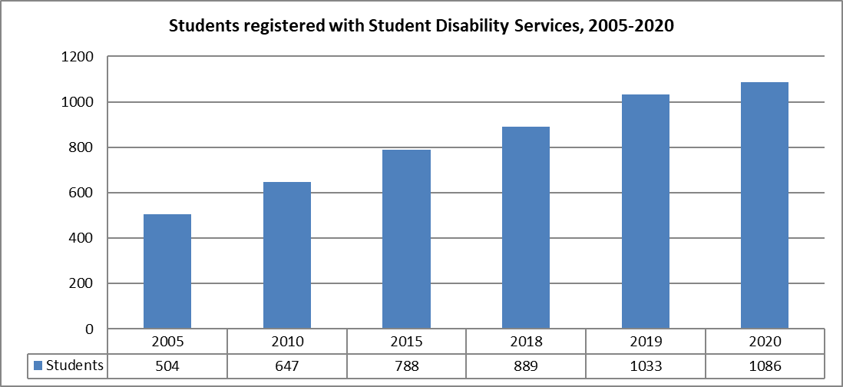

“Invisible” disabilities, such as specific learning and mental health issues, continue to make up the largest section of those impairments disclosed. Over the past ten years, the number of students with specific learning disabilities seeking assistance has more than doubled, as has the number of students with diagnosed mental health conditions.

Note that students increasingly have multiple disabilities. The 2020 figures in the chart below capture all disabilities, so a student with a specific learning disability and a mental health condition will be counted separately under each category.

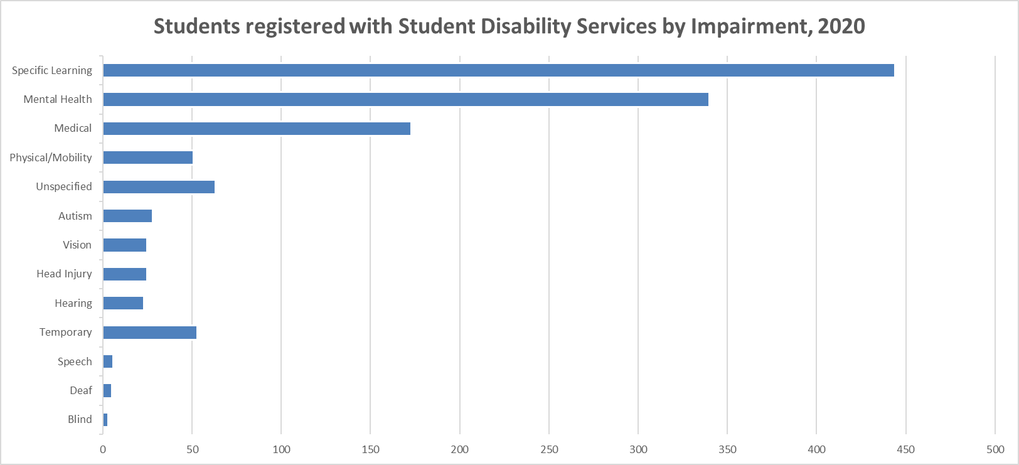

### Ethnicity

The number of students registered with SDS by ethnicity is shown below. Students may identify with more than one ethnicity, which in part explains the increase in numbers across most ethnic groups in the last two years.

Over the last two years, there has also been significant increases in the number of students identifying as Pacific and those identifying as Asian. Māori student engagement with SDS has also been increasing.

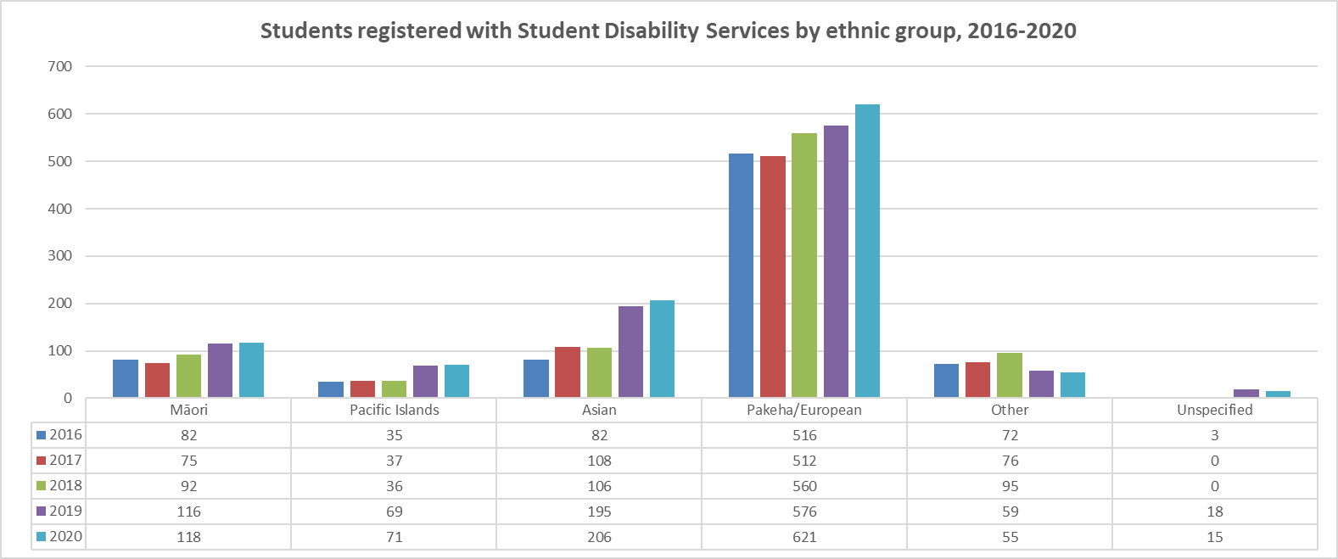

The chart below shows the proportion of EFTS by ethnicity for students indicating an impairment at the point of enrolment.

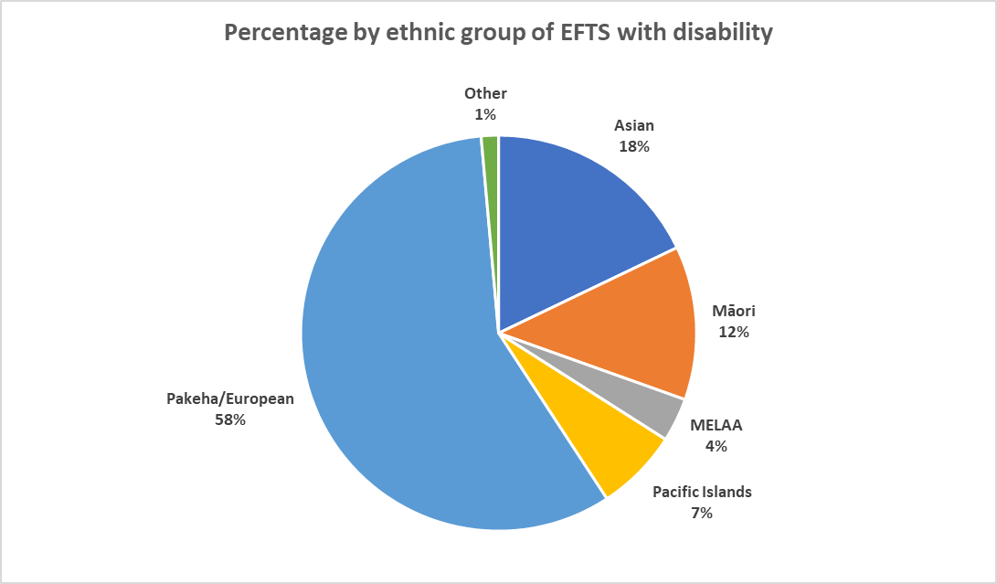

### Gender

Across all ethnic groups, women made up a larger proportion of EFTS for students who indicated an impairment at the point of enrolment (N.B. these are not necessarily the same students who register with SDS).

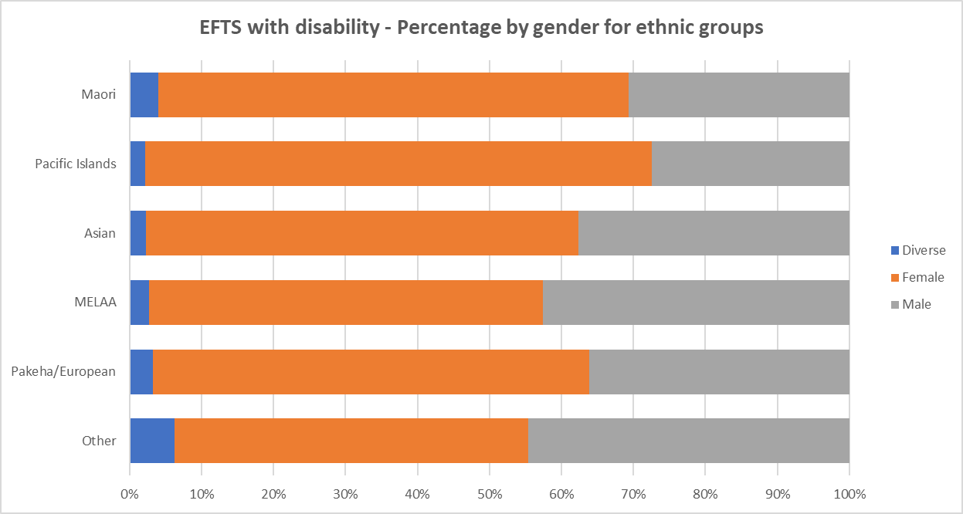

**Table 29: EFTS with disability – percentage by gender for each ethnic group**

|  |  |  |  |  |  |  |
| --- | --- | --- | --- | --- | --- | --- |
|  | Māori | Pacific | Asian | MELAA | Pākehā/European | Other |
| Diverse | 4.0% | 2.2% | 2.2% | 2.7% | 3.3% | 6.2% |
| Female | 65.3% | 70.3% | 60.1% | 54.7% | 60.6% | 49.2% |
| Male | 30.7% | 27.5% | 37.7% | 42.6% | 36.1% | 44.6% |

### Student Disability Services data by gender and ethnicity, 2016-2020

Over the last 5 years, women have consistently made up a higher percentage of students registered with SDS. This is in line with general enrolment data, where female students also make up the majority of EFTS enrolled at the University.

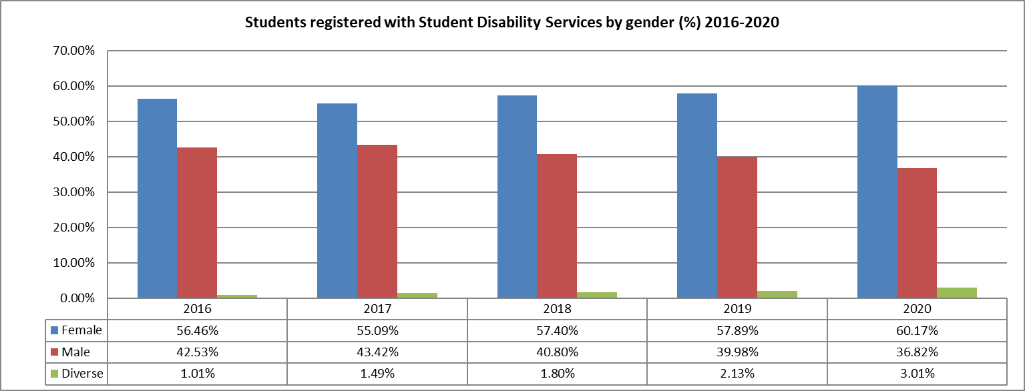

In 2020, women made up over half of the numbers across all ethnic groups for students registered with SDS. There were more than twice as many females as males who identified as Māori and/or Pacific.

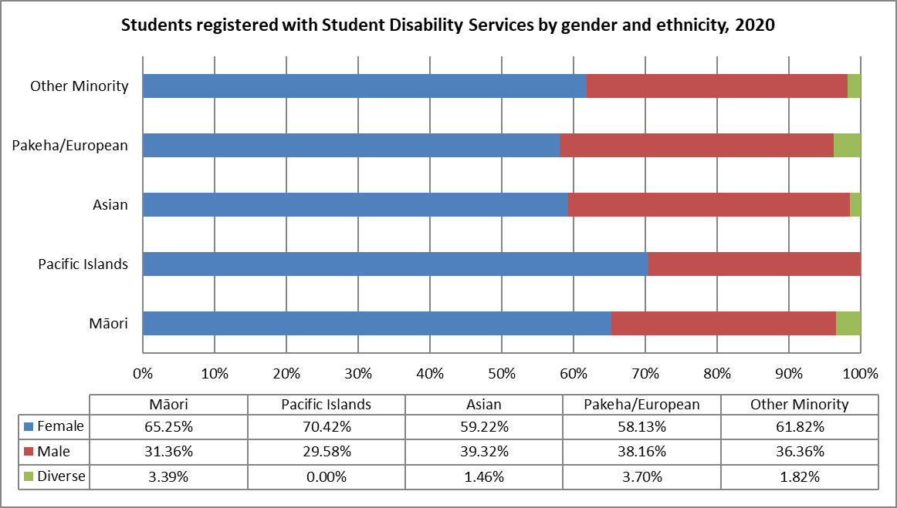

### 

### Where students are studying

The faculties of Arts and Science account for the largest proportion of students indicating at enrolment that they live with an impairment in 2020.

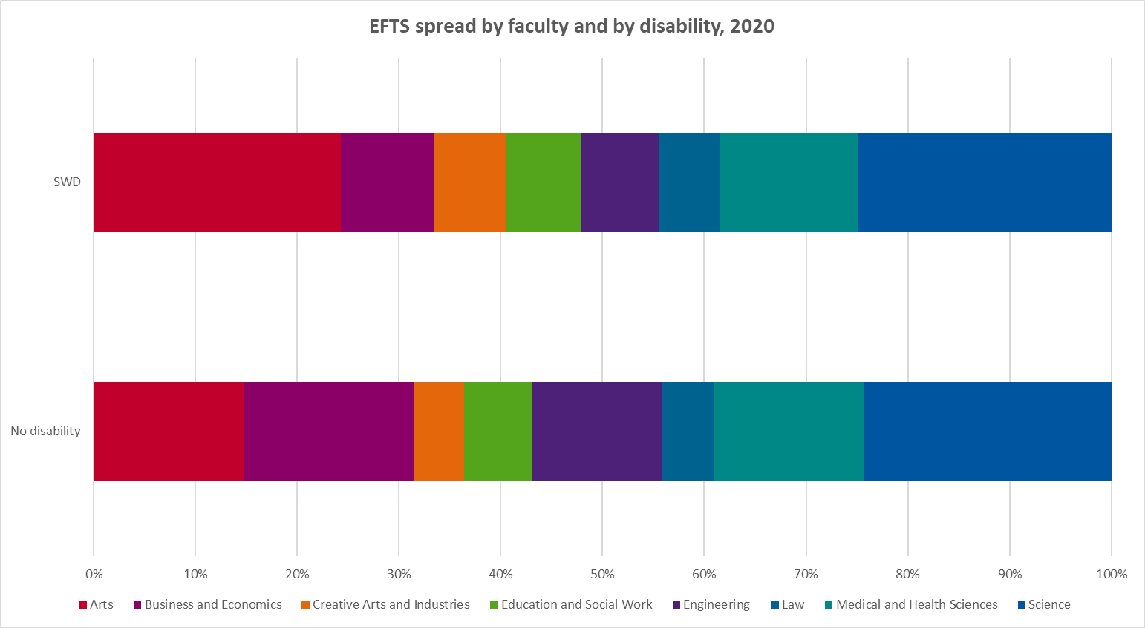

**Table 30: EFTS spread by faculty, SWD and overall, 2020**

|  |  |  |  |  |
| --- | --- | --- | --- | --- |
|  | SWD | | No Disability | |
| Faculty | EFTS | % of SWD | EFTS | % of EFTS |
| Arts | 414 | 24.3% | 4,674 | 14.7% |
| Business and Economics | 154 | 9.1% | 5,325 | 16.7% |
| Creative Arts and Industries | 122 | 7.2% | 1,584 | 5.0% |
| Education and Social Work | 125 | 7.3% | 2,111 | 6.6% |
| Engineering | 130 | 7.7% | 4,081 | 12.8% |
| Law | 103 | 6.0% | 1,597 | 5.0% |
| Medical and Health Sciences | 231 | 13.6% | 4,670 | 14.7% |
| Science | 423 | 24.9% | 7,754 | 24.4% |

Similarly, students in the faculties of Arts and Science (followed by the Faculties of Medical and Health Sciences, and Business & Economics) make up the largest proportions of students registered with SDS.

In 2020, the percentage of students registered with SDS in Education & Social Work continued to fall.

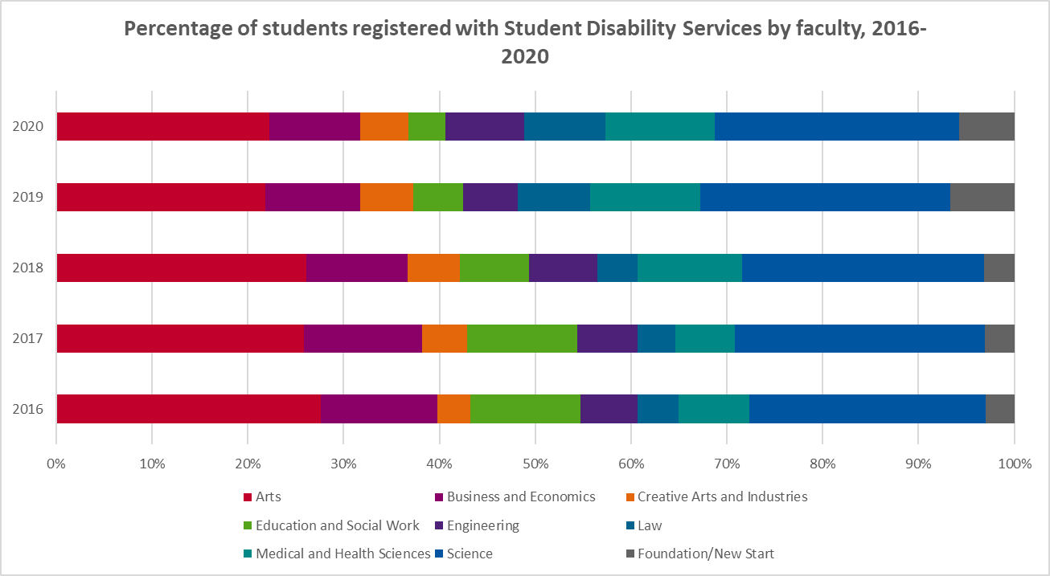

**Table 31: Percentage of students registered with SDS by faculty, 2016-2020**

|  |  |  |  |  |  |
| --- | --- | --- | --- | --- | --- |
| Faculty/Year | 2016 | 2017 | 2018 | 2019 | 2020 |
| Arts | 26.9 | 25.4 | 25.4 | 23.3 | 23.6 |
| Business and Economics | 11.9 | 12.1 | 10.3 | 10.5 | 10.1 |
| Creative Arts and Industries | 3.3 | 4.7 | 5.3 | 5.9 | 5.4 |
| Education and Social Work | 11.2 | 11.3 | 7.1 | 5.5 | 4.0 |
| Engineering | 5.8 | 6.2 | 7.0 | 6.1 | 8.8 |
| Law | 4.2 | 3.9 | 4.0 | 8.1 | 9.0 |
| Medical and Health Sciences | 7.2 | 6.0 | 10.7 | 12.3 | 12.1 |
| Science | 24.0 | 25.7 | 24.6 | 27.8 | 27.1 |
| Foundation/New Start | 2.9 | 3.0 | 3.0 | 7.1 | 6.1 |

### EFTS with disability by funding level[22]

The graph below shows the proportions of domestic EFTS with disability (SWD) compared to the same breakdown for domestic EFTS without a disability. The proportion of students with disability at postgraduate levels (both PG taught and research) is lower than the similar proportion for students without a disability.

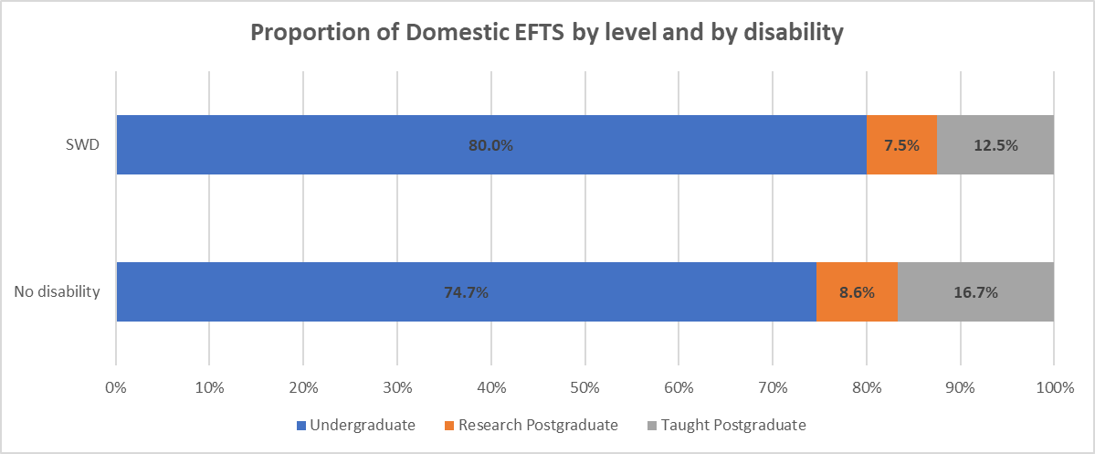

**Table 32: Domestic EFTS by funding level and disability, 2020**

|  |  |  |  |  |  |  |
| --- | --- | --- | --- | --- | --- | --- |
|  | Undergraduate | | Research Postgraduate | | Taught Postgraduate | |
|  | EFTS | % | EFTS | % | EFTS | % |
| SWD | 1,410 | 80.0% | 132 | 7.5% | 220 | 12.5% |
| No Disability | 24,260 | 74.7% | 2,806 | 8.6% | 5,419 | 16.7% |

Over 88% of students registered with SDS in 2020 were studying towards an undergraduate degree, while 12% were studying towards postgraduate programmes, including PhDs.

Student numbers registered with SDS from ‘non-formal’ programmes such as New Start and the Tertiary Foundation programmes remained high.

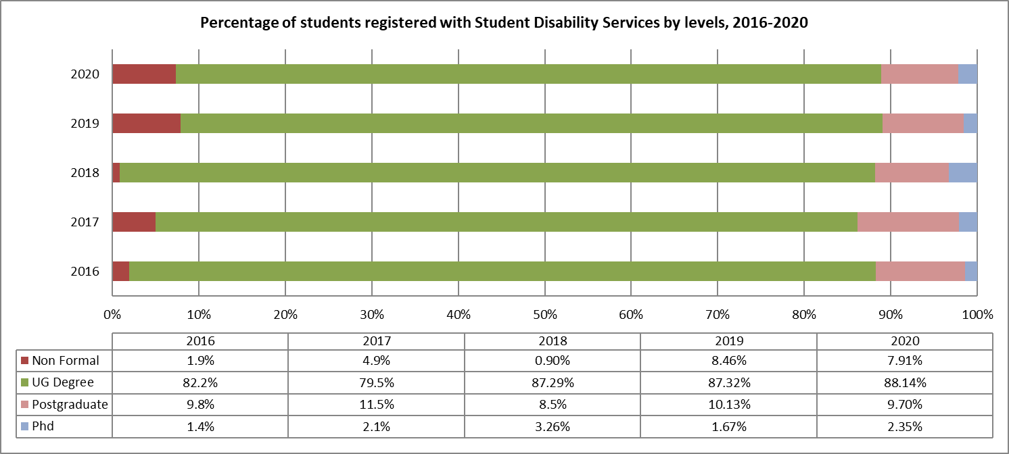

# Staff equity

## Key facts

This section describes the overall employment trends for Māori, Pacific, Asian, women and staff with disabilities. It also provides an age profile of staff at the University.

The grades that make up “academic staff” include professor, associate professor, senior lecturer, senior research fellow, research fellow, professional teaching fellow, senior tutor and assistant lecturer/graduate teaching assistant/teaching assistant as defined in Academic Collective Agreements.

* Māori academic FTE increased from 141.1 in 2019 to 149 FTE in 2020, and the proportion increased from 5.9% to 6.1%. The faculties of Arts, Creative Arts and Industries, Medical and Health Sciences and Science increased their proportion of Māori academic staff from 2019 to 2020.
* From 2019 to 2020, Pacific academic staff increased from 59.3 FTE to 64.9 FTE. The proportion of academic staff who are Pacific increased slightly from 2.5 in 2019 to 2.6 in 2020. The Faculties of Arts, Education and Social Work, Law and Medical and Health Sciences increased their proportion of Pacific academic staff from 2019 to 2020.
* Asian academic staff increased from 493.5 (20.6%) in 2019 to 528.3 FTE (21.6%) in 2020. Asian professional staff increased from 969.4 (30.1%) in 2019 to 994.1 (30.8%) in 2020.
* In 2020, 48.4% of academic staff were women, 51.4% were men and 0.2% gender diverse.
* The proportion of associate professors who are women was 38.7% (131.8 FTE) in 2019 and 39.1% (129.8 FTE) in 2020.
* The proportion of professors who are women was 30.5% (101.2 FTE) in 2019 and 31% (102.2 FTE) in 2020.
* The proportion of women in senior academic positions (associate professor and professor) reached 35%, a small increase from 34.4% in 2019.
* In 2020, 18 women (62% of the female applicants) and 19 men (57% of the male applicants) were promoted to associate professor.
* In 2020, 23 associate professors applied for promotion to professor (7 women and 16 men). Of those who applied, 5 of the women (71%) and 10 of the men (62%) were successful.
* 6.7% of professional staff were Māori in 2020 – unchanged from 2019.
* 6.7% of professional staff were Pacific in 2020, up from 6.4% in 2019.
* Women comprised around 63% of professional staff, a trend that has remained consistent in recent years.
* The percentage of senior women professional staff was 51.5%, slightly higher than 49.9% in 2019.
* In 2020,3.9% of staff reported they had a disability or impairment, with medical conditions being the most common, followed by mental health conditions then specific learning disorders.
* In 2020, 37.1% of academic staff and 27.7% of professional staff were 51 years of age and over.

## Ethnicity and equity

In 2020, the largest proportion of academic and professional staff were Pākehā/European.

**Table 33: Academic and professional staff by ethnicity 2020 (FTE and %)**

|  |  |  |  |  |
| --- | --- | --- | --- | --- |
| Ethnic Reporting Group | Academic | | Professional | |
| FTE | % | FTE | % |
| Asian | 528.3 | 21.6 | 994.1 | 30.8 |
| Māori | 149.0 | 6.1 | 216.0 | 6.7 |
| MELAA | 100.7 | 4.1 | 141.2 | 4.4 |
| Pacific | 64.9 | 2.6 | 217.6 | 6.7 |
| Pākehā/European | 1476.3 | 60.3 | 1551.9 | 48.1 |
| Other | 129.4 | 5.3 | 102.4 | 3.2 |
| Total | 2448.6 | 100.0 | 3223.1 | 100.0 |

*Source: SMR HR FTE – 5 Years*

### Māori staff

There was a total of 365 FTE (6.4%) Māori staff at the University in 2020.

*Source: 2015-2019 from SMR HR FTE – 5 Years*

**Table 34: Māori academic and professional staff FTE 2016-2020**

|  |  |  |  |  |  |
| --- | --- | --- | --- | --- | --- |
|  | 2016 | 2017 | 2018 | 2019 | 2020 |
| Māori academic | 134.5 | 134.6 | 138.0 | 141.1 | 149.0 |
| Māori professional | 227.5 | 227.9 | 227.9 | 215.3 | 216.0 |

*Source: 2015-2019 from SMR HR FTE – 5 Years*

### Māori academic staff

The Faculty of Education and Social Work had the highest percentage of Māori academic staff in 2020.

*Source: SMR HR FTE – 5 Years*

**Table 35: Māori academic staff in faculties 2016-2020 (FTE and %)**

|  |  |  |  |  |  |  |  |  |  |  |
| --- | --- | --- | --- | --- | --- | --- | --- | --- | --- | --- |
| Faculty | 2016 | | 2017 | | 2018 | | 2019 | | 2020 | |
| FTE | % | FTE | % | FTE | % | FTE | % | FTE | % |
| Arts | 19.0 | 7.9 | 17.5 | 7.9 | 18.0 | 8.0 | 19.4 | 8.1 | 22.0 | 8.4 |
| B&E | 8.0 | 3.5 | 9.6 | 4.0 | 10.3 | 4.2 | 7.8 | 3.2 | 6.9 | 2.7 |
| CAI | 7.7 | 7.0 | 6.7 | 6.3 | 7.8 | 7.2 | 8.1 | 7.4 | 9.8 | 8.9 |
| EDSW | 26.6 | 14.0 | 26.6 | 14.1 | 25.0 | 13.8 | 23.6 | 14.4 | 20.9 | 13.7 |
| Engineering | 3.1 | 1.6 | 2.7 | 1.3 | 3.6 | 1.7 | 5.5 | 2.5 | 5.7 | 2.5 |
| Law | 4.6 | 9.5 | 5.2 | 10.0 | 7.5 | 13.0 | 7.0 | 12.9 | 6.7 | 12.2 |
| MHS | 35.5 | 6.5 | 37.1 | 6.7 | 34.3 | 5.7 | 36.2 | 5.8 | 38.6 | 6.1 |
| Science | 24.0 | 4.8 | 23.3 | 4.5 | 23.4 | 4.4 | 25.0 | 4.6 | 30.9 | 5.4 |

*Source: SMR HR FTE (Equity)-5 years*

### Māori professional staff

For 2020, the highest percentages of Māori professional staff in faculties were in the Faculty of Arts and the Faculty of Education and Social Work.

*Source: SMR HR FTE – 5 Years*

**Table 36: Māori professional staff in faculties 2016-2020 (FTE and %)**

|  |  |  |  |  |  |  |  |  |  |  |
| --- | --- | --- | --- | --- | --- | --- | --- | --- | --- | --- |
| Faculty | 2016 | | 2017 | | 2018 | | 2019 | | 2020 | |
| FTE | % | FTE | % | FTE | % | FTE | % | FTE | % |
| Arts | 15.1 | 15.2 | 16.1 | 15.4 | 15.2 | 13.1 | 15.6 | 13.8 | 17.8 | 15.8 |
| B&E | 8.9 | 6.4 | 8.1 | 5.7 | 8.6 | 6.0 | 10.4 | 8.0 | 10.4 | 8.6 |
| CAI | 3.9 | 6.6 | 3.6 | 6.0 | 2.0 | 3.2 | 1.3 | 2.1 | 0.7 | 1.2 |
| EDSW | 13.9 | 11.8 | 15.3 | 12.5 | 15.7 | 12.6 | 13.9 | 13.3 | 12.8 | 15.0 |
| Engineering | 7.9 | 4.8 | 7.6 | 4.4 | 8.3 | 4.3 | 7.5 | 3.9 | 8.4 | 4.3 |
| Law | 3.6 | 14.9 | 3.4 | 11.6 | 2.9 | 10.1 | 2.5 | 8.7 | 2.8 | 9.2 |
| MHS | 27.8 | 6.6 | 28.9 | 6.7 | 32.5 | 7.1 | 33.1 | 7.3 | 29.7 | 6.9 |
| Science | 9.8 | 3.3 | 11.1 | 3.7 | 13.0 | 4.0 | 13.4 | 4.1 | 12.4 | 4.0 |

*Source: SMR HR FTE – 5 Years*

Of the Māori professional staff working in the University’s largest service divisions, the highest percentage were employed in the Libraries and Learning Services in 2020. Campus Life employed the next largest number of Māori professional staff.

*Source: SMR HR FTE – 5 Years*

**Table 37: Māori professional staff in service divisions 2016-2020 (FTE and %)**

|  |  |  |  |  |  |  |  |  |  |  |
| --- | --- | --- | --- | --- | --- | --- | --- | --- | --- | --- |
| Faculty | 2016 | | 2017 | | 2018 | | 2019 | | 2020 | |
| FTE | % | FTE | % | FTE | % | FTE | % | FTE | % |
| Academic Services | 3.8 | 3.2 | 5.7 | 4.5 | 7.4 | 5.8 | 6.9 | 5.2 | 10.3 | 7.4 |
| Campus Life | 28.0 | 12.4 | 33.9 | 14.8 | 34.3 | 14.5 | 33.6 | 13.5 | 30.0 | 11.9 |
| Finance | 1.0 | 1.5 | 1.0 | 1.4 | 2.8 | 2.7 | 3.2 | 2.3 | 3.9 | 2.0 |
| Human Resources | 3.0 | 3.8 | 3.0 | 3.5 | 3.3 | 3.7 | 3.1 | 3.4 | 3.7 | 4.0 |
| Digital Services | 7.2 | 2.7 | 4.3 | 1.6 | 4.0 | 1.7 | 6.4 | 2.4 | 8.5 | 2.4 |
| Library | 24.0 | 9.4 | 21.8 | 8.9 | 9.1 | 7.5 | 24.5 | 11.9 | 22.6 | 12.0 |
| Property Services | 7.9 | 5.5 | 7.5 | 5.2 | 5.8 | 4.2 | 6.2 | 4.7 | 7.2 | 5.7 |

*Source: SMR HR FTE – 5 Years*

### Pacific staff

There were 289.9 FTE (5.1%) Pacific staff at the University in 2020.

*Source: SMR HR FTE – 5 Years*

**Table 38: Pacific academic and professional staff FTE 2016-2020**

|  |  |  |  |  |  |
| --- | --- | --- | --- | --- | --- |
|  | 2016 | 2017 | 2018 | 2019 | 2020 |
| Pacific academic | 53.7 | 58.9 | 63.0 | 59.3 | 64.9 |
| Pacific professional | 185.2 | 191.9 | 204.9 | 214.5 | 225.0 |

*Source: SMR HR FTE – 5 Years*

### Pacific academic staff

The highest faculty FTE percentage of Pacific academic staff in 2020 was in Education and Social Work, followed by the Faculty of Arts. The faculties of Arts, Creative Arts and Industries, Education and Social Work, Law and Science have increased their percentage of Pacific academic staff compared with 2016 figures.

*Source: SMR HR FTE – 5 Years*

**Table 39: Pacific academic staff in faculties 2016-2020 (FTE and %)**

|  |  |  |  |  |  |  |  |  |  |  |
| --- | --- | --- | --- | --- | --- | --- | --- | --- | --- | --- |
| Faculty | 2016 | | 2017 | | 2018 | | 2019 | | 2020 | |
| FTE | % | FTE | % | FTE | % | FTE | % | FTE | % |
| Arts | 10.6 | 4.0 | 12.1 | 4.9 | 13.2 | 5.3 | 12.9 | 5.1 | 15.1 | 5.7 |
| B&E | 4.4 | 1.9 | 5.8 | 2.4 | 5.3 | 2.1 | 4.2 | 1.7 | 4.1 | 1.6 |
| CAI | 1.8 | 1.6 | 2.4 | 2.3 | 2.5 | 2.3 | 2.6 | 2.4 | 2.7 | 2.4 |
| EDSW | 8.2 | 4.3 | 10.0 | 5.3 | 11.6 | 6.4 | 10.0 | 6.1 | 9.5 | 6.2 |
| Engineering | 1.2 | 0.6 | 1.0 | 0.5 | 1.0 | 0.5 | 1.0 | 0.5 | 1.2 | 0.5 |
| Law | 1.1 | 2.2 | 2.1 | 4.1 | 2.2 | 3.7 | 1.2 | 2.2 | 1.9 | 3.4 |
| MHS | 17.2 | 3.2 | 14.7 | 2.7 | 15.6 | 2.6 | 13.3 | 2.1 | 14.3 | 2.3 |
| Science | 5.2 | 1.0 | 6.3 | 1.2 | 6.7 | 1.3 | 7.0 | 1.3 | 7.4 | 1.3 |

*Source: SMR HR FTE – 5 Years*

### Pacific professional staff

In 2020, the Faculty of Law had the highest percentage of Pacific professional staff.

*Source: SMR HR FTE – 5 Years*

**Table 40: Pacific professional staff in faculties 2016-2020 (FTE and %)**

|  |  |  |  |  |  |  |  |  |  |  |
| --- | --- | --- | --- | --- | --- | --- | --- | --- | --- | --- |
| Faculty | 2016 | | 2017 | | 2018 | | 2019 | | 2020 | |
| FTE | % | FTE | % | FTE | % | FTE | % | FTE | % |
| Arts | 7.4 | 5.7 | 10.2 | 8.0 | 10.4 | 7.3 | 5.9 | 5.7 | 8.3 | 7.3 |
| B&E | 10.2 | 7.4 | 11.8 | 8.3 | 11.0 | 7.8 | 10.9 | 8.4 | 9.0 | 7.4 |
| CAI | 4.0 | 7.1 | 4.0 | 6.8 | 5.9 | 9.3 | 4.8 | 8.1 | 4.9 | 8.6 |
| EDSW | 7.7 | 6.6 | 7.8 | 6.3 | 7.3 | 5.9 | 9.4 | 7.4 | 9.8 | 10.4 |
| Engineering | 4.4 | 2.7 | 4.1 | 2.3 | 6.4 | 3.3 | 6.1 | 3.2 | 6.6 | 3.4 |
| Law | 3.5 | 14.3 | 3.3 | 11.4 | 4.0 | 13.9 | 4.2 | 14.6 | 4.1 | 13.5 |
| MHS | 17.4 | 4.2 | 21.5 | 5.0 | 27.1 | 6.0 | 29.5 | 6.5 | 31.3 | 6.9 |
| Science | 12.6 | 4.2 | 12.5 | 4.2 | 12.9 | 4.0 | 12.3 | 3.7 | 11.6 | 3.8 |

*Source: SMR HR FTE – 5 Years*

Of the University’s largest service divisions, Academic Services had the largest percentage of Pacific professional staff in 2020.

*Source: SMR HR FTE – 5 Years*

**Table 41: Pacific professional staff in service divisions 2016-2020 (FTE and %)**

|  |  |  |  |  |  |  |  |  |  |  |
| --- | --- | --- | --- | --- | --- | --- | --- | --- | --- | --- |
| Faculty | 2016 | | 2017 | | 2018 | | 2019 | | 2020 | |
| FTE | % | FTE | % | FTE | % | FTE | % | FTE | % |
| Academic Services | 17.3 | 14.4 | 17.7 | 13.9 | 21.0 | 16.4 | 24.8 | 18.7 | 22.8 | 16.4 |
| Campus Life | 18.8 | 8.4 | 19.0 | 8.3 | 20.3 | 8.6 | 21.1 | 8.3 | 23.2 | 9.1 |
| Finance | 13.3 | 13.1 | 12.6 | 8.8 | 12.0 | 7.5 | 11.9 | 6.1 | 12.4 | 6.4 |
| Human Resources | 4.0 | 5.1 | 3.5 | 4.0 | 3.9 | 4.4 | 4.1 | 4.4 | 5.5 | 5.9 |
| Digital Services | 7.8 | 2.6 | 8.5 | 2.8 | 8.4 | 3.0 | 13.4 | 3.8 | 14.2 | 3.9 |
| Library | 13.7 | 5.4 | 14.0 | 5.7 | 13.2 | 5.8 | 10.7 | 5.2 | 12.8 | 6.7 |
| Property Services | 14.8 | 10.4 | 14.9 | 10.4 | 13.7 | 9.9 | 16.3 | 12.3 | 16.8 | 13.1 |

*Source: SMR HR FTE – 5 Years*

### Asian staff

Ethnic identity is determined by self-identification. “Asian” covers a wide range of ethnicities including Chinese, Korean and Indian.

There was a total of 1572.8 (27.7%) Asian staff at the University in 2020.[23]

**Table 42: Asian academic and professional staff FTE 2016-2020**

|  |  |  |  |  |  |
| --- | --- | --- | --- | --- | --- |
|  | 2016 | 2017 | 2018 | 2019 | 2020 |
| Asian academic | 373.5 | 397.6 | 451.8 | 494.2 | 529.1 |
| Asian professional | 801.3 | 879.6 | 942.7 | 1018.3 | 1043.7 |

*Source: SMR HR FTE – 5 Years*

### MELAA staff

“MELAA” includes Middle Eastern, Latin American and African ethnic groups.

There was a total of 251.8 FTE (4.4%) MELAA staff at the University in 2020.[24]

**Table 43: MELAA academic and professional staff FTE 2016-2020**

|  |  |  |  |  |  |
| --- | --- | --- | --- | --- | --- |
|  | 2016 | 2017 | 2018 | 2019 | 2020 |
| MELAA academic | 56.2 | 62.2 | 79.6 | 86.5 | 100.7 |
| MELAA professional | 78.7 | 96.5 | 116.7 | 138.5 | 151.1 |

*Source: SMR HR FTE – 5 Years*

## Gender

### Women academic staff

In 2020, 1187.3 FTE (48.4%) out of 2451.9 FTE of academics were women, and 1260 FTE (51.4%) were men. 4.3 FTE (0.2%) identified as diverse.

The numbers of women and men at lecturer level in 2020 were 94.7 FTE (51.2%) and 90.1 FTE (48.8%) respectively, followed by decreasing proportions of women in the Associate Professor and Professor grades.

Currently, the greatest numbers of both female and male academics are at senior lecturer grade. This is important for enlarging the pool of eligible applicants to associate professor and professor, as internal promotions will usually be from the senior lecturer grade.

*Source: SMR HR FTE – 5 Years*

**Table 44: Academic staff by rank and gender 2020**

|  |  |  |  |  |  |  |  |  |  |
| --- | --- | --- | --- | --- | --- | --- | --- | --- | --- |
| Grade | Female | | Male | | Diverse | | Not provided | | Total |
| FTE | % | FTE | % | FTE | % | FTE | % |  |
| Professor | 102.2 | 31.0 | 227.6 | 69.0 |  |  |  |  | **329.6** |
| Associate Professor | 129.8 | 39.1 | 201.6 | 60.6 | 1.0 | 0.30 |  |  | **332.5** |
| Senior Lecturer | 257.9 | 48.7 | 271.5 | 51.3 | 1.0 | 0.19 |  |  | **529.4** |
| Senior Research Fellow | 49.2 | 48.3 | 52.6 | 51.7 |  |  |  |  | **101.8** |
| Lecturer | 94.7 | 51.2 | 90.1 | 48.8 |  |  |  |  | **184.8** |
| Research Fellow | 217.3 | 56.3 | 167.3 | 43.4 | 1.1 | 0.3 |  |  | **385.7** |
| Senior Tutor | 22.6 | 65.5 | 11.9 | 34.5 |  |  |  |  | **34.5** |
| Professional Teaching Fellow | 187.5 | 61.3 | 118.4 | 38.7 |  |  |  |  | **305.9** |
| AL/GTA/TA | 65.5 | 51.8 | 59.5 | 47.1 | 1.3 | 1.0 | 0.1 | 0.1 | **126.4** |
| Academic Other | 60.6 | 50.0 | 59.6 | 49.2 | 0.9 | 0.7 | 0.2 | 0.1 | **121.3** |
| Total | **1187.3** | **48.4** | **1260.0** | **51.4** | **4.3** | **0.2** | **0.3** | **0.0** | **2451.9** |

*Source: SMR HR FTE – 5 Years*

*Source: SMR HR FTE – 5 Years*

Women academic staff in Science, Technology, Engineering, Mathematics and Medicine (STEMM)

In Science, women academics are under-represented (<30% at Professor level) in the Departments of Computer Science, Environment, Mathematics and Physics.

**Table 45: Women academic staff in Science by rank 2020 (FTE, %)**

|  |  |  |  |  |  |  |  |  |  |  |  |  |  |  |  |  |  |  |  |  |
| --- | --- | --- | --- | --- | --- | --- | --- | --- | --- | --- | --- | --- | --- | --- | --- | --- | --- | --- | --- | --- |
| Grade | Biological Sciences | | Computer Science | | Environment | | | Chemical Sciences | | Mathematics | | | | Physics | | | Psychology | | Statistics | |
| Female | | Female | | Female | | | Female | | Female | | | | Female | | | Female | | Female | |
| FTE | % | FTE | % | FTE | | % | FTE | % | FTE | | % | | FTE | | % | FTE | % | FTE | % |
| Professor | 5.3 | 40.9 | 1.0 | 12.9 | 1.5 | | 18.8 | 3.2 | 36.3 | 1.0 | | 8.5 | | 0.1 | | 1.1 | 7.0 | 58.0 | 2.1 | 45.3 |
| Associate Professor | 4.8 | 29.2 | 0.1 | 1.0 | 4.1 | | 27.9 | 0.1 | 1.9 | 3.2 | | 45.0 | | 1.7 | | 16.2 | 6.9 | 58.4 | 1.0 | 17.2 |
| Senior Lecturer | 9.7 | 42.2 | 5.0 | 22.1 | 8.1 | | 53.2 | 3.0 | 36.1 |  | |  | | 1.0 | | 17.9 | 10.9 | 99.2 | 5.0 | 41.3 |
| Senior Research Fellow | 4.0 | 74.1 | 0.0 | 5.1 |  | |  | 1.7 | 35.3 |  | |  | | 1.0 | | 37.9 | 0.4 | 27.7 | 0.6 | 43.9 |
| Lecturer | 1.6 | 100.0 | 2.4 | 37.8 | 3.0 | | 48.3 | 0.8 | 44.4 | 2.4 | | 33.5 | | 1.0 | | 74.0 | 1.6 | 23.8 | 5.5 | 58.0 |
| Research Fellow | 21.8 | 69.0 | 0.2 | 4.3 | 1.9 | | 60.8 | 5.5 | 39.9 | 0.6 | | 17.6 | | 7.8 | | 40.5 | 2.9 | 79.6 |  |  |
| Senior Tutor | 1.0 | 100.0 | 0.7 | 39.6 | 1.1 | | 52.0 | 0.3 | 23.1 |  | |  | |  | |  | 2.8 | 100.0 | 0.8 | 100.0 |
| Professional Teaching Fellow | 5.9 | 90.4 | 6.0 | 52.3 | 1.1 | | 24.6 | 2.0 | 39.5 | 2.2 | | 37.7 | | 1.0 | | 33.1 | 7.6 | 97.4 | 5.5 | 59.1 |
| AL/GTA/TA | 3.7 | 67.8 | 2.7 | 23.5 | 3.0 | 52.6 | | 2.4 | 44.8 | | 1.2 | | 35.7 | 0.7 | 23.0 | | 4.5 | 74.3 | 3.7 | 48.6 |
| Academic Other | 1.3 | 83.9 | 0.3 | 51.0 | 1.1 | 57.9 | | 0.1 | 10.2 | | 0.3 | | 51.0 | 0.2 | 43.3 | | 0.9 | 52.0 | 0.1 | 22.5 |
| **Total** | **59.0** | **56.0** | **18.3** | **25.3** | **24.8** | **40.6** | | **19.1** | **33.9** | | **11.0** | | **26.5** | **14.6** | **28.1** | | **45.5** | **70.0** | **24.3** | **47.2** |

*Source: SMR HR FTE – 5 Years*

Women are under-represented in Engineering, particularly in the higher position ranks

**Table 46: Women academic staff in Engineering by rank 2020**

|  |  |  |
| --- | --- | --- |
| Grade | Female | |
| FTE | % |
| Professor | 1.5 | 4.9 |
| Associate Professor | 1.9 | 6.0 |
| Senior Lecturer | 8.7 | 14.9 |
| Senior Research Fellow | 0.3 | 8.9 |
| Lecturer | 6.0 | 25.1 |
| Research Fellow | 6.1 | 26.7 |
| Senior Tutor | 1.0 | 100.0 |
| Professional Teaching Fellow | 5.7 | 20.7 |
| AL/GTA/TA | 6.1 | 29.1 |
| Academic Other | 1.5 | 17.6 |
| Total | **38.8** | **16.9** |

*Source: SMR HR FTE – 5 Years*

Women are under-represented at Professor level in Medical and Health Sciences, Particularly in the departments of Medical Sciences and Optometry and Vision Science. Men are under-represented in general in Nursing and Pharmacy.

**Table 47: Women academic staff breakdown in Medical and Health Sciences departments by rank 2020**

|  |  |  |  |  |  |  |  |  |  |  |  |  |
| --- | --- | --- | --- | --- | --- | --- | --- | --- | --- | --- | --- | --- |
| Grade | Medical Sciences | | Nursing | | Optometry and Vision Science | | Pharmacy | | Population Health | | School of Medicine | |
| Female | | Female | | Female | | Female | | Female | | Female | |
| FTE | % | FTE | % | FTE | % | FTE | % | FTE | % | FTE | % |
| Professor | 3.8 | 20.0 | 2.1 | 66.9 | 0.1 | 8.6 | 0.5 | 84.2 | 4.3 | 32.6 | 8.8 | 36.6 |
| Associate Professor | 7.3 | 35.4 | 2.8 | 74.5 | 0.5 | 31.3 | 3.0 | 43.0 | 7.8 | 48.0 | 6.0 | 33.0 |
| Senior Lecturer | 13.9 | 56.0 | 10.6 | 91.4 | 2.0 | 29.2 | 5.8 | 76.0 | 11.0 | 57.6 | 19.5 | 66.1 |
| Senior Research Fellow | 11.4 | 51.6 | 1.3 | 97.4 | 0.0 | 0.0 | 1.1 | 100.0 | 8.1 | 73.1 | 6.5 | 82.0 |
| Lecturer | 2.6 | 72.1 | 3.6 | 87.7 | 0.9 | 79.1 | 0.1 | 3.4 | 3.0 | 66.0 | 1.8 | 89.6 |
| Research Fellow | 50.2 | 64.4 | 6.9 | 98.5 | 1.0 | 100.00 | 1.0 | 30.6 | 16.1 | 86.1 | 33.1 | 65.9 |
| Senior Tutor | 1.4 | 31.9 | 0.0 | 0.0 |  |  | 0.3 | 100.0 | 0.5 | 100.0 | 1.0 | 97.9 |
| Professional Teaching Fellow | 13.4 | 79.6 | 21.5 | 92.3 | 9.2 | 81.4 | 8.5 | 96.4 | 6.9 | 60.0 | 4.4 | 64.7 |
| AL/GTA/TA | 4.2 | 54.3 | 2.0 | 87.7 | 0.5 | 95.3 | 0.4 | 81.9 | 2.3 | 66.6 | 1.9 | 70.5 |
| Academic Other | 1.2 | 46.3 | 0.6 | 85.3 | 0.3 | 88.4 | 0.4 | 88.4 | 2.4 | 82.8 | 1.1 | 42.3 |
| Total | **109.4** | **54.8** | **51.3** | **89.9** | **14.4** | **57.3** | **20.9** | **66.1** | **62.2** | **61.7** | **84.1** | **58.1** |

*Source: SMR HR FTE – 5 Years*

### Senior women academic staff

Senior academic data combines associate professors and professors. The proportion of associate professors who are women has increased substantially from 27.7% (68.2 FTE) in 2010 to 39.1% (129.8 FTE) in 2020. The proportion of professors who are women increased from 20% (44.16 FTE) in 2010 to 31% (102.2 FTE) in 2020. In 2010, 23.5% (112.4 FTE) of senior academics were women and in 2020 this increased to 35% (231 FTE).

Between 2010 and 2020 there has been an increase in women senior academics of 118.6 FTE.

*Source: SMR Staff Equity – 5 Years*

**Table 48: Senior and all academic staff by gender 2010, 2019 and 2020**

|  |  |  |  |  |  |  |  |  |  |  |  |  |
| --- | --- | --- | --- | --- | --- | --- | --- | --- | --- | --- | --- | --- |
| Gender | 2010 | | | | 2019 | | | | 2020 | | | |
| All | | Senior | | All | | Senior | | All | | Senior | |
|  | FTE | % | FTE | % | FTE | % | FTE | % | FTE | % | FTE | % |
| Female | 905.3 | 44.7 | 112.4 | 23.5 | 1150.3 | 47.9 | 224.7 | 34.4 | 1187 | 48.4 | 231.0 | 35.0 |
| Male | 1122.1 | 55.3 | 366.5 | 76.5 | 1249.1 | 52.0 | 427.6 | 65.6 | 1259 | 51.4 | 428.2 | 64.9 |
| Diverse |  |  |  |  | 3.4 | 0.1 |  |  | 4.3 | 0.2 | 0.9 | 0.1 |

*Source: SMR Staff Equity – 5 Years*

The percentage of women academic staff outnumbered men in the faculties of Arts, Education and Social Work, Law, and Medical and Health Sciences.

*Source: SMR HR FTE – 5 Years*

**Table 49: Academics in faculties by gender 2020**

|  |  |  |  |  |  |  |  |  |
| --- | --- | --- | --- | --- | --- | --- | --- | --- |
| Faculty | Female | | Male | | Diverse | | Not provided | |
| FTE | % | FTE | % | FTE | % | FTE | % |
| Arts | 150. | 57.1 | 112.0 | 42.6 | 0.8 | 0.3 |  |  |
| B&E | 116.5 | 45.8 | 137.7 | 54.1 |  |  | 0.1 | 0.1 |
| CAI | 47.2 | 43.1 | 62.2 | 56.8 | 0.0 | 0.0[25] | 0.0 | 0.0 |
| EDSW | 111.4 | 72.8 | 41.4 | 27.1 | 0.2 | 0.1 | 0.0 | 0.0 |
| Engineering | 38.8 | 16.9 | 190.1 | 83.0 | 0.1 | 0.0[26] |  |  |
| Law | 28.8 | 52.5 | 26.0 | 47.4 | 0.0 | 0.0[27] |  |  |
| MHS | 378.7 | 60.1 | 250.5 | 39.7 | 1.1 | 0.2 | 0.0 | 0.0 |
| Science | 236.5 | 41.6 | 330.1 | 58.0 | 2.1 | 0.4 |  |  |

*Source: SMR Staff Equity – 5 Years*

Women academic staff held the most senior positions in the Faculty of Education and Social Work.

*Source: SMR HR FTE – 5 Years*

**Table 50: Senior academics in faculties by gender 2020**

|  |  |  |  |  |
| --- | --- | --- | --- | --- |
| Faculty | Female | | Male | |
| FTE | % | FTE | % |
| Arts | 43.2 | 48.9 | 45.2 | 51.1 |
| B&E | 22.9 | 35.4 | 41.8 | 64.6 |
| CAI | 10.6 | 40.1 | 15.8 | 59.9 |
| EDSW | 27.5 | 63.4 | 15.9 | 36.6 |
| Engineering | 3.2 | 5.1 | 59.9 | 94.9 |
| Law | 11.9 | 45.7 | 14.2 | 54.3 |
| MHS | 53.6 | 35.3 | 98.1 | 64.7 |
| Science | 48.0 | 29.4 | 114.5 | 70.1 |

*Source: SMR HR FTE – 5 Years*

### Promotions success by gender - associate professor[28]

Increasing the numbers of women associate professors and professors is essential for gender equity.

Staff are entitled to apply for promotion to associate professor from any grade which makes it difficult to identify an “eligible” group but typically they will be in the top two steps of the senior lecturer grade (grades 7 and 8). The number of applications from women has been between 18 and 29 and applications from men have fluctuated from 28 to 42 over the last five years.

In the last five years an average of 24 women have applied for promotion to AP compared with 34 men, and 63% of women and 59% of male applicants were successful. A higher number of women applied in 2020 than in the previous three years.

**Table 51: Applicants and success rates for promotion to Associate Professor by gender 2016-2020**

|  |  |  |  |  |  |  |  |  |  |  |  |
| --- | --- | --- | --- | --- | --- | --- | --- | --- | --- | --- | --- |
|  | 2016 | | 2017 | | 2018 | | 2019 | | | 2020 | |
| F | M | F | M | F | M | F | M | D | F | M |
| Number of applicants | 29 | 28 | 25 | 33 | 18 | 42 | 20 | 36 | 1 | 29 | 33 |
| As % of total applicants | 50 | 50 | 43 | 57 | 30 | 70 | 35 | 63 | 2 | 47 | 53 |
| Number of successful applicants | 18 | 21 | 18 | 23 | 9 | 20 | 14 | 16 | 1 | 18 | 19 |
| Success as % of applicants by gender | 62 | 75 | 72 | 70 | 50 | 48 | 70 | 44 | 100 | 62 | 57 |

### Promotions success by gender - professor

Women’s applications have fluctuated from seven to 19 and men’s from ten to 18 over the last five years. Women have averaged a 68% success rate and men 62%.

In 2018 there was an unusual application and success pattern with the same number of male and female applicants to professor, but women having a higher success rate.

In 2020 the number of women applicants (seven) was the lowest in the last five years.

**Table 52: Applicants and success rates for promotion to Professor by gender 2016-2020[29]**

|  |  |  |  |  |  |  |  |  |  |  |  |
| --- | --- | --- | --- | --- | --- | --- | --- | --- | --- | --- | --- |
|  | 2016 | | | 2017 | | 2018 | | 2019 | | 2020 | |
| F | M | F | | M | F | M | F | M | F | M |
| Applicants | 19 | 10 | 9 | | 16 | 13 | 13 | 11 | 18 | 7 | 16 |
| Progressed | 16 | 7 | 6 | | 12 | 9 | 6 | 7 | 14 | 5 | 10 |
| Success % of gender | 13 | 7 | 6 | | 12 | 9 | 5 | 7 | 12 | 5 | 10 |
| 68% | 70% | 67% | | 75% | 70% | 39% | 64% | 66% | 71% | 62% |

### Women professional staff

Women were in the majority among professional staff, although underrepresented in the Faculty of Engineering, and in Property Services and Digital Services.

Unlike academic staff, who have a clear progression from lecturer to professor, professional staff do not have incremental step increases or a “promotions” process of regular opportunities for application to higher grades.[30]

*Source: SMR HR FTE – 5 Years*

**Table 53: Professional staff by grade and gender 2020 (FTE and %)**

|  |  |  |  |  |  |  |  |  |  |
| --- | --- | --- | --- | --- | --- | --- | --- | --- | --- |
| Grade | Female | | Male | | Diverse | | Not provided | | Total |
| FTE | % | FTE | % | FTE | % | FTE | % |
| Professional Staff - Level 1 | 89.7 | 56.9 | 67.5 | 42.9 | 0.3 | 0.2 | 0.0 | 0.0 | **157.5** |
| Professional Staff - Level 2 | 184.8 | 74.2 | 63.7 | 25.6 | 0.4 | 0.2 | 0.0 | 0.0 | **248.9** |
| Professional Staff - Level 3 | 185.7 | 71.5 | 73.0 | 28.1 | 1.0 | 0.4 | 0.0 | 0.0 | **259.7** |
| Professional Staff - Level 4 | 590.6 | 71.3 | 236.4 | 28.5 | 1.4 | 0.2 | 0.0 | 0.0 | **828.4** |
| Professional Staff - Level 5 | 358.0 | 62.9 | 207.3 | 36.4 | 4.1 | 0.7 | 0.0 | 0.0 | **56.9.3** |
| Professional Staff - Level 6 | 263.8 | 58.9 | 184.2 | 41.1 |  |  |  |  | **448.0** |
| Senior Professional Staff Over L6 | 313.7 | 51.5 | 293.8 | 48.3 | 1.0 | 0.2 | 0.0[31] | 0.0 | **608.5** |
| Other grades | 54.6 | 53.1 | 47.8 | 46.5 | 0.3 | 0.3 | 0.1 | 0.1 | **102.8** |
| Total | **2040.8** | **63.3** | **1173.8** | **36.4** | **8.4** | **0.3** | **0.1** | **0.0** | **3223.1** |

*Source: SMR HR FTE – 5 Years*

### Professional staff by gender in faculties and service divisions

The majority of professional staff in faculties are women - apart from the Faculty of Engineering. Similarly, the majority of professional staff in all major service divisions are generally women, apart from in Property Services and Digital Services.

**Table 54: Professional female staff FTE by faculty and level 2020 (FTE and %)**

|  |  |  |  |  |  |  |  |  |  |  |  |  |  |  |  |  |  |  |  |  |  |  |  |  |  |
| --- | --- | --- | --- | --- | --- | --- | --- | --- | --- | --- | --- | --- | --- | --- | --- | --- | --- | --- | --- | --- | --- | --- | --- | --- | --- |
| Grade | Arts | | | | B&E | | | | CAI | | | | EDSW | | Engineering | | Law | | | MHS | | Science | | | |
| Female | | | | Female | | | | Female | | | | Female | | Female | | Female | | | Female | | Female | | | |
| FTE | | % | | FTE | | % | | FTE | | % | | FTE | % | FTE | % | FTE | % | | FTE | % | FTE | | % |
| Level 1 | 3.7 | | 86.0 | | 4.5 | | 72.8 | | 0.7 | | 63.2 | | 2.8 | 77.0 | 4.2 | 36.8 | 1.7 | 63.5 | | 6.3 | 81.0 | 7.3 | | 61.1 |
| Level 2 | 12.6 | | 83.0 | | 12.2 | | 92.8 | | 4.4 | | 94.5 | | 9.8 | 89.5 | 5.4 | 35.9 | 0.4 | 100.0 | | 28.7 | 81.0 | 15.0 | | 81.8 |
| Level 3 | 9.3 | | 84.1 | | 5.6 | | 54.3 | | 1.7 | | 58.2 | | 3.7 | 82.4 | 4.7 | 58.9 | 2.3 | 100.0 | | 17.0 | 74.1 | 17.8 | | 78.5 |
| Level 4 | 34.8 | | 82.1 | | 27.9 | | 83.8 | | 20.6 | | 70.7 | | 27.2 | 83.4 | 34.6 | 63.4 | 13.8 | 98.6 | | 171.6 | 75.9 | 85.8 | | 70.7 |
| Level 5 | 10.8 | | 61.3 | | 20.6 | | 90.6 | | 3.5 | | 46.5 | | 14.4 | 93.9 | 10.8 | 17.3 | 2.7 | 87.8 | | 61.4 | 82.1 | 44.8 | | 60.0 |
| Level 6 | | 8.8 | | 85.1 | | 9.2 | | 82.4 | | 1.2 | | 38.0 | 5.9 | 91.4 | 8.0 | 34.2 | 1.3 | | 43.5 | 28.8 | 77.1 | 24.7 | 68.8 | |
| Over L6 | | 6.4 | | 53.6 | | 17.0 | | 70.8 | | 5.8 | | 72.8 | 9.7 | 81.4 | 9.7 | 54.0 | 4.7 | | 94.3 | 18.1 | 61.2 | 9.5 | 46.3 | |
| Other grades | | 0.0 | |  | | 0.0 | |  | |  | |  |  |  | 0.0[32] | 100 |  | |  | 0.0[33] | 100.0 |  |  | |
| Total | | **86.3** | | **76.6** | | **97.0** | | **80.3** | | **38.0** | | **67.0** | **73.6** | **86.1** | **77.3** | **40.1** | **26.9** | | **88.4** | **331.8** | **76.5** | **205.0** | **67.1** | |

*Source: SMR HR FTE – 5 Years*

**Table 55: Professional female staff FTE by service division and level 2020 (FTE and %)**

|  |  |  |  |  |  |  |  |  |  |  |  |  |  |  |
| --- | --- | --- | --- | --- | --- | --- | --- | --- | --- | --- | --- | --- | --- | --- |
| Grade[34] | Academic Services | | Campus Life | | Finance | | Human Resources | | Digital Services | | Library | | Property Services | |
| Female | | Female | | Female | | Female | | Female | | Female | | Female | |
| FTE | % | FTE | % | FTE | % | FTE | % | FTE | % | FTE | % | FTE | % |
| Level 1 | 9.6 | 69.1 | 26.4 | 51.7 | 0.0 |  | 0.6 | 95.2 | 1.3 | 32.2 | 8.3 | 54.6 | 0.2 | 36.0 |
| Level 2 | 18.7 | 78.5 | 16.5 | 80.8 | 3.0 | 99.6 |  |  | 0.2 | 21.7 | 24.8 | 69.3 |  |  |
| Level 3 | 18.0 | 73.9 | 10.8 | 67.0 | 36.0 | 79.0 | 1.3 | 73.7 | 9.4 | 57.3 | 19.1 | 69.9 | 4.2 | 46.3 |
| Level 4 | 26.1 | 71.0 | 21.8 | 64.7 | 7.6 | 80.6 | 17.0 | 80.2 | 10.6 | 23.6 | 11.8 | 76.4 | 1.6 | 64.9 |
| Level 5 | 14.3 | 62.5 | 20.2 | 83.1 | 22.1 | 80.7 | 10.6 | 88.3 | 16.9 | 28.2 | 36.7 | 78.6 | 6.6 | 57.3 |
| Level 6 | 2.6 | 54.1 | 19.6 | 74.1 | 17.2 | 60.3 | 11.6 | 91.6 | 34.6 | 31.9 | 24.2 | 83.0 | 6.7 | 42.3 |
| Over L6 | 9.9 | 77.7 | 21.2 | 71.3 | 21.5 | 55.8 | 32.9 | 73.9 | 19.9 | 15.7 | 18.7 | 89.6 | 11.5 | 27.6 |
| Other grades | 0.0[35] | 48.1 | 50.3 | 93.8 |  |  | 0.1 | 100.0 |  |  | 0.6 | 100.0 | 3.1 | 6.6 |
| Total | **99.2** | **71.2** | **186.5** | **73.1** | **107.4** | **70.4** | **73.9** | **79.7** | **92.9** | **25.7** | **144.2** | **75.5** | **33.9** | **26.4** |

*Source: SMR HR FTE – 5 Years*

*Source: SMR HR FTE – 5 Years*

### Senior women professional staff

Women have held around 50% of senior positions (i.e. professional staff above level 6/band G) over the last five years.[36]

*Source: SMR HR FTE – 5 Years*

The only faculty in which men hold the majority of senior professional staff positions is Science.

*Source: SMR HR FTE – 5 Years*

In service divisions, men hold the majority of senior professional staff positions in Finance, Property Services and Digital Services.

*Source: SMR HR FTE – 5 Years*

## Staff with disabilities

In 2020 418 (3.9%) of staff reported they had a disability or impairment, with medical conditions being the most common, followed by mental health conditions then specific learning disorders. Some staff members have more than one disability.

It is likely that the rate of disclosure does not match the actual incidence of disabilities and impairments.

**Table 56. Types of Disability**

|  |  |
| --- | --- |
| Disability | Percentage of Disabled Staff with Disability |
| Medical conditions | 27% |
| Mental health conditions | 22% |
| Specific learning disorders | 10% |
| Physical/Mobility impairment | 9% |
| Unspecified/Not disclosed | 7% |
| Hearing impairment | 7% |
| Vision impairment | 6% |
| Attention Deficit Disorder | 5% |
| Autism Spectrum Disorder | 2% |
| Deaf | 2% |
| Head injury | 1% |
| Blind | 0.5% |
| Speech impairment | 0.4% |
| Sensory[37] | 0.2% |

**Table 57: Disability by Faculty or Division**[38]

|  |  |
| --- | --- |
| Faculty or Division | Percentage of Staff with Disabilities (academic and professional staff) |
| Academic Services | 5% |
| Arts | 13% |
| Bioengineering Institute | 2% |
| Business and Economics | 7% |
| Campus Life | 5% |
| Communications and Marketing | 1% |
| Creative Arts and Industries | 2% |
| Digital Services | 3% |
| Education and Social Work | 4% |
| Engineering | 5% |
| Human Resources | 1% |
| Law | 2% |
| LLS and Graduate Studies | 4% |
| Medical Health Sciences and Liggins | 20% |
| Science | 20% |
| Central Services[39] | 24% |

## Age

In 2020, 37.1% of academic staff were 51 years of age and over. The greatest proportion of women academic staff was in the 31-40 age group. The peak group for men and diverse people is also 31 to 40. The percentage of academic men over 50 years was slightly more (40.1%) compared to women (34.1%). 13.5% of women and 16.4% of men were 61 years and over.

*Source: SMR HR FTE – 5 Years*

**Table 58: Academic staff by age group and gender 2020 (FTE and %)**

|  |  |  |  |  |  |  |  |  |  |  |  |  |  |
| --- | --- | --- | --- | --- | --- | --- | --- | --- | --- | --- | --- | --- | --- |
| Age group | | Female | | | Male | | Diverse | | | Not provided | | Total | |
| FTE | % | | FTE | % | FTE | | % | FTE | % | FTE | % |
| <=17 | | 0.0 | 0.0 | |  |  |  | |  |  |  | 0.0 | 0.0 |
| 18-20 | | 4.9 | 0.4 | | 4.6 | 0.3 | 0.0 | | 1.1 |  |  | 9.5 | 0.3 |
| 21-25 | | 45.2 | 3.8 | | 35.1 | 2.7 | 0.7 | | 17.2 |  |  | 81.0 | 3.3 |
| 26-30 | | 90.9 | 7.6 | | 83.0 | 6.5 | 1.1 | | 25.5 | 0.0 | 1.4 | 175.0 | 7.1 |
| 31-40 | | 328.0 | 27.6 | | 334.5 | 26.5 | 1.3 | | 29.6 | 0.2 | 54.41 | 663.9 | 27.0 |
| 41-50 | | 311.7 | 26.2 | | 296.3 | 23.5 | 1.1 | | 26.4 | 0.0 | 0.0 | 609.1 | 24.8 |
| 51-60 | | 245.5 | 20.6 | | 299.4 | 23.7 |  | |  | 0.0 | 0.7 | 544.9 | 22.2 |
| 61-65 | 81.9 | 6.9 | 100.8 | | 8.0 |  |  | |  |  | 182.7 | 7.4 |
| >65 | 79.4 | 6.6 | 106.3 | | 8.4 |  |  | | 0.1 | 43.3 | 185.8 | 7.5 |
| Unknown |  |  |  | |  |  |  | | 0.0 | 0.0 | 0.0 | 0.0 |
| Total | 1187.3 | 100 | 1260.0 | | 100 | 4.3 | 100 | | 0.3 | 100 | 2451.9 | 100 |

*Source: SMR HR FTE – 5 Years*

In 2020, 27.7% of professional staff were 51 years of age and over. The highest percentages of men and women were in the 31-40 age group. The highest percentage of diverse people were aged 26-30 years. 49.1% of men and 50.3% of women professional staff are below 41 years. 9.2% of women and 9.7% of men were 61 years and over.

*Source: SMR HR FTE – 5 Years*

**Table 59: Professional staff by age group and gender 2020 (FTE and %)**

|  |  |  |  |  |  |  |  |  |  |  |
| --- | --- | --- | --- | --- | --- | --- | --- | --- | --- | --- |
| Gender | Female | | Male | | Diverse | | Unknown | | Total | |
| Age Group | FTE | Percent to Total (FTE) 1 | FTE | Percent to Total (FTE) 1 | FTE | Percent to Total (FTE) 1 | FTE | Percent to Total (FTE) 1 | FTE | Percent to Total (FTE) 1 |
| <=17 | 0.2 | 0.0 | 0.8 | 0.0 |  |  | 0.0 | 0.0 | 0.9 | 0.0 |
| 18-20 | 27.0 | 1.2 | 23.8 | 1.9 | 0.2 | 2.8 | 0.0 | 0.0 | 50.1 | 1.5 |
| 21-25 | 176.0 | 8.1 | 105.6 | 8.5 | 1.6 | 19.2 | 0.2 | 2.8 | 283.4 | 8.3 |
| 26-30 | 294.5 | 13.6 | 164.3 | 13.2 | 3.4 | 40.8 | 1.7 | 27.3 | 463.9 | 13.6 |
| 31-40 | 593.6 | 27.4 | 315.9 | 25.5 | 0.1 | 1.4 | 1.9 | 31.2 | 911.5 | 26.7 |
| 41-50 | 468.2 | 21.6 | 277.6 | 22.4 | 1.0 | 11.8 | 1.0 | 16.4 | 747.8 | 21.9 |
| 51-60 | 397.5 | 18.4 | 227.7 | 18.4 | 2.0 | 23.7 | 1.2 | 19.2 | 628.3 | 18.4 |
| 61-65 | 131.2 | 6.0 | 83.3 | 6.7 |  |  | 0.0 | 0.0 | 214.4 | 6.2 |
| 66+ | 71.1 | 3.2 | 37.2 | 3.0 |  |  | 0.2 | 2.8 | 108.5 | 3.1 |
| Unknown | 0.0 | 0.0 |  |  |  |  |  |  | 0.0 | 0.0 |
| Total | 2,159.2 | 100.0 | 1,236.1 | 100.0 | 8.4 | 100.% | 6.1 | 100.0 | 3,409.8 | 100.0 |

*Source: SMR HR FTE – 5 Years*

# Appendix

## Large Scale Research Institutes’ Data

Data for the Large-Scale Research Institutes differs from faculties, in that it includes international students (as well as domestic).

2020 senior professional staff data is currently unavailable, due to changes being undertaken to the University’s banding system.

### Auckland Bioengineering Institute

**Table 1: Student Equity - EFTS (%)**

|  |  |  |  |  |  |  |
| --- | --- | --- | --- | --- | --- | --- |
| % of postgraduate EFTS that are: | UoA  Actual 2020 | LSRI  Actual 2020 | LSRI  Actual 2019 | LSRI  Actual 2018 | LSRI  Actual 2017 | LSRI  Actual 2016 |
| Māori | 5.7 | 1.0 |  | 1.0 | 1.9 | 1.0 |
| Pacific | 5.3 |  |  |  |  | 0.4 |
| Students with a disability | 4.0 | 2.5 | 3.8 | n/a | n/a | n/a |
| LGBTQITakatāpui+ | 5.9 | 2.3 | 0.8 | n/a | n/a | n/a |
| Refugee background | 1.1 | 0.8 | 0.7 | n/a | n/a | n/a |
| Low socio-economic background | 54.7 | 62.1 | 64.4 | n/a | n/a | n/a |
| female | 60.8 | 31.7 | 34.7 | 30.2 | 26.9 | 26.4 |
| male | 38.7 | 68.3 | 65.3 | 69.8 | 73.1 | 73.6 |
| gender diverse | 0.5 | n/a | n/a | n/a | n/a | n/a |

**Table 2: Staff Equity KPIs - FTE**

|  |  |  |  |  |  |  |  |
| --- | --- | --- | --- | --- | --- | --- | --- |
| KPIs | | UoA  Actual 2020 | LSRI  Actual 2020 | LSRI  Actual 2019 | LSRI  Actual 2018 | LSRI  Actual 2017 | LSRI  Actual 2016 |
| Women staff in senior academic positions | FTE | 231.0 | 1.1 | 0.9 | 0.8 | 0.8 | 0.7 |
| % | 35.0 | 8.4 | 7.9 | 7.8 | 10.5 | 8.9 |
| Women staff in senior professional positions | FTE |  |  | 4.0 | 3.8 | 2.8 | 2.0 |
| % |  |  | 50.0 | 49.7 | 71.6 | 66.7 |
| Māori staff in academic positions | FTE | 150.0 | 0.6 | 0.6 | 0.6 | 0.7 | 0.7 |
| % | 6.1 | 0.9 | 1.1 | 1.2 | 1.5 | 1.6 |
| Pacific staff in academic positions | FTE | 64.9 |  | 0.1 |  |  |  |
| % | 2.6 |  | 0.2 |  |  |  |
| Māori Professional Staff | FTE | 224.5 | 0.3 | 0.3 | 0.1 | 0.2 | 0.0 |
| % | 6.6 | 0.4 | 0.5 | 0.2 | 0.6 | 0.1 |
| Pacific Professional Staff | FTE | 225.6 | 2.0 | 1.9 | 1.0 | 1.9 | 3.2 |
| % | 6.6 | 2.5 | 2.6 | 1.9 | 4.9 | 9.1 |

**Table 3: Staff Equity KPIs – FTE not including casual staff, FTE<.2, PTF and GTA**

|  |  |  |  |  |  |  |  |
| --- | --- | --- | --- | --- | --- | --- | --- |
| KPIs | | UoA  Actual  2020 | LSRI  Actual 2020 | LSRI  Actual 2019 | LSRI  Actual 2018 | LSRI  Actual 2017 | LSRI  Actual 2016 |
| Women staff in senior academic positions | FTE | 229.5 | 1.1 | 0.9 | 0.8 | 0.8 | 0.7 |
| % | 35.0 | 8.5 | 7.9 | 7.9 | 10.7 | 8.9 |
| Women staff in senior professional  positions[40] | FTE |  |  | 4.0 | 3.7 | 2.8 | 2.0 |
| % |  |  | 50.0 | 49.1 | 73.7 | 66.7 |
| Māori staff in academic positions | FTE | 115.1 | 0.6 | 0.6 | 0.6 | 0.7 | 0.7 |
| % | 6.0 | 0.9 | 1.1 | 1.2 | 1.6 | 1.6 |
| Pacific staff in academic positions | FTE | 40.8 |  |  |  |  |  |
| % | 2.1 |  |  |  |  |  |
| Māori Professional Staff | FTE | 197.9 | 0.0 |  |  | 0.2 |  |
| % | 6.3 | 0.1 |  |  | 0.7 |  |
| Pacific Professional Staff | FTE | 203.3 | 2.0 | 1.8 | 1.0 | 1.8 | 3.0 |
| % | 6.5 | 3.0 | 3.1 | 2.2 | 5.5 | 10.0 |

**Table 4: Staff Equity – head count, not including casual staff, FTE<.2, PTF and GTA**

|  |  |  |  |  |  |  |
| --- | --- | --- | --- | --- | --- | --- |
| KPIs | UoA  Actual  2020 | LSRI  Actual 2020 | LSRI  Actual 2019 | LSRI  Actual 2018 | LSRI  Actual 2017 | LSRI  Actual 2016 |
| Women staff in senior academic positions | 254 | 2 | 1 | 1 | 1 | 1 |
| Women staff in senior professional positions[41] |  |  | 4 | 4 | 3 | 2 |
| Māori staff in academic positions | 139 | 1 | 1 | 2 | 2 | 2 |
| Pacific staff in academic positions | 53 |  |  |  |  |  |
| Māori Professional Staff | 262 | 1 |  |  | 1 |  |
| Pacific Professional Staff | 257 | 2 | 2 | 1 | 3 | 3 |

**Table 5: Academic Grades – by gender and ethnicity**

|  |  |  |  |  |  |
| --- | --- | --- | --- | --- | --- |
| Gender/ethnicity | | Female | Male | Māori | Pacific |
| Professor | FTE | 1.1 | 6.7 | 17.1 |  |
| % | 14.0 | 86.0 | 5.2 |  |
| Associate Professor | FTE |  | 5.2 | 17.2 | 7.8 |
| % |  | 100.0 | 5.2 | 2.4 |
| Senior Research Fellow | FTE | 5.3 | 14.3 | 3.6 | 0.1 |
| % | 27.2 | 72.8 | 3.4 | 0.1 |
| Senior Lecturer | FTE | 0.1 | 0.8 | 35.7 | 13.0 |
| % | 5.7 | 94.3 | 6.7 | 2.4 |
| Lecturer | FTE |  | 0.6 | 20.0 | 11.4 |
| % |  | 100.0 | 10.9 | 6.2 |
| Research Fellow | FTE | 7.9 | 21.6 | 13.8 | 7.2 |
| % | 26.7 | 73.3 | 3.5 | 1.9 |

### Liggins Institute

**Table 6: Student Equity - EFTS (%)**

|  |  |  |  |  |  |  |
| --- | --- | --- | --- | --- | --- | --- |
| % of postgraduate EFTS that are: | UoA  Actual  2020 | LSRI  Actual 2020 | LSRI  Actual 2019 | LSRI  Actual 2018 | LSRI  Actual 2017 | LSRI  Actual 2016 |
| Māori | 5.7 | 2.0 | 3.7 | 1.7 | 1.6 |  |
| Pacific | 5.3 | 6.5 | 4.4 | 2.3 | 8.4 | 3.8 |
| Students with a disability | 4.0 |  | 1.1 | n/a | n/a | n/a |
| LGBTQITakatāpui+ | 5.9 | 0.8 | 1.0 | n/a | n/a | n/a |
| Refugee background | 1.1 | 1.3 | 0.8 | n/a | n/a | n/a |
| Low socio-economic background | 54.7 | 73.3 | 70.7 | n/a | n/a | n/a |
| female | 60.8 | 76.1 | 79.0 | 75.1 | 76.2 | 75.8 |
| male | 38.7 | 23.9 | 29.0 | 24.1 | 23.8 | 24.2 |
| gender diverse | 0.5 | n/a | n/a | n/a | n/a | n/a |

**Table 7: Staff Equity KPIs - FTE**

|  |  |  |  |  |  |  |  |
| --- | --- | --- | --- | --- | --- | --- | --- |
| KPIs | | UoA  Actual 2020 | LSRI  Actual 2020 | LSRI  Actual 2019 | LSRI  Actual 2018 | LSRI  Actual 2017 | LSRI  Actual 2016 |
| Women staff in senior academic positions | FTE | 231.0 | 3.4 | 3.1 | 2.9 | 2.1 | 2.0 |
| % | 35.0 | 35.3 | 33.6 | 31.0 | 24.6 | 28.0 |
| Women staff in senior professional positions[42] | FTE |  |  | 4.4 | 4.8 | 4.9 | 3.4 |
| % |  |  | 70.2 | 99.6 | 99.7 | 78.7 |
| Māori staff in academic positions | FTE | 150.0 | 0.0 | 0.0 | 0.0 | 0.0 | 0.5 |
| % | 6.1 | 0.1 | 0.1 | 0.1 | 0.0 | 2.1 |
| Pacific staff in academic positions | FTE | 64.9 | 0.1 | 0.1 |  |  |  |
| % | 2.6 | 0.4 | 0.2 |  |  |  |
| Māori Professional Staff | FTE | 224.5 | 6.8 | 5.5 | 4.1 | 3.2 | 3.0 |
| % | 6.6 | 14.0 | 10.9 | 8.7 | 8.2 | 8.4 |
| Pacific Professional Staff | FTE | 225.6 | 0.4 | 0.5 | 0.7 | 0.2 | 0.8 |
| % | 6.6 | 0.9 | 1.0 | 1.5 | 0.5 | 2.1 |

**Table 8: Staff Equity KPIs – FTE not including casual staff, FTE<.2, PTF and GTA**

|  |  |  |  |  |  |  |  |
| --- | --- | --- | --- | --- | --- | --- | --- |
| KPIs | | UoA  Actual 2020 | LSRI  Actual 2020 | LSRI  Actual 2019 | LSRI  Actual 2018 | LSRI  Actual 2017 | LSRI  Actual 2016 |
| Women staff in senior academic positions | FTE | 229.5 | 3.2 | 3.1 | 2.9 | 2.1 | 2.0 |
| % | 35.0 | 34.3 | 34.2 | 31.4 | 25.2 | 28.0 |
| Women staff in senior professional positions[43] | FTE |  |  | 4.4 | 4.8 | 4.9 | 3.4 |
| % |  |  | 73.5 | 100.0 | 100.0 | 79.1 |
| Māori staff in academic positions | FTE | 115.1 | 0.0 | 0.0 | 0.0 | 0.0 | 0.5 |
| % | 6.0 | 0.1 | 0.1 | 0.1 | 0.0 | 2.1 |
| Pacific staff in academic positions | FTE | 40.8 |  |  |  |  |  |
| % | 2.1 |  |  |  |  |  |
| Māori Professional Staff | FTE | 197.9 | 6.6 | 5.4 | 3.8 | 2.9 | 2.5 |
| % | 6.3 | 15.5 | 12.4 | 9.6 | 8.9 | 8.2 |
| Pacific Professional Staff | FTE | 203.3 | 0.3 | 0.5 | 0.6 |  | 0.7 |
| % | 6.5 | 0.7 | 1.0 | 1.5 |  | 2.4 |

**Table 9: Staff Equity – head count, not including casual staff, FTE<.2, PTF and GTA**

|  |  |  |  |  |  |  |
| --- | --- | --- | --- | --- | --- | --- |
| KPIs | UoA  Actual 2020 | LSRI  Actual 2020 | LSRI  Actual 2019 | LSRI  Actual 2018 | LSRI  Actual 2017 | LSRI  Actual 2016 |
| Women staff in senior academic positions | 254 | 6 | 6 | 6 | 4 | 4 |
| Women staff in senior professional positions[44] |  |  | 6 | 8 | 6 | 6 |
| Māori staff in academic positions | 139 | 1 | 1 | 1 | 2 | 1 |
| Pacific staff in academic positions | 53 |  |  |  |  |  |
| Māori Professional Staff | 262 | 7 | 6 | 5 | 5 | 4 |
| Pacific Professional Staff | 257 | 1 | 1 | 2 |  | 2 |

**Table 10: Academic Grades – by gender and ethnicity**

|  |  |  |  |  |  |
| --- | --- | --- | --- | --- | --- |
| Gender/ethnicity | | Female | Male | Māori | Pacific |
| Professor | FTE | 2.2 | 5.1 |  |  |
| % | 29.6 | 70.4 |  |  |
| Associate Professor | FTE | 1.2 | 1.0 |  |  |
| % | 54.4 | 45.6 |  |  |
| Senior Research Fellow | FTE | 1.4 | 3.3 |  |  |
| % | 29.6 | 70.4 |  |  |
| Senior Lecturer | FTE | 1.7 | 0.5 | 0.0 |  |
| % | 76.2 | 23.8 | 0.8 |  |
| Lecturer | FTE | 0.0 |  |  |  |
| % |  |  |  |  |
| Research Fellow | FTE | 7.9 | 1.9 |  | 0.1 |
| % | 80.5 | 19.5 |  | 1.0 |
| Academic Other | FTE | 0.3 |  |  |  |
| % | 100.0 |  |  |  |

# Glossary and data sources

Glossary of Terms

**AL/GTA/TA**: Assistant Lecturer/Graduate Teaching Assistant/Teaching Assistant

**ASD**: Autism Spectrum Disorder

**B&E**: Faculty of Business and Economics

**CAI**: Faculty of Creative Arts and Industries

**EDSW**: Faculty of Education and Social Work

**EFTS**: Equivalent Full-Time Student

**ENG**: Faculty of Engineering

**MELAA**: Middle Eastern, Latin American and African

**MHS**: Faculty of Medical and Health Sciences

**OOS**: Occupational overuse syndrome

**SCR**: Student Completion Rate = the sum of EFTS for all pass grades (A+ to C-, Conceded Pass, Aegrotat, Pass) as a proportion of the sum of all EFTS enrolled (including courses for which no grade has yet been assigned)

**SDS**: Student Disability Services

**STEMM**: Science Technology, Engineering, Mathematics and Medicine

Definitions

* + - Academic staff include all grades listed in Grade Descr: Professor, Associate Professor, Senior Lecturer, Senior Research Fellow, Lecturer, Research Fellow, Senior Tutor, Professional Teaching Fellow, Associate Lecturer/Graduate Teaching Assistant/Teaching Assistant (including GTA>11mths); all other academic staff are grouped into ‘Other grades’.
    - Professional staff include Professional Staff – Level 1, Professional Staff – Level 2, Professional Staff – Level 2, Professional Staff – Level 3, Professional Staff – Level 4, Professional Staff – Level 5, Professional Staff

– Level 6, Senior Professional Staff over L6 (Senior Professional Staff Over L6, Senior General Staff, Senior Management Staff); all other professional staff are grouped into ‘Other grades.’

Data sources

SMR Headcount and EFTS 5 year Detailed

* + - Generated by Deepa Chaturvedi 20th December 2020
    - Using Progression Funding Scr for ‘domestic’
    - Using Funding level to derive undergraduate (degree + non-degree) and postgraduate (taught postgraduate and research postgraduate)
    - The EFTS data differs from the previous years’ report. This is caused by data movement that in turn is affected by change in gender, ethnicity and nationality and such factors.

SMR HR FTE – 5 Years

* + - Generated by Deepa Chaturvedi 20th December 2020
    - Using Sal Admin Plan (grouped into Academic [AS1, AS2], Professional [GS1, GS2, TR1], Other [all others]).
    - Using Current Cost Centre Level 2 for department
    - Senior academic/professional derived using Highest Position Descr
    - Grade Descr used for grades
    - For tables excluding casual staff, FTE<0.2, PTF and GTA:
      * Exclude casual (C) from Reg Temp
      * Over Point 2 Calendar FTE Ind = Y
      * Exclude GTA, GTA>11mths, PTF in Grade
    - Using MoE age for age (as at 1 July 2019)
    - Some entries may show a % even though FTE is 0. This is where the figure is so small it has been rounded to 0 FTE, however the portion of FTE is reflected in the %.

1. Equity groups are more likely to have experienced one or more barriers to accessing and succeeding at the University, such as discrimination, marginalisation, under- representation, underachievement in school, and/or socio-economic background. The University supports Māori and equity groups including:

   * Pacific students and staff members
   * Staff members and students with disabilities
   * Lesbian, Gay, Bisexual, Transgender, Queer, Intersex Takatāpui + (LGBTQITakatāpui+) students and staff members
   * Students and staff members from refugee backgrounds (SSRB)
   * Students from low socio-economic backgrounds (low SEB)
   * Men, women and gender diverse people where there are barriers to access and success.

  
2. Additional equity data and information can be found in the University Strategic Management Reporting system.
3. The University is now able to collect data and report on gender diverse students and staff, as well as LGBTQITakatāpui+ students and students from refugee backgrounds. However, given this data has only just begun to be collected, it is not yet able to be used in a longitudinal sense or to show trends. The University values the privacy and protection of every individual’s personal information, and has an established privacy regime.
4. Particularly data on women in senior positions and students and staff with disabilities.
5. Includes doctoral.
6. Includes doctoral.
7. EFTS as a proportion of total EFTS in the eight teaching faculties shown only.
8. Shows the percentage of Māori students at the University who are enrolled in each faculty, not the percentage of students in each faculty who are Māori.
9. EFTS as a proportion of total EFTS in the eight teaching faculties shown only.
10. Shows the percentage of Pacific students at the University who are enrolled in each faculty, not the percentage of students in each faculty who are Pacific.
11. Includes doctoral.
12. Includes doctoral.
13. Includes doctoral.
14. Includes doctoral.
15. Low socio-economic background.
16. Includes doctoral.
17. Includes doctoral.
18. Includes doctoral.
19. Includes doctoral.
20. Middle Eastern, Latin American or African (MELAA).
21. Includes all other ethnic groups.
22. Includes doctoral.
23. From SMR HR FTE – 5 Years
24. From SMR HR FTE – 5 Years
25. 0.02%
26. 0.03%
27. 0.04%
28. Data for promotions supplied by Human Resources.
29. One female applicant was appointed to a chair outside of the process but has been included as part of the original cohort.
30. In 2020, a new remuneration system was introduced with alphabetical bands from B to L replacing the previous numerical levels from one to 6 and “above level 6”. The numerical level system has been used in this report, for comparative purposes and to allow for the new system to be fully established. The grade levels have been broadly grouped according to the band structure provided by HR. Level 1-6 have Band B, C, D, E, F and G respectively. Bands H-T, considered senior, have been grouped in Senior Professional Staff Over L6.
31. 0.006
32. 0.028.
33. 0.002.
34. The grade levels have been broadly grouped according to the band structure by HR. Level 1-6 have Band B, C, D, E, F and G respectively. Bands H-T considered senior have been grouped in Senior Professional Staff Over L6.
35. 0.042.
36. 2020 data includes bands H-T.
37. Sensory is an old category which was later replaced by Vision and Hearing impairments. Longer term employees may still be categorised as such.
38. Areas with less than 4 people have been combined - e.g.: FMHS and Liggins; LLS and Graduate Studies; Central Services.
39. Central Services includes Finance, Management, Organisational Performance and Improvement, Planning and Information, Properties, PVCs Equity, Māori and Pacific, Strategic Engagement.
40. The University has undergone changes in its banding system in 2020 and the final bands for senior professional positions were undecided till the time of compiling this report.
41. The University has undergone changes in its banding system in 2020 & the final bands for senior professional positions were undecided till the time of compiling this report.
42. The University has undergone changes in its banding system in 2020 & the final bands for senior professional positions were undecided till the time of compiling this report.
43. The University has undergone changes in its banding system in 2020 & the final bands for senior professional positions were undecided till the time of compiling this report.
44. The University has undergone changes in its banding system in 2020 & the final bands for senior professional positions were undecided till the time of compiling this report.