Fire Warden Action Card

Area/Floor:

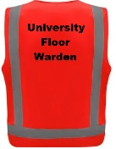
UPON HEARING THE FIRE ALARM:
- Put on the fire warden vest
- Instruct everyone to commence evacuation of the area via the nearest safe route and to proceed to the assembly point:

- The assembly point is:
- Appoint staff to:
- Check all rooms/areas, including toilets, to ensure everyone evacuates
- Assist those who may need assistance
- If it is safe to do so, turn off any equipment, appliances or systems that if left unattended could cause a fire e.g. toasters, microwaves etc…
- Check all fire/smoke doors are closed when leaving your area and that no one returns
- Only if it is safe to do so should fire-fighting be attempted
- Report to the building warden at the main fire panel and advise if your area is clear or if people remain
- The main fire panel is located:
- Assist with crowd control or other duties as directed

