Health, Safety and Wellbeing -

How to Undertake a Risk Assessment

  - Further Guidance Information for Risk Assessors

Table of Contents
Introduction 3
What is a health, safety and wellbeing risk assessment? 3
Why do I need to undertake risk assessments? 3
Does every activity or workplace need a risk assessment? 3
How the risk assessment process works 4
Example Risk Assessments and Assessment Forms 5
Identify the hazards 5
Decide who might be harmed and how 6
Evaluate the risks and decide on precautions 6
Evaluation of Risk 7
Record your findings and implement them 9
Getting Your Risk Assessment Signed Off. 10
Action plans 11
Communication 11
Further Considerations 11
Review the risk assessment and update if necessary 12
Some frequently asked questions 13
What if an accident occurs after I have my risk assessment approved? 13
Can I be prosecuted if something goes wrong? 13
What is “Reasonably Practicable”? 14
What if the activities I manage tend to vary a lot, or staff and/or students move from one site to another? 14
Do staff and students in my area have responsibilities? 14
What if one of my staff or student’s circumstances change in a way that could impact on their health and safety? 14
Who needs to know about the risk assessment? 14
How important is training as part of a risk assessment? 14
How do I get help? 14

Introduction
Risk assessments are an important step in protecting you, your colleagues, students, and others impacted by our work activities as well as being a legal requirement. An assessment helps you focus on the risks that really matter in your workplace or during activities – the ones with the potential to cause real harm or damage.
In many instances, straightforward hazards can be easily eliminated – for example, spillages should be cleaned up promptly so people do not slip, work areas should be clean and free of clutter, and only competent people should use complex equipment. For most workplaces, simple, cost-effective and practical solutions (or controls) will ensure that everyone is protected.
It’s not always possible to eliminate all hazards, so any remaining risk needs to be minimised and controlled so far as is ‘reasonably practicable’. This guide tells you how that is achieved, and will walk you through our step-by-step risk assessment process.
Before we begin, please note that any person who writes a risk assessment should have first completed the University course: “How to undertake a risk assessment” and be familiar with the activity they are assessing.

What is a health and safety risk assessment?
Foremost, risk assessment is a proactive and practical technique. Risk assessment is a careful examination of what, in your area of work, could cause harm, injury or ill-health to people. Through assessing health and safety risk, you can decide whether enough precaution has been taken or whether you should do more to prevent harm. All staff and students have the right to reasonable control measures that protect them from harm .

Why do I need to undertake risk assessments?
The University must ensure that the risks arising from its activities are assessed and appropriately controlled. Trained people such as yourself need to assess these risks and make sure that if we need to, adequate safety measures are put in place so that people are not hurt.
Once the assessment is written, you need to pass it on to your line manager or academic leader (i.e. the approver) for cross-checking and approval.
Under the Health and Safety at Work Act 2015, a Person Conducting a Business or Undertaking (PCBU) must ensure, so far as is reasonably practicable, the health and safety of workers, and that other people are not put at risk by its work. In our case, the University as an entity is the PCBU and our staff are workers, while other people include students and the public.

Does every activity or workplace need a risk assessment?
Thinking about risk assessments as either for places (building, departments and rooms) or as activities is a natural thing to do. Risk assessments should be carried out for all areas, even low risk areas such as offices. These risk assessments are communicated to new staff so they are aware of any potential risks in the areas where they work; such as the need for being aware of fire evacuation routes, emergency procedures and basic safety rules in their work areas. In other words, the risk assessment describes what is being done to protect them.
Areas that present a greater risk to health and safety (such as biological and chemical laboratories, and engineering facilities and workshops) may need a different risk assessment for each different activity they carry out.
If staff and students want to conduct lone work or work out of normal working hours, you will need to provide evidence that the activity is low risk. A formal risk assessment provides that evidence.
What does it mean if I sign a risk assessment?
When you sign a risk assessment, and pass it on for cross-checking and approval, it tells your manager that you believe the assessment is sufficient and suitable, that you believe the controls you have in place are reasonable, and that you will ensure the findings of the risk assessment are communicated to relevant staff.
It also means there will be some way for you to ensure that the people who are involved in the activity understand and adopt the identified controls.

How the risk assessment process works
The risk assessment process follows five steps:
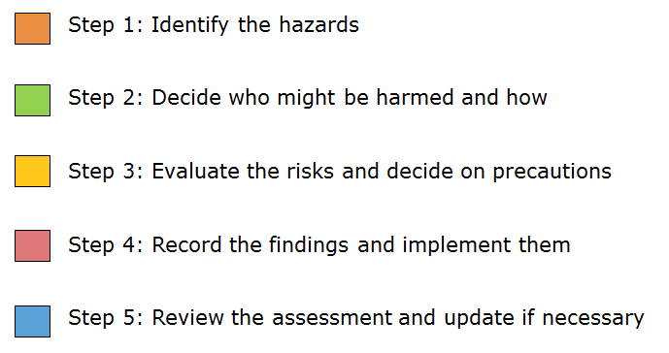
The process will often be relatively simple. In most instances risks and associated controls are well known either in this University or in others. For example, there are already proven standard operating procedures for when staff or students work alone, work with chemicals or machinery, or if they need to drive vehicles.
In most instances you and your colleagues will be well equipped to assess health and safety risks as you will have detailed knowledge of your specific areas – the people within it, the physical environment and the nature of the activities. It is also recommended that you consult with other staff, experienced students, your Health and Safety Representative and your Health, Safety and Wellbeing Manager to make the assessment more thorough and effective. You will also need to keep the person who will eventually approve the risk assessment advised on your progress.
When thinking about health and safety risk assessments, remember:
- Risk is the likelihood that a hazard will cause harm (injury, ill health, or damage) and the degree of harm that is likely to result (consequence).
- A Hazard is anything that has the potential to cause harm (injury or ill-health) or damage to property or equipment in connection with a work activity.
- A Control (or control measure) is an item or action designed to remove a hazard or to reduce the risk from it.

Example Risk Assessments and Assessment Forms
The Health, Safety and Wellbeing Service have developed multiple “example” (or generic) risk assessments that can be downloaded from their website or provided on request. These assessments list common hazards and controls for many different activities. If used, they must be adapted by you to suit your needs. https://www.staff.auckland.ac.nz/en/human-resources/health-safety-and-wellbeing/health-and-safety-risk-management.html
_____________________________________________________________

Step 1 | Identify the hazards
You must consider what things, processes or situations could reasonably be expected to cause harm or damage either in their workplace, or in the course of your activities.
When you work in the same environment every day, it is easy to overlook some hazards, so here are some tips to help identify the hazards that matter:
- Walk around the workplace and look at what could reasonably be expected to cause harm.
- Visualise performing the activity. Can you think of any potentially dangerous or complex equipment you are going to use?
- Ask others in your workplace for their opinions as they may be aware of things that are not immediately obvious to you.
- Check the Health, Safety and Wellbeing web site, and with colleagues in similar areas to see if there is an example risk assessment similar to your activity.
- Review completed inspection forms and look for any action points or recommendations.
- Review past accident, incident and near-miss reports.
- Check manufacturers’ instructions.
- Check the safety data sheets for chemicals and hazardous materials.
- Remember to think about long-term hazards to health (e.g. high levels of noise, stressful work, or exposure to harmful substances) as well as immediate safety hazards.
- If you are going on a field activity, check news reports about the area you will be heading to. Some areas may be subject to travel or health warnings, or there may be cultures or local customs to highlight to participants.
Do not worry about ‘unreasonable hazards’; the chance of being attacked by a dog in the city campus is almost nil, so it does not need be considered as a hazard. Consider only what is likely to arise in the workplace or during the activity.
_____________________________________________________________
Step 2 | Decide who might be harmed and how

For each hazard, you need to consider who might be harmed (e.g. students, visitors, specific groups of staff) and how. Deciding who might be harmed doesn’t mean listing everyone by name, but rather identifying groups and numbers of people (e.g. staff, students or others).
Remember
- Members of the public expect to be free from harm as a result of your activities.
- Cleaners, visitors, workers from another organisations, security guards and maintenance workers may not be in the workplace all the time or may not be aware of the hazards within the workplace.
- If the workplace is shared, the ways different work groups interact will need to be considered. Dust, noise and fumes generated by one work group may affect the other.
In each case, identify how they might be harmed and what type of injury or ill health might occur. For example, library staff may suffer back injuries from lifting boxes of books, machinists may be struck by rotating machinery, the public may be exposed to excessive noise, or people doing off-campus work may experience harassment from others in the group or members of the public.
_____________________________________________________________
Step 3 | Evaluate the risks and decide on precautions

The law requires us to control risk as far as is ‘reasonably practicable’ to protect people from harm. Your experience and expertise is crucial in this step, but the easiest way to make sure you are doing the right thing is to compare what you are doing with good practice. Also check the example risk assessments on the HSW website.
First, look at what you’re already doing; think about what controls you have in place and how the work is organised. Then compare this with good practice requirements and see if there’s more you should be doing to bring yourself up to standard. In asking yourself this, consider:
- Can we get rid of the hazard altogether? (Eliminate)
- If we can’t get rid of the hazard, how can we control it so that the risk of harm is unlikely? (Minimise)
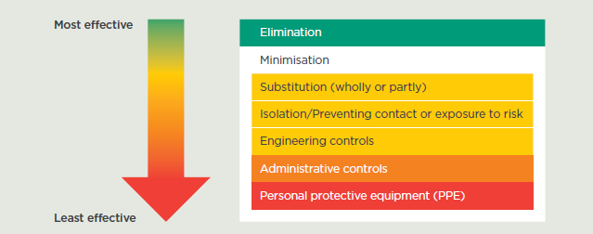
Figure 1. Hierarchy of control.
When ‘minimising’ risks, start from the upper part of the hierarchy of control, and only work your way down if the higher control is not reasonably practicable:
- substitute a less risky option (e.g. switch to using a less hazardous chemical, or do fieldwork at safer times, in more protected locations);
- isolate the hazard by preventing access (e.g. put barriers between pedestrians and traffic);
- engineer a way to reduce exposure to the hazard (e.g. use fume cupboards to suck away hazardous fumes);
- use administrative controls to reduce exposure to a hazard (e.g. use training to make people aware of the hazard, and use time limits when working with a hazard such as noise, ensure participants are aware of the University Code of Conduct). Remember – if relying on procedures to control risks, these usually need to be backed up by appropriate training and supervision;
- issue personal protective equipment (PPE) to reduce the harm from a hazard (e.g. hearing and eye protection). Remember - PPE is the least effective of all the controls as it does not remove the hazard, nor reduce the likelihood or harm being caused - it just reduces the potential consequence.
Welfare facilities (e.g. first aid and washing facilities for removal of contamination) should also be provided where needed.

Evaluation of Risk
Once you have considered the reasonable methods to control a hazard, you need to calculate the risk rating. There are two important components that need to be measured:
Likelihood – The chance of something happening.
Consequence – The degree of harm that would reasonably be expected from an event.
Likelihood is rated from 4-1.
4 | Very likely | Probably expect the event to occur in most circumstances
3 | Likely | Event likely to occur at least once over the coming year
2 | Possible | Event may occur at some time
1 | Unlikely | Occurrence is conceivable, but not expected to occur

Consequence is also rated from 4-1.
4 | Severe | Fatality or major injury  (death, permanent disablement, or significant long-term illness)
3 | Major | Serious injury  (serious injury or illness, admission to hospital required)
2 | Moderate | Minor injury  (illness or injury is not serious, medical treatment required)
1 | Minor | Trivial or negligible injury  (no injury, or a slight injury which requires localised first aid)

Once we have a number assigned to likelihood and consequence, we can calculate the risk. Risk = Likelihood x Consequence.
Risk is then calculated using this matrix
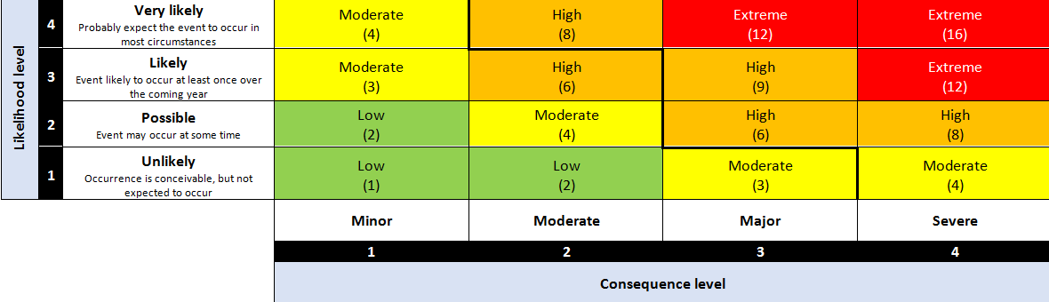

Risk can be reduced by reducing the likelihood of something happening, or by reducing the consequences of the event.

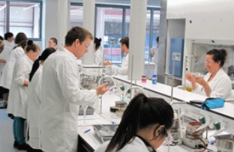
Example: Calculating the risk of skin burns from acid splashes.
‘Existing’ controls in place:
- Administration: Supervision
- PPE: lab coats, safety glasses, closed toe shoes.

With current controls and acid concentration
Likelihood of spilling on the body  Consequence (concentrated Sulphuric Acid)  Risk level (3x3) = | 3. Likely  3. Serious skin burns  9. High
After diluting the acid
Likelihood of spilling on the body  Consequence (extremely diluted Sulphuric Acid)  Risk level (3x1) = | 3. Likely  1. Trivial injury (minor irritation)  3. Moderate

In this case, substitution of the concentrated acid with diluted acid has reduced the consequence of an acid splash. If we still need to work with concentrated acid, we must use better methods to reduce the likelihood of it making skin contact with our students.
_____________________________________________________________

Step 4 | Record your findings and implement them
The Assessment
When documenting the controls you have decided on, you need to keep things simple and concise; this is an extract from the example risk assessment for Laboratories (chemical burn hazard):
Hazard | Who might be harmed and how | Reasonable Controls | L | C | R | Comments
Chemical burns | - 2 Staff  - 45 Students  Chemicals may be spilled or contact the body. | - All users of chemicals must access and understand the safety datasheets for the chemicals before they are used.  - Users must comply with University Safe Methods of Use during the experiment.  - Mandatory Personal Protective Equipment for using laboratory equipment includes:  - Lab coat  - Eye protection  - Closed toe shoes  - Emergency eyewash and washing facilities to be available. | 3 | 1 | 3 | - Chemical safety data sheets are available on the ChemGold FFX data base available via the library.  - Additional protection depending on the chemicals being used may be required.

Prioritise and tackle the most important things first – think of the hierarchy of control.
Particularly complex hazards may need to have other information sources referenced. In this case, they can be referred to in either the controls or comments column.
When correctly done, the risk assessment can be used as a checklist by line managers and academic supervisors when they are about to conduct an activity; they can verify that safety equipment is available, and that everyone has the correct PPE before they start.

Getting Your Risk Assessment Signed Off.
Here is where your approver comes in. Hopefully you have been keeping them informed of what you have been doing, so they should not be surprised.
They will compare the risk rating you have scored to the legend in the risk assessment form (which is summarised below):
Rating | Comment
Extreme (12-16) | The activity must not go ahead with this level of risk.
High (6-9) | The activity should not go ahead unless extra controls are in place.
Moderate (3-4) | The activity can go ahead. Ongoing controls such as supervision and monitoring of workplace conditions or weather may be required.
Low (1-2) | The activity can go ahead without the need for further controls.

They may ask for further clarification so they can be satisfied that the controls are appropriate and will be effective.
They may ask you to rethink some of your controls. They may even say that the activity is too risky to go ahead.
Risk assessments are not expected to be perfect, but they must be suitable and sufficient.
As an assessor, you will need to show that:
- a proper check of hazards was made;
- you involved others in the process and determined who might be affected;
- you have dealt with all the obvious significant hazards by taking reasonable precautions;
- the remaining risk is moderate or low; and
- any other relevant information is documented or attached.

Action plans
If your ‘approver’ finds that the controls in place are not suitable or sufficient, they may work with you to create an action plan. If it is possible, they may either clear the activity to go ahead while the extra actions are being put in place, or they can state that the activity is not to go ahead until the action plan is completed.
Action plan items may include:
- the use of a temporary control to allow an activity to begin;
- the implementation of a long-term solution to a hazard;
- arrangements for training employees on the main risks that remain and how they are to be controlled; and
- regular checks to make sure that the control measures stay in place.
The names of the people responsible for carrying out the action plan must be clearly documented, and you need to ensure that you do what you have been asked to do by the date that is specified.

Communication
It’s no good having the risk assessment just sitting in a folder, so the findings of the risk assessment need to be communicated to relevant staff and other participants.
These methods include:
- formal communication to staff
- collaboration tools such as Teams
- e-mail
- team meetings
- inductions
- tool box talks

Further Considerations
What do I do if my approver determines that my risk assessment is not sufficient or suitable?
Seek further assistance from someone with the appropriate knowledge (e.g. a specialist in the activity or a member of the Health, Safety and Wellbeing Service). If it’s beyond your scope of knowledge or experience, say so.

What if my approver and I do not agree on the proposed control measures?
Again it is recommended that you seek further guidance from a specialist (e.g. a colleague, or a member of the Health, Safety and Wellbeing Service).
How do I make sure we have not missed a significant hazard?
In most cases, you and your workmates are the subject matter experts, and are aware of the most significant hazards. Asking a colleague for a second opinion of your risk assessment is a good way of checking that you have not missed anything obvious.
If in doubt, seek further advice from colleagues, Health and Safety Representatives, or the Health, Safety and Wellbeing Managers.
Don’t forget that WorkSafeNZ may also need to be informed of your work if it is especially hazardous.
_____________________________________________________________
Step 5 | Review the risk assessment and update if necessary

Few workplaces stay the same. Sooner or later, you will bring in new equipment, substances and procedures that could change your levels of risk. It therefore makes sense to review your risk on the following occasions:
- After an infrequent, complex activity has concluded.
- After a change in a workplace.
- After a period of time.
- After an incident/near miss.

Post activity. A post activity review will capture knowledge and experience for next time. Think of:
- What worked? Make sure we do the same next time!
- What didn’t? Make sure that people don’t make the same mistakes. If you will be doing the same activity next year as part of your course, fix the problems now.
Workplace change. A change in the workplace is normally for the better, whether it be with new machinery or equipment, the introduction of less hazardous chemicals, or through the adoption of better technology. In many cases, you will have introduced enhanced safety features, and the need for some safety controls may be relaxed. Think about a workshop that normally works with petrol powered vehicles now having to work with high voltage batteries and electric vehicles: hazards associated with the storage of petrol are now gone, but we have now introduced workers to high voltage electrical systems.
Annual reviews may incorporate updated knowledge about a subject or capture a change in legislation. Excellent guidance is now available with regards to mobile elevating working platforms, emergency management, drones, lasers and many other subjects that the University is involved with.
Post Incident. Obviously, if an incident has occurred, our controls have failed. Is there anything we can do to prevent it happening again? What lessons can be learned? We need to look at our risk assessment and think about whether there are improvements we need to make. Get feedback from your staff or students.
_____________________________________________________________

Some frequently asked questions

What if an accident occurs after I have my risk assessment approved?
Health and safety is not a perfect science and there is no such thing as a perfect risk assessment. Cases of personal liability are rare and only occur when there is a clear breach of health and safety legislation.
Generally speaking, it is essential to share and discuss health and safety information and to always give staff and students an opportunity to raise their safety concerns so that those concerns can be appropriately dealt with. A breach may occur if concerns are raised, but then people are forced to continue without corrective measures being applied.

Can I be prosecuted if something goes wrong?
It would be unlikely for an individual to be prosecuted, but it is possible. The laws intent is to punish those who do nothing (fail to prevent harm), who are disengaged or undermine the occupational health and safety system, or who commit flagrant violations that could of or did lead to harm. If you act with the best intent and are reasonable, any issues are likely to be perceived as a failure of our University systems or processes.
You could be prosecuted if:
- You know of a reasonable way to control a hazard and you insist that work take place without that control (such as edge protection around an elevated platform).
- Someone highlights a worsening situation and you insist that work carries on (such as setting off on a field expedition that involves river crossings and you know that severe storms have been forecast).
- Insisting that someone carries on with a task that they have not been trained for (such as telling an unqualified student to abseil down a cliff to look for rock samples).
You could not be prosecuted if:
- An activity participant decides to defeat a control that you have identified in the risk assessment (such as removing a safeguard without the line managers or academic supervisor’s knowledge).
- An activity participant decides to not take reasonable steps to maintain their own safety (such as taking a “selfie” in a dangerous place or not wearing the personal protective equipment provided).
- You are affected by an event that would not be reasonably expected to happen (such as being struck by a freak weather event).

What is “Reasonably Practicable”?
It’s a bit tricky, so you may need to refer to the Health, Safety and Wellbeing Service for further advice. The answer can depend on the circumstances and it is the role of the service to assist in making a competent and informed decision.

What if the activities I manage tend to vary a lot, or staff and/or students move from one site to another?
Identify the hazards you can reasonably expect and assess the risks from them. This general assessment should stand you in good stead for the majority of your work. Where new activities or locations are introduced, cover any new or different hazards with a specific assessment. You do not have to start from scratch each time.

Do staff and students in my area have responsibilities?
Yes. Both staff and students have legal responsibilities to co-operate with their manager’s efforts to improve health and safety (e.g. they must wear protective equipment when it is provided), and to look out for each other.

What if one of my staff or student’s circumstances change in a way that could impact on their health and safety?
You’ll need to look again at the health and safety risk assessment. You are required to carry out a specific risk assessment for new or expectant mothers, as some tasks (heavy lifting or work with chemicals for example) may not be appropriate. If someone in your area develops a disability or becomes pregnant then you are required to make reasonable adjustments. People returning to work following major surgery may also have particular requirements. Consider the best way forward that works for you, your staff and students.

Who needs to know about the risk assessment?
You need to tell anyone who may be affected by the risks. This includes staff and students, but might also include people like cleaners, estates staff or contractors or carry out maintenance work.
In the simplest of cases, information can be given by word of mouth. More usually it will need to be written down and copies of the health and safety risk assessment made available.

How important is training as part of a risk assessment?
One of the control measures may include specialised training for all those working within the area of risk. Training is particularly important when people are new to the job, are exposed to new or increased risk, or when their existing skills have become rusty or need updating.
Training is not a substitute for proper risk control, e.g. to compensate for poorly designed equipment. However it may be appropriate as a supplementary or temporary measure of control until permanent improvements can be made.

How do I get help?
If you get stuck, don’t panic - there is a wealth of information available to help you. Contact the Health Safety and Wellbeing Service, or talk to your Health and Safety representatives.

