Club Treasurer’s Manual

Generally, a club’s Treasurer is responsible for managing the club’s finances and maintaining accurate financial records.

Treasurers have an important job to perform, so it is important that they are:
- Able to keep accurate records
- Able and prepared to make regular time commitment
- Confident in handling figures
- Well organised
- Careful when handling money and cheques
- Honest
- Able to answer questions in meetings

Generally, a club’s Treasurer is responsible for:
- Looking after the finances of the organisation
- (Serving as the club’s financial advisor)
- Keeping up-to-date records for all financial transactions (i.e. book keeping)
- Collecting subscriptions/membership fees and all money due to the organisation
- Ensuring that funds are spent properly
- Paying expenses on time and recording the information
- Issuing receipts for all money received and recording this information
- Financial planning including preparing an annual budget and monitoring it throughout the year
- Regularly reporting to the club’s executive team on the financial position
- Presenting an end-of-year financial report at the Annual General Meeting
- (Preparing a year-end statement of accounts to present to the Auditors)
- (Applying for grants/funds – filling in required documentation)
- Helping to prepare and submit any statutory documents that are required, for example tax returns, GST returns, Charities Commission annual returns and grant aid reports

Recommended equipment for being an efficient Treasurer:
- Petty cash box that locks (and has a spare key)
- Financial information of the organisation from previous years
- A Treasurer’s folder(s) (ring binders)for storing:
  - Completed documents both financial and non-financial
  - Receipts from expenses and reimbursements
  - Invoices sent to the club
- Receipt book (in duplicate) to issue receipts for money received
- General journal / General ledger (may be online)

Treasurer folder:
- A Treasurer folder is the most important piece of equipment a Treasurer should have.
- It should contain all the information the Treasurer (and the club) needs in order to run an effective and financially sound organisation - e.g. financial documents, the club’s constitution and policies, members list etc.
- Specifically, it should store all the information required by the club for applying for Clubs - Campus Life’s Annual Financial Health Check.
- A well organised Treasurer folder should comprise of:
  - Club information document
  - Financial documents
  - Non-financial documents

- Club information document:
- Official/legal name
- Official/legal postal address
- Executive members and their contact details, particularly:
  - President
  - Treasurer
  - Secretary
- Financial year
  - Most UoA clubs operate in line with the academic year - from January 1st to December 31st
- Reporting date
  - Is generally a date just before the club holds its AGM
- Incorporation number (if club is an incorporated society)
- Charities Commission number (if club is a registered charity)
  - (Charities website login information)
- GST number (if club is GST registered)
- IRD number
- Bank account(s) number(s)
  - (Bank account login information)

- Financial documents:
- General journal/ledger (Cash book)
- Chart of accounts
- Bank reconciliations
- Statement of financial performance (profit/loss statement)
- Statement of financial position (balance sheet)
- Budgets
  - Whole club - Yearly
  - Specific events
- Asset register
- Bank statements
- GST returns
- Invoices/receipts
- Deposit slips (i.e. the slips of paper received after depositing money at the bank)

- Non-financial documents:
- Club constitution
- Club’s policies and procedures
- Certificate of incorporation (if club is an incorporated society)
- Certificate of charity status (if club is a registered charity)
- List of officials/members with delegation authority
- Minutes of meetings
- AGM and other reports
- Membership forms and receipts issued to members
- Current membership list
- Current membership fees

Paying bills/expenses:
- Instead of giving petty cash to exec members before they pay for expenses, arrange to reimburse them after they’ve paid with their own money.
  - This ensures that they won’t spend club money needlessly, as well as that no unused funds are misplaced or lost.
- All payments should relate back to a written invoice or document.
  - This also applies to claims for expenses from members of the exec team and other club members.
  - Produce a simple claim form for them to fill in before you pay them. Make sure they attach the relevant receipts/documentation to it.
- It is important to pay out-of-pocket expenses to exec members/volunteers promptly, since they have already paid out the money on behalf of the organisation, and are also giving their time free of charge.
  - Their co-operation and good will is vital to the success of the organisation.
- Bills/expenses should be paid in a timely fashion (i.e. one-month of receiving them), especially when dealing with companies that you use often.
  - Their goodwill is important, and they will be more likely to want to trade with you again and are more likely to give you good terms or discounts, if they know that they will be paid reasonably promptly.
- When handing out cheques do not rely on your memory, always make sure that you have some proper documentation.
- Keep all relevant documentation
  - Note down as much information as possible on the documentation as if someone new to the organisation will immediately understand what the expense was for if they read it.

- Expense reimbursement form:

Collecting money/Sending invoices:
- It is essential to keep cash received separate from your own money.
- Keep a cash box solely for the club's money, and write receipts in duplicate as soon as you receive the money.
- Hand one receipt to the person who pays you and the other one is your copy which should be kept in the book.
  - Note: if your club uses internet banking to receive payments, you could send electronic receipts, but generally will not need to bother if the online payment has been referenced correctly.
- All cash and cheques should be deposited in the bank or as soon as possible after receiving it.
  - Not only is this efficient administration, it also makes good financial sense, since money in the bank is likely to earn interest, and reduce banking charges.
- (If you send out invoices to collect some of your money, you will need a book that shows that an invoice has been issued and later confirms that is had been settled).
- Keep a record of your members, noting who has paid and who has not paid their membership fee.
  - Remember to update this asap once membership fees have been paid
  - Google doc spreadsheet is ideal as it can be updated from anywhere.

- Invoice:
- Receipt book:
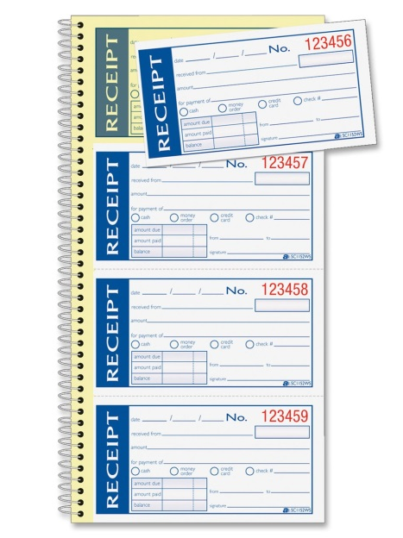

- Membership fee list:
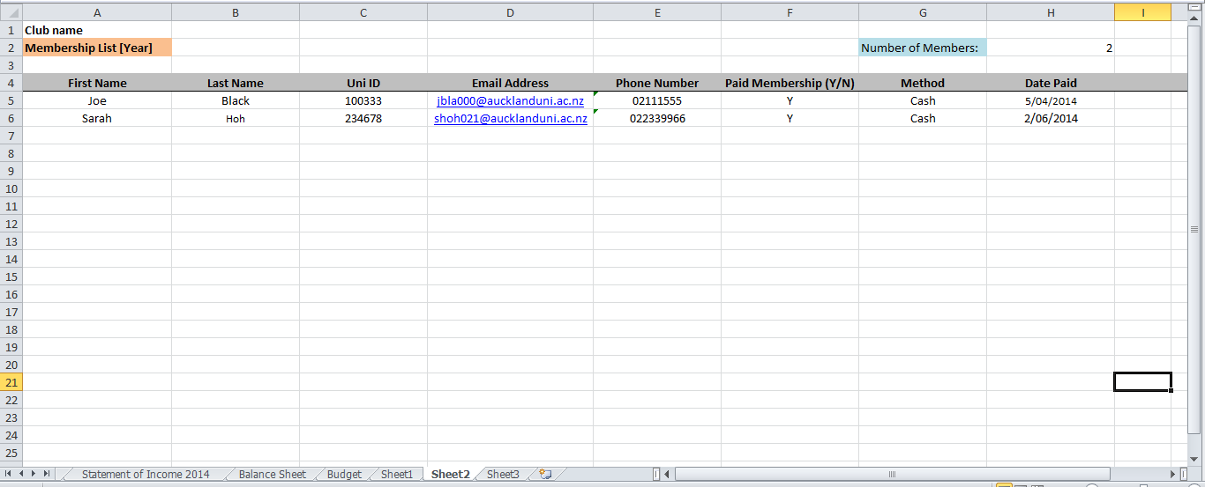
Assets
- Whatever the purpose of your club or the activities it engages in, it is likely that there will be items (i.e. assets) purchased by the club to be used by its members or at its events.
  - i.e. club assets = things that will be retained by the club for future benefit.
- Given that club assets are bought with the club’s money and have significant value, it is important they are looked after - otherwise your club might as well throw the money down a hole.
- Since the club’s Treasurer is likely to have bought the items or given authorisation for their purchase, they are probably the best person to keep track of them - though this responsibility should be shared with the exec team.
- A simple assets register should contain:
  - A description of the asset
  - Its purchase price and the date it was purchase
  - A guesstimate of its current market value
  - The location of where its stored
  - The name and contact details of the club member responsible for it

- Assets register:
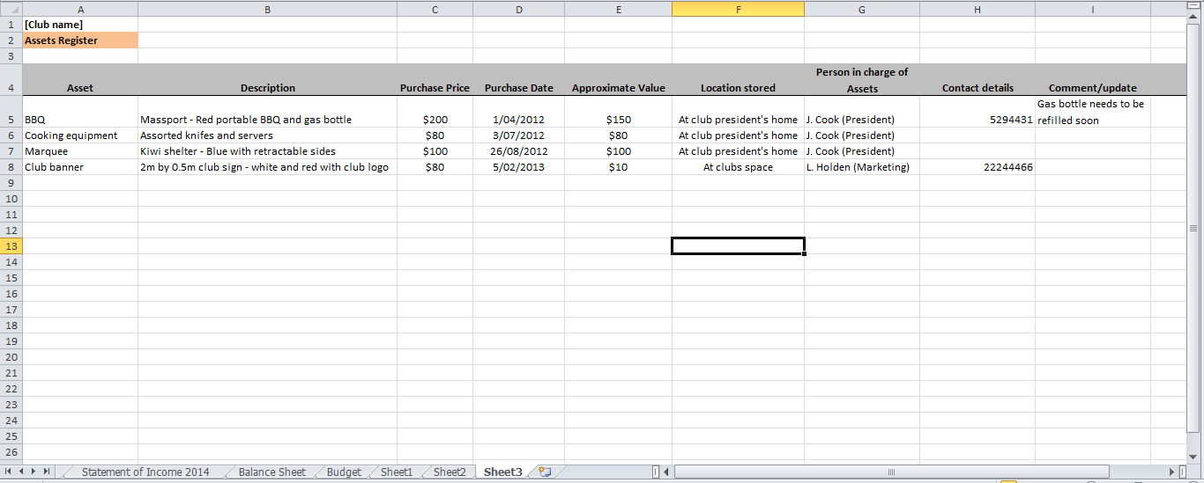
Writing cheques
- Given the simplicity of internet banking and direct deposit, cheques are gradually being phased out. Nonetheless, there still might be the odd occasion where you might need to dust off your club’s cheque book to make a payment.
- It’s important to fill out the cheque correctly to ensure that it is usable and that it can’t be altered by an unauthorised person.
- Also make sure you keep the cheque book and cheque stubs in a safe place.
- When you write a cheque you need to include the following information:
  - Payee name (the person you’re paying)
    - You need to write the payee name as it appears on the person you’re paying’s bank account.
    - If you are making the cheque out to an individual you will need to use their full name, for example ‘Martin Lane’ or ‘M Lane’.
    - If you are paying a company you should check exactly how you should write their business’s name on the cheque – this information is likely to be on your bill, statement or invoice.
  - Date
    - The date will usually be day you are writing the cheque and needs to include the day, month and year.
    - You can, pre date your cheque by writing a date in the future, this will prevent the recipient from cashing it until that date.
  - Amount in words
    - When you write the amount in words you need to write the amount in full, followed by the word “ONLY” – this is to stop anyone amending the amount written on your cheque.
      - E.g. $54.35 would be written as Fifty Four Dollars and Thirty Five Cents Only.
    - It is also common practice to draw a line through the rest of the amount box after the word ONLY.
  - Amount in numbers
    - This should be entered in the small box on the right hand side, must match the amount in words and should include dollars and cents.
  - Your signature
    - You will need to sign your cheque in the space in the bottom right hand corner, this signature must match the signature on record with your bank, or your cheque will bounce.
- Remember to fill out the cheque stub.
- Note: a cheque can be open or crossed.
  - An open cheque can be taken to the bank and exchanged for cash. Whoever has the cheque can present it to the bank and be paid cash, even if it does not belong to them.
  - However a crossed cheque has two lines drawn across it preventing the cheque form being cashed. The cheque must be deposited into a bank account. If the cheque has been stolen, it is easily traced by locating the account it was deposited into.
    - Cheques can be crossed in two ways:
      - Not Transferable: This cheque must be deposited into any bank account (i.e cannot be cashed).
      - Not Negotiable, A/C Payee only: This cheque can only be deposited into a payee's bank account.
Cheque stub

Payee
Date
Cross-out bearer so that no one but the payee may bank or cash the cheque

Amount in numbers

Amount in words
The double lines and words “Not transferable” ensures your cheques can only be banked in the payee’s bank account.
Keep a record of each cheque you write to help you manage your account balance

Preparing a budget
- A good Treasurer not only records details of what has happened, but also what is likely to happen.
- This forecast (the budget) is very important for your club.
  - It helps planning and decision making, and allows you to decide e.g. whether to spend money, increase fees, or rethink your activities.
  - A budget is simply an estimate of any income (from e.g. tickets) and expenditure (e.g. venue hire, drinks) for running a club or an event. It should state the overall profit (or loss) of the year’s activities or the event:
    - All income - all expenditure = profit/loss
- It should be discussed with the exec team for modification and approval.
  - (In a small organisation you should involve the members, and keep them aware of what is happening. They are more likely to agree to an increase of fees or charges if they understand the financial pressures that the committee is facing).
  - (People who are going to have to work within a budget are much more likely to be careful with the money if they understand the reasons for the decisions, and were involved in setting the figures).
- Do not set a budget with a deficit in the hope that something will turn up. Always aim for the budget to at least break-even, and ideally build in a contingency fund.
  - E.g. Add 10% onto your total expected expenditure.
  - This caters for unexpected things that crop up during the year, or turn out to cost more than you anticipated.
- Remember to factor in GST of 15% - many suppliers will not include this in their estimates.
- Use previous budgets as a guide - the previous exec team should leave you with old budgets.
- Sometimes, you will find that your original budget was inaccurate, and it will then be worth preparing a revised budget forecast with a more accurate prediction of the final outcome for the year.
- A yearly budget should be prepared (for the entire academic year), but can prepare two budgets for each semester.
- Ideally you should also prepare a budget for each event your club holds
  - An event budget lets you know what the event is likely to cost and, if you are going ask members to pay, how much you will need to break even etc.

- Budget:
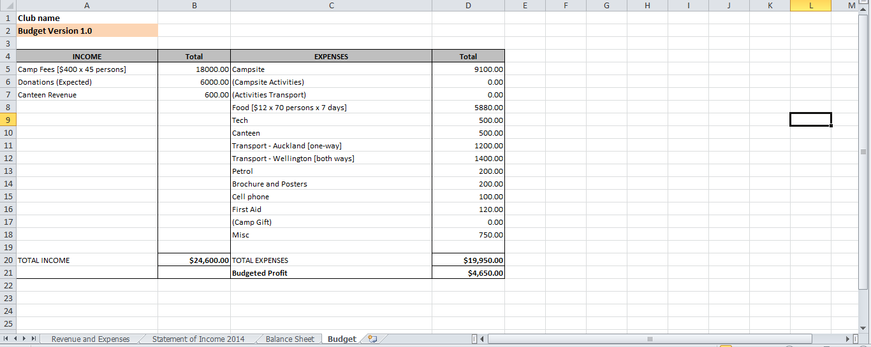

Financial accounts/Bookkeeping:
- All receipts and payments should be recorded in the financial account books
- The financial accounts keep a record of all income and expenditure.
  - They comprise a Journal or Ledger, usually covering a 12-month period (the financial year).
- Your club might be using a proper accounting system already e.g. Xero, MYOB. For those that are not, Excel offers a simpler and cheaper alternative (if done right).
- Simplified account information system:
  - Accounts Financial statements
    - Journal or Cashbook ( Ledger) Profit/Loss
Balance Sheet
- Your club may use a cash book (used for recording only cash transactions) as well as a journal/ledger. It is easier just to use a journal to record all transactions.
  - Are you running a cash or accrual accounting system? Check your organisations constitution.

- The general journal:
- A journal is a chronological record of all recordable economic events.
- The complete effect of an event is disclosed in one place.
- The journal helps locate errors.
- Note: expenses are recorded as outflows (Debit on your bank statement) and income recorded as inflows (Credit on your bank statement)
  - Note: Not referring to the more complicated accounting double entry system
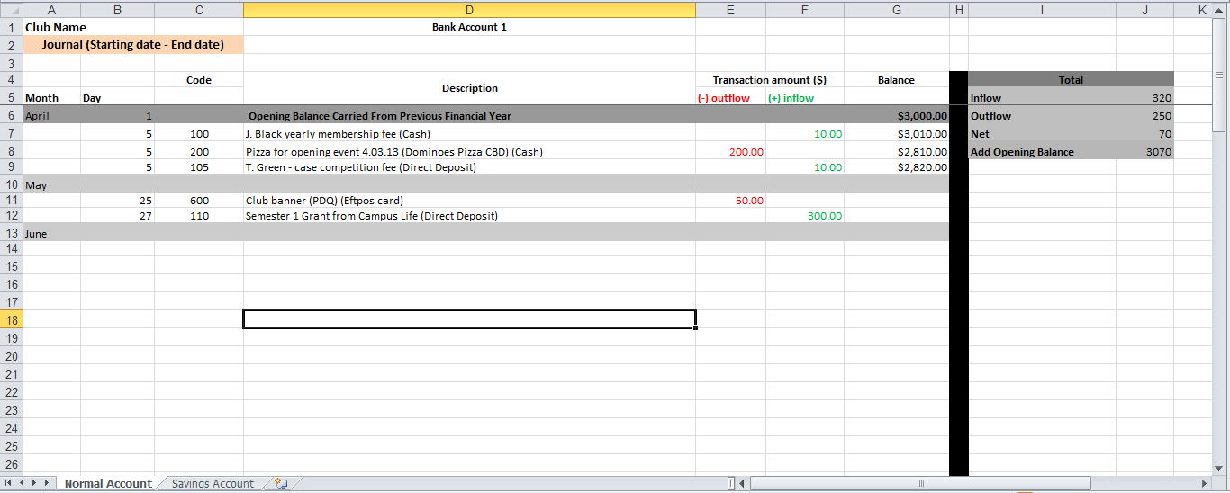

- The general ledger:
- Contains all asset, liability and equity accounts.
- Unlike journals, will provide you with balances.
- NB: Hybrid General Ledger/Journal
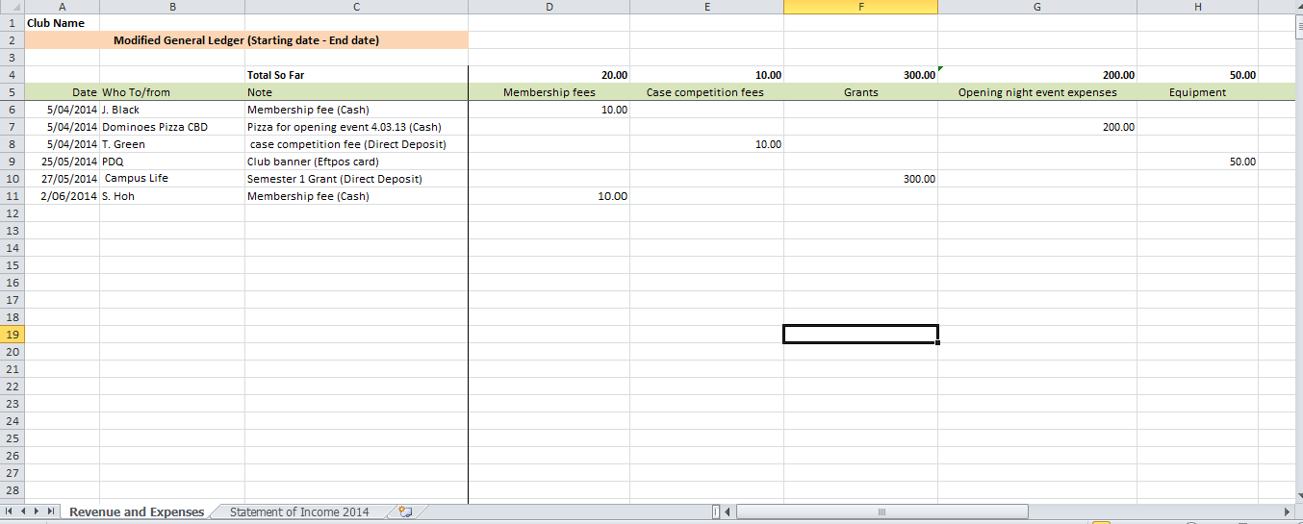

- Chart of accounts:
- A listing of all accounts and associated account numbers for a business.
- The table of contents for the General Ledger
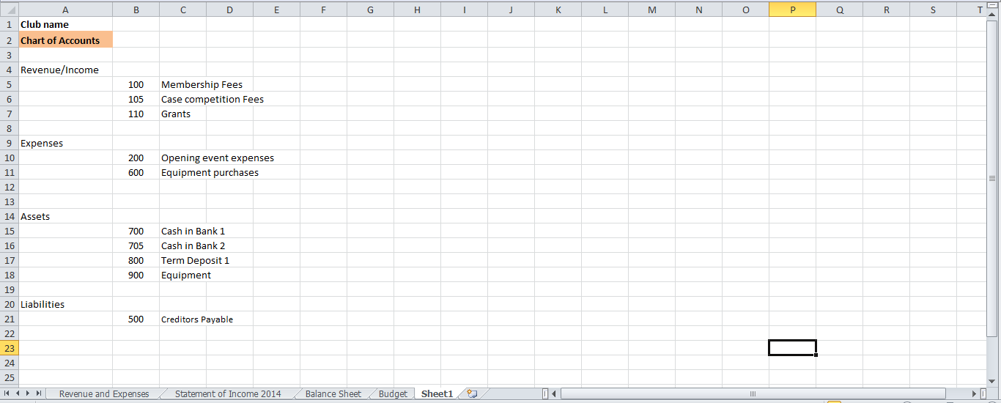

- Income statement:
- Purpose: to report the success or failure of the club’s operations for a period of time
- Lists the clubs income (revenue and gains) followed by its expenses
- Profit (or loss) is determined by deducting expenses from income.
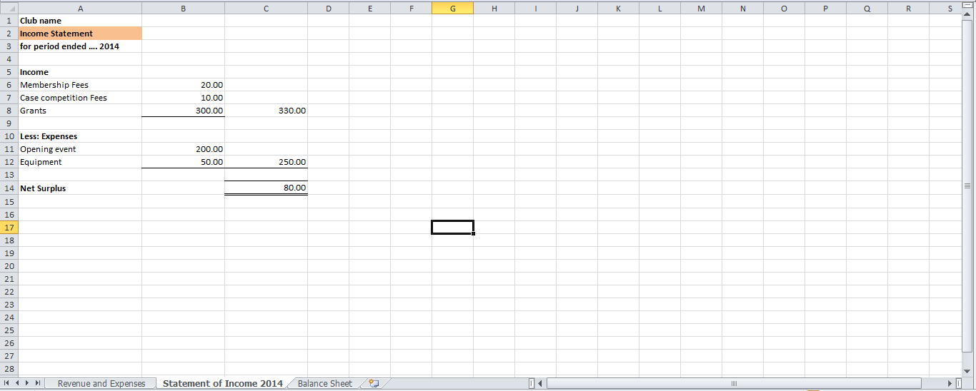
- Balance sheet
- Purpose: Reports assets and claims to those assets, at a specific point in time.
- Claims are subdivided into: claims of creditors (liabilities) and claims of owners (equity).
- Assets = Liabilities + Equity
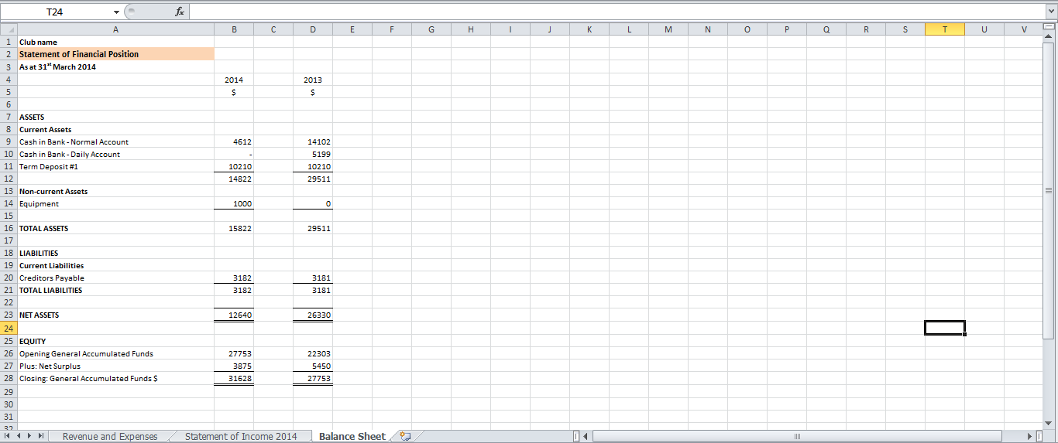
Balancing the bank account/Bank reconciliation:
- A bank statement is the bank's record of the club’s finances. Your club should probably have access to online bank statements - if you do not have already, it is well worth getting.
- The banks record may not agree exactly with what is kept by the Treasurer in the cash book/Journal because it can take a few days for income/expenses to appear in a bank account.
- Bank statements should be obtained regularly (monthly is usually about right) and be checked immediately against the books/Journal to reconcile the bank with these books/Journal.
  - This enables you to keep up-to-date and identify any mistakes or discrepancies. It will be much easier to sort out any differences now, rather than several months later, and it helps too avoid having an overdraft, which is expensive.
  - For more information about bank reconciliations see:
    - www.youtube.com/watch?v=mkBDcpMHzR4
    - www.youtube.com/watch?v=RnQnU4mANLI

- A few tips about banks:
- If your club does not have a bank account, get one [Clubs - Campus Life requires clubs to have one]
- Ensure that signing authority is in-line with your club’s constitution/policies [Clubs - Campus Life requires clubs to have at least two signatories]
  - Be aware that, while having more signatories increases the layers of security, it might make life too difficult for the Treasurer.
- Banks offer different bank accounts depending on the club’s status – e.g. if a registered charity, your club will not have to pay tax on interest and might not have to pay many of the bank fees
- Internet banking is a great way to pay expenses/reimburse exec members – saves having to handle cash or write out cheques and leaves a more reliable record if details are filled out correctly.

Tips to remember:
- Keep proper accounts and prepare regular statements. There is no substitute for timely and thorough records and reports.
- Do not over estimate your ability to remember details of financial transactions-write them down.
  - Transaction records and reports should include a meaningful description of where funds come from, and where they go to.
    - E.g. if given a receipt from exec members, make sure they record on the receipt who it is from and what exactly it was for.
- The important thing about accounting, apart from being accurate, is to be consistent, so that you can make meaningful comparisons from month to month, and from year to year.
- Always give receipts for money received and get receipts for money paid out.
- Keys to the petty cash boxes should only be held by specified people who are always responsible for them.
- Keep incoming and outgoing money separate.
- Pay surplus cash into the bank promptly.
- (When opening mail or collecting tins containing cash, there should be at least two people present).
- Budgeting is one of the most important financial functions for any organisation, do not be tempted to try to manage without a budget, or you will be heading for financial difficulties.
  - Make a budget, and stick to the budget.
- Money may not be the root of all evil, but when dealing with other peoples' money you can expect high levels of interest and emotion. They will always expect their money to be handled with extreme care and sensitivity. Not only must you look after the funds with scrupulous honesty, but you must be seen to do so.
- Try to establish a system which prevents fraud, rather than one to discover or compensate for it

The Treasurer’s 10 commandments:
- Issue receipts for all money received.
- Promptly bank all money received.
- Seek out the safest and most productive place to bank the organisation’s cash.
- Do not pay out any money without the authority of the exec team.
- Do not issue petty cash without receiving a voucher/completed reimbursement form.
- Clearly distinguish between capital (i.e. equipment), revenue and expenditure.
- Record receipts and payments clearly and accurately.
- Make sure the balance shown on the bank statements can be reconciled to the balance in the cashbook/journal.
- Report the past, present and future financial progress and position of the organisation to all exec meetings and the AGM.
- Faithfully discharge your responsibilities to the exec team of the club, its members, its sponsors and others with whom it does business.

